Gersowitz Libo & Korek, P.C.
www.lawyertime.com

Media Contact
Callisto Griffith
Status Labs
(512) 576-9825
Callisto@statuslabs.com

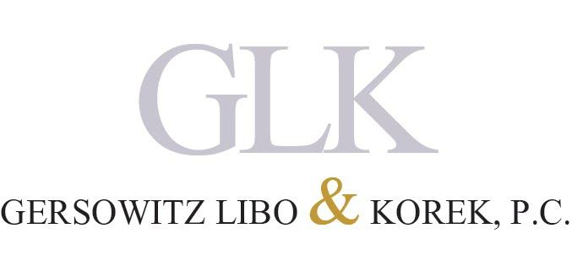
Jeff Korek Recognized for Outstanding Merit as 2016 Best Lawyers® “Lawyer of the Year” in New York City
Senior Trial Partner at New York City Law Firm Gersowitz Libo and Korek, P.C. Featured in the 22nd Edition of The Best Lawyers in America©

NEW YORK, New York – October 2015 – Jeff Korek, Senior Trial Partner with Gersowitz Libo and Korek, P.C. (GLK) was recognized amongst industry peers for exceptional work in personal injury litigation. As a result of his efforts, peers hand selected Korek to receive the honorable accolade Best Lawyers® 2016 Personal Injury Litigation - Plaintiffs "Lawyer of the Year" in New York City.

Bestowed upon by industry peers annually, only one lawyer is recognized as the “Lawyer of the Year” for each specialty and geographic location. The recognitions are awarded to individual attorneys with the highest overall peer-feedback and is based on a methodology that includes nomination, peer review, analysis of feedback and an eligibility check.

“It’s always nice to be recognized for the passion and hard work we bring to every case,” said Korek. “This award is clearly a team effort and one our entire office is proud of. “

Since Korek’s partnership with GLK in 1992, he has been an indispensable key litigator in medical malpractice and personal injury cases throughout New York and New Jersey. He helms a track record of successful litigations and settlements that have earned him recognition in the New York Times, New York Magazine and Crain’s New York Business.

Korek was admitted to the United States Supreme Court in 2013. Additionally, he has been appointed by four successive Presiding Justices of the Appellate Division, Second Department to the Committees on Character and Fitness for the Ninth Judicial District. Korek is a member of the American Bar Association, American Board of Trial Advocates, American Association of Justice, New York City Bar Association, Bronx County Bar Association, and the New York County Lawyers Association. In years past, he served as President for both the New York State Trial Lawyers Association and the New York City Chapter of the American Board of Trial Advocates.

The 2016 winners are featured in the 22nd edition of The Best Lawyers in America© and will include honorary practices and lawyers from around the nation.

The latest edition can be found online at: http://www.bestlawyers.com/

About Best Lawyers
Best Lawyers is the oldest and most highly-respected peer review guide to the legal profession worldwide. They provide a robust search engine to search lists of peer-recommended lawyers by individual, firm, practice area, and location.

About Gersowitz Libo & Korek, P.C.
The experienced personal injury attorneys at Gersowitz Libo & Korek, P.C. have been aggressively fighting for victims’ rights in New York and New Jersey for over 30 years. They are dedicated to the pursuit of justice for those who have suffered in the face of negligence or recklessness in the courtroom and beyond. Lawyertime.com

###

