**Media Contact:**

Callisto Griffith

[Callisto@statuslabs.com](mailto:Callisto@statuslabs.com)

(512) 576-9825

FOR IMMEDIATE RELEASE: September 2015

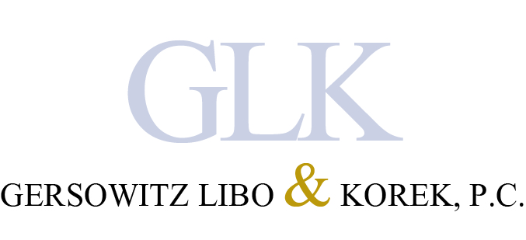

**Gersowitz Libo and Korek, P.C. Successfully Filed Suit Against the City for Gross Negligence with Immigrant Family**

*New York Law Firm Received Favorable Appellate Division Ruling for Darden Binkaj’s Death*

NEW YORK, New York – September 2015 – New York personal injury law firm Gersowitz Libo and Korek, P.C. received a favorable Appellate Division ruling after five years for the family of Albanian immigrant Darden Binkaj. A drunk driver killed Binkaj on the Bronx River Parkway in a head-on collision in 2010. The police neglected to inform the family of the death for more than 36 hours during which an unauthorized [autopsy](http://nypost.com/2015/09/09/family-can-sue-city-over-autopsy-given-against-kins-religion/) followed, violating their Muslim faith. The ruling entitles the next of kin to receive damages for the City’s dereliction to inform the family in a timely manner and the consequences they suffered as a result.

The family sought the firm’s assistance to file suit claiming a breach of the common-law right of sepulcher, which is the family’s right to receive the body of the deceased *post haste* to allow funeral and burial rights to ensue. The tragic withholding of information and the unnecessary autopsy inflicted severe emotional anguish, and on September 8, 2015, a judicial panel ruled in [favor](http://www.newyorklawjournal.com/id=1202736675617/City-Found-Liable-for-Failure-to-Notify-Family-of-Death?slreturn=20150817014244) of the family.

The attorneys at Gersowitz Libo and Korek, P.C. are passionate to find answers for families that have undergone tragedies and suffered consequences from injustices. Edward Gersowitz, managing partner of the firm, represented the Binkaj family in the lower court.

“It is doctrine that when the police have the means to identify a decedent, they have an obligation to impart that information in a timely fashion to the next of kin,” said Gersowitz. “This case represented a significant indiscretion by New York City authorities and this type of negligence should not occur anywhere.”

Please consult the attorneys at Gersowitz Libo and Korek, P.C. for any matter related to remiss actions, personal injury or medical malpractice by visiting the [website](https://www.lawyertime.com/) or calling 1-800-529-9997.

**About Gersowitz, Libo & Korek, P.C.**

The experienced personal injury attorneys at Gersowitz Libo & Korek, P.C. have been aggressively fighting for victims’ rights in New York and New Jersey for over 30 years. They are dedicated to the pursuit of justice for those who have suffered in the face of negligence or recklessness in the courtroom and beyond. [Lawyertime.com](https://www.lawyertime.com/)

###