
Media Contacts:
Pat Monroe
pmonroe@aem.org
(414) 298-4123
Kate Huskin
khuskin@aem.org
(414) 298-4155

U.S. Retail Sales of Small Tractors Slowed in September,
Continue to Beat 5-Year Average
MILWAUKEE (October 14, 2015) – U.S. retail sales of small farm tractors under 40HP decreased
2.4 percent in September 2015 compared to the same period last year, according to the Association of Equipment Manufacturers (AEM), the leading trade organization for off-road equipment manufacturers and suppliers. Year-over-year, retail sales for all other tractor categories also decreased, led by four-wheel drive tractor sales, which were down 48 percent in September.

Year-to-date sales of the smaller, less than 40HP tractors maintained their growth compared to 2014, while sales of 40 to 100HP farm tractors remained stable. In a more long-term comparison, retail sales in units for agriculture tractors and combines nearly matched the 5-year average (2010-2014).

“We’re not surprised to see slower sales during August and September due to seasonal trends, but the year-over-year dip, especially in the large and 4WD farm tractor category, is quite significant,” said Charlie O’Brien, AEM’s senior vice president. “Lower commodity prices and lower farm incomes continue to impact equipment purchases. With farmers’ balance sheets still relatively healthy, we look to a correction in equipment inventories and hopefully the reactivation of incentives like Section 179 to stabilize equipment sales.”

U.S. Agriculture Equipment Retail Sales – September 2015 Report:
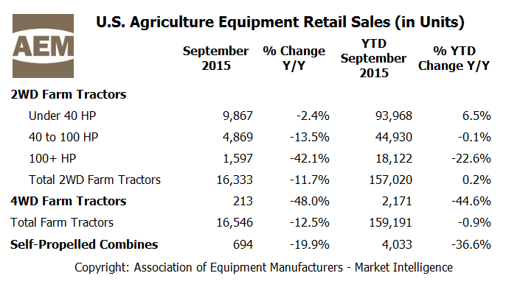

U.S. Agriculture Equipment Retail Sales – 5-year Average and Unit Trends:
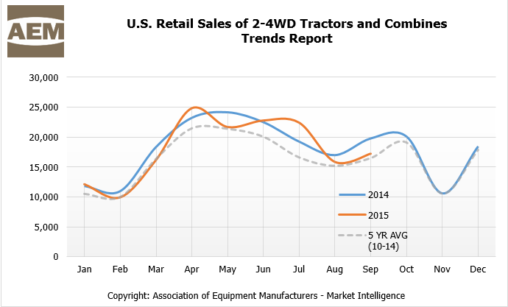

About the Report
Data from AEM’s Agriculture Equipment Retail Sales Flash Report is provided monthly and is derived from AEM member companies through our proprietary statistical reporting programs. The analysis of the data is provided by AEM’s Market Intelligence department. Visit www.aem.org/agreports to view the reports, as well as reports from Russia and Canada.
About the Association of Equipment Manufacturers (AEM) - www.aem.org
AEM is the North American-based international trade group providing innovative business development resources to advance the off-road equipment manufacturing industry in the global marketplace. AEM membership comprises more than 850 companies and more than 200 product lines in the agriculture, construction, forestry, mining and utility sectors worldwide. AEM is headquartered in Milwaukee, Wisconsin, with offices in the world capitals of Washington, D.C.; Ottawa, Canada; and Beijing, China.

###

