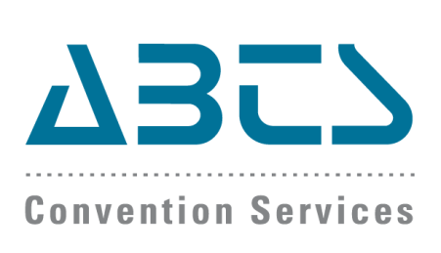  Contact: Patricia Andrade  305.562.1211  pandrade@abtscs.com | FOR IMMEDIATE RELEASE  October 15, 2015
PRESS RELEASE
ABTS CONVENTION SERVICES ACQUIRES THE RED BOOK FOR MEDICAL MEETINGS

The Red Book’s high-quality CME/CPD compliance information for 100+ countries worldwide augments ABTS’ portfolio of strategic global planning and growth consulting services.
MIAMI, Florida (October 15, 2015) –ABTS Convention Services (ABTS), the leader in delivering globally-focused sales, online and onsite customer service, technology, and integrated marketing strategy solutions for US-based medical associations and their medical meetings, today announced that it has entered into an agreement to acquire The Red Book for Medical Meetings, a comprehensive global medical meetings guide and the number 1 reference source of updated and detailed pharmaceutical regulation and continuing medical education (CME) information for over 100 countries.
For more than 20 years ABTS has specialized in providing an extensive range of services essential for the creation of successful meetings and has been focused on assisting US based medical associations and their housing partners manage international growth through internationally friendly group housing, onsite support, and global sales and marketing strategy.
The Red Book for Medical Meetings was developed by The Society for Worldwide Medical Exchange, an international non-profit focused on advancing global health through continuing medical education, and The Rome Group, an international group of experts in the field of CME focused on bridging national boundaries to build common ground among accreditation systems around the world.
The Red Book for Medical Meetings will bring to ABTS a proprietary source of the most updated and in-depth current and emerging rules and regulations that govern the participation of international healthcare providers in US based medical meetings. With The Red Book for Medical Meetings, ABTS expands on its portfolio of strategic global planning and growth consulting services which include assisting medical associations looking to grow in international markets through the analysis, evaluation, recommendations and assistance in implementation of international growth strategies, including international marketing, social media, competitor analysis, market analysis, relationship building, relevancy, sales, payment and business processes.
ABTS is also interested in utilizing data sets from The Red Book to further advance Project Pythia- a joint venture to analyze variables/factors that affect annual meeting attendance in an effort to determine a model to predict best-case scenarios for annual meetings with a goal to increase attendance, registration, and overall participation of attendees.
"This is such an exciting moment in the 20-year history of ABTS Convention Services, and I couldn't imagine a better pairing than ABTS and The Red Book," said Davide Veglia, president of ABTS Convention Services.
##

ABOUT ABTS CONVENTION SERVICES- With over 20 years of experience delivering global internationally-focused sales and integrated marketing strategy solutions, negotiating internationally-friendly group housing and providing on-site expertise to manage your international groups, ABTS is recognized as one of the leaders in medical association management. ABTS specializes in moving your medical association forward in today’s global meetings market by managing and growing your international attendance. www.abtscs.com
ABOUT THE REDO BOOK FOR MEDICAL MEETINGS- The Red Book for Medical Meetings is an international compendium of pharmaceutical codes, continuing medical education/continuing professional development (CME/CPD) systems and health authorities. Developed with the aim of encouraging transparency and efficiency in planning medical education events, The Red Book for Medical Meetings is the go-to-guide for meeting planners, academic institutions and CME/CPD providers and currently features information on over 100 countries, with topics ranging from sponsorship limitations on class of service, length of stay, expenditure on meals, whether or not CME/CPD is required or voluntary for physicians and the name and contact information for the primary national health authority. www.redbook-medicalmeetings.org

