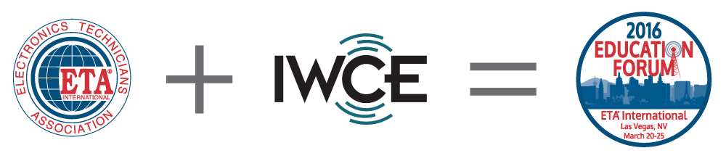

EF16 HANDS-ON TRAINING WORKSHOPS

LAS - Line and Antenna Sweep
Presented by Ira Wiesenfeld, CETsr, IWA Technical Services
$899 (early bird thru 2-4-16), $949 after
Sunday, March 20 – Monday, March 21
• Designed for beginners as well as senior-level technicians and engineers, this course goes beyond traditional line sweep and PIM testing and provides all the knowledge in order to test and evaluate RF signals that begin at the output of a radio transmitter and eventually are propagated into the air to a receiver. Hands-on exercises will include applications of everyday problems found in the field such as: testing fundamentals, reflectometers, RF wattmeters, calibration, determining problems, distance-to-fault measurements, system sweeps, FDR operation and troubleshooting.
R56 - Communications Site Installer (R56) Training
Presented by Chris Hoch, CETma, Motorola Solutions
$1,199 (early bird thru 2-4-16), $1299 after
Sunday, March 20 – Wednesday, March 23
• This workshop is for Motorola employees and affiliates only, unless invited and Motorola authorization given. This certification validates examinees knowledge of the core concepts required in the installation of a communications site, based on the R56 industry codes and standards. If you hold a Standalone R56 and later complete the Associate CET (CETa), then you are eligible to upgrade to a Journeyman CET.

F123 - Fiber 1-2-3
Presented by Light Brigade
$1,849
Sunday, March 20 – Wednesday, March 23
• Novice and experienced fiber professionals alike will find the class and extensive hands-on skills training beneficial to prepare for ETA's Fiber Optic Installer (FOI) Certification Exam.
This class provides a practical understanding and the skills required to properly design, install, and maintain fiber optic networks. Students will use the latest fiber optic technology and equipment to learn how to splice, connectorize, test, and troubleshoot fiber optic networks.

RFIM - Interference Hunting
Presented Tom Dover, Dover Telecommunications Services
$799 (early bird thru 2-4-16), $849 after
Monday, March 21 – Tuesday, March 22
• This course is for anyone involved with interference hunting in radio services and to prepare for ETA's Radio Frequency Interference Mitigation (RFIM) certification exam. It begins with an overview of basic RF principles, signal types, propagation and spectrum allocation. It will provide theoretical and practical fundamentals needed to effectively identify and locate radio frequency interference issues in any band or network. Methods of radio location (direction finding) and signal analysis will be demonstrated using live signal sources and hands-on exercises.

DAS - Distributed Antenna Systems
Presented by Dane Brockmiller, FOT, Dover Telecommunications Services
$799 (early bird thru 2-4-16), $849 after
Monday, March 21 – Wednesday, March 23
• This course introduces DAS for in-building and stadium use and prepares students for ETA's Distributed Antenna Systems (DAS) certification exam. Attendees completing this course will better understand the components required to install DAS, how DAS systems work, how they are designed and why the design is critical to proper operation. Exercises demonstrating critical design and decision points are included.

MCEI - Mobile Communications and Electronics Installer
Presented by Chris Dalton, LAS, Radio System Analytics
$1,099 (early bird thru 2-4-16), $1199 after
Monday, March 21 – Wednesday, March 23
• This certification workshop includes basic knowledge concepts of land mobile radio (LMR) and associated electronics equipment installation. This also incorporates required skills applicable to all of the functions required to safely and completely install mobile communications and associated electronic equipment, including removal and reinstallation. MCEI certification ensures the installer has acquired the necessary fundamental skills to deliver more safety, compliance, and efficiency through the use of onboard technology.

RFID - Understanding RFID
Presented by Andre Smalling, CETsr
$599 (early bird thru 2-4-16), $649 after
Tuesday, March 22
• This certification workshop is intended for an electronics technician with an understanding of Radio Frequency Identification. The technician should have a basic understanding of the hardware and theory of operation of radio communications as it applies to RFID radio transceiver technology. RFID is a stand-alone but can be used as a Journeyman option when the CETa exam is also taken and passed.

CETa – Associate Certified Electronics Technician
Presented by Fred Weiss, CET and Chris Miller, GROL
$410 (early bird thru 2-4-16), $410 after
Wednesday, March 23 – Thursday, March 24
• Whether you are a student wanting more in-depth information, a Maker Movement technician needing expert guidance or a practicing electronics technician wanting to prepare for ETA's Associate Certified Electronics Technician (CETa) certification exam, this class and extensive hands-on training will be beneficial.

