**Safe robotic cable retraction without looping – the new Triflex RSE system**

**The retraction system for industrial robots enables cost-effective, automatic guidance of energy supply systems and supply hoses.**

**East Providence, RI - November 2, 2015 –** The motion plastics experts igus has developed a lightweight, cost-effective retraction system for the automatic retraction of cables and hoses. The new Triflex RSE system prevents looping of the cable carrier, allowing power, data, media to be safely supplied to the end of the robotic arm.

**Lightweight, space saving design**

The extremely lightweight RSE system is based around the self-lubricating, maintenance-free DryLin linear bearings from igus. A moving carriage guides the cable carrier, allowing for a retraction stroke of up to 23.6 inches, while a durable elastic cord automatically retracts any excess slack, preventing loop formation within the system. The low profile RSE features integrated adjustable attachment plates, which allow the system to be mounted close to the robot, making RSE a space-saving and cost-effective solution.

Triflex RSE was designed for use with the Triflex R line of cable carriers from igus, which are available in a variety of diameters and styles. A large range of mounting options are available, allowing the system to be fitted to a variety of robot models.

**About igus®**

igus**®** develops industry-leading Energy Chain**®** cable carriers, Chainflex**®** Motion Cables, DryLin**®** linear bearings and linear guides, iglide**®** plastic bushings, and igubal**®** spherical bearings. These seemingly unrelated products are linked together through a belief in making functionally advanced, yet affordable plastic components and assemblies. With plastic bearing experience since 1964, cable carrier experience since 1971 and Motion Cables since 1989, igus provides the right solution from over 100,000 products available from stock. No minimum order required. For more information, contact igus at 1-800-521-2747 or visit www.igus.com.

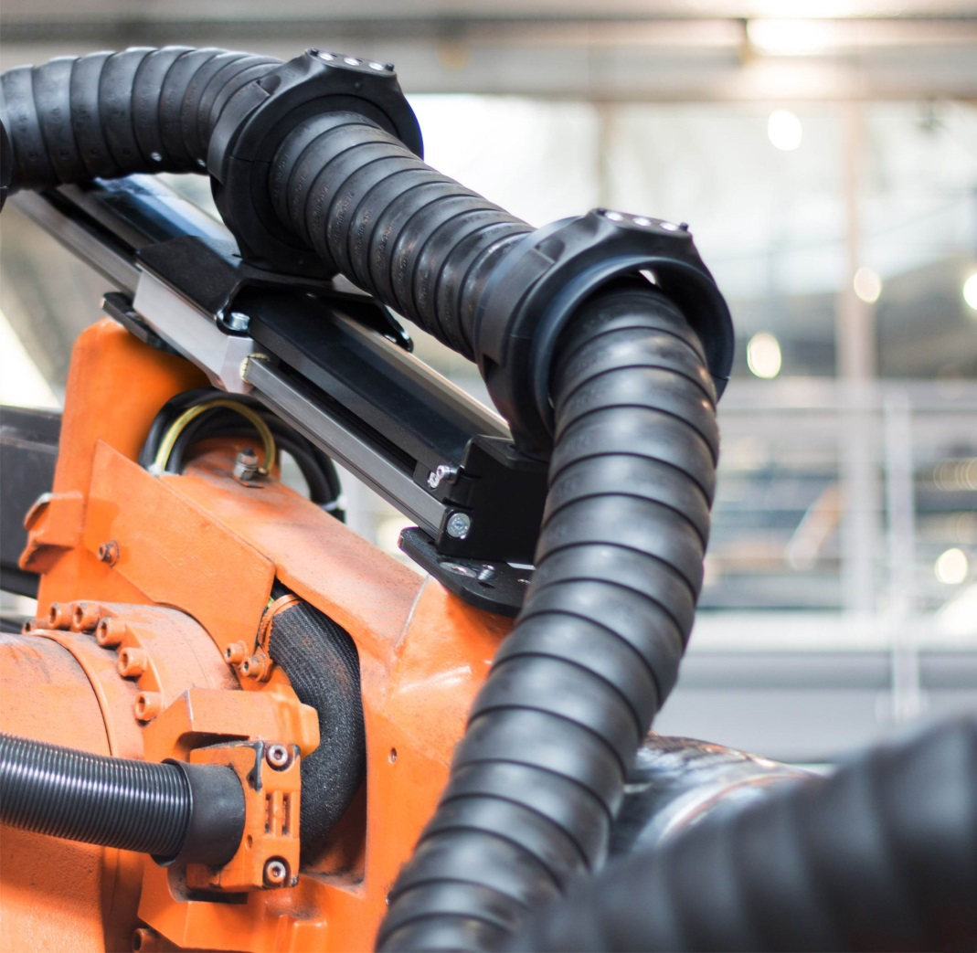

**Photo:**

**Picture 1215-01, igus Inc.**

Lightweight, affordable Triflex RSE guides and retracts cable management systems on robotic arm applications.

|  |  |
| --- | --- |
| **CONTACT:**  igus® Inc.  PO Box 14349  East Providence, RI, 02914  Tel.: 800.521.2747  Fax: 401.438.2200  sales@igus.com  www.igus.com  **PRESS CONTACT:**  Ellen Rathburn  Public Relations Specialist  PO Box 14349  East Providence, RI, 02914  Tel.: 800.521.2747 x. 288  erathburn@igus.com  www.igus.com | igus, Energy Chain, DryLin, Chainflex, iglide, dry-tech, and igubal are registered trademarks of igus Inc. All other company names and products are trademarks or registered trademarks of their respective companies. |