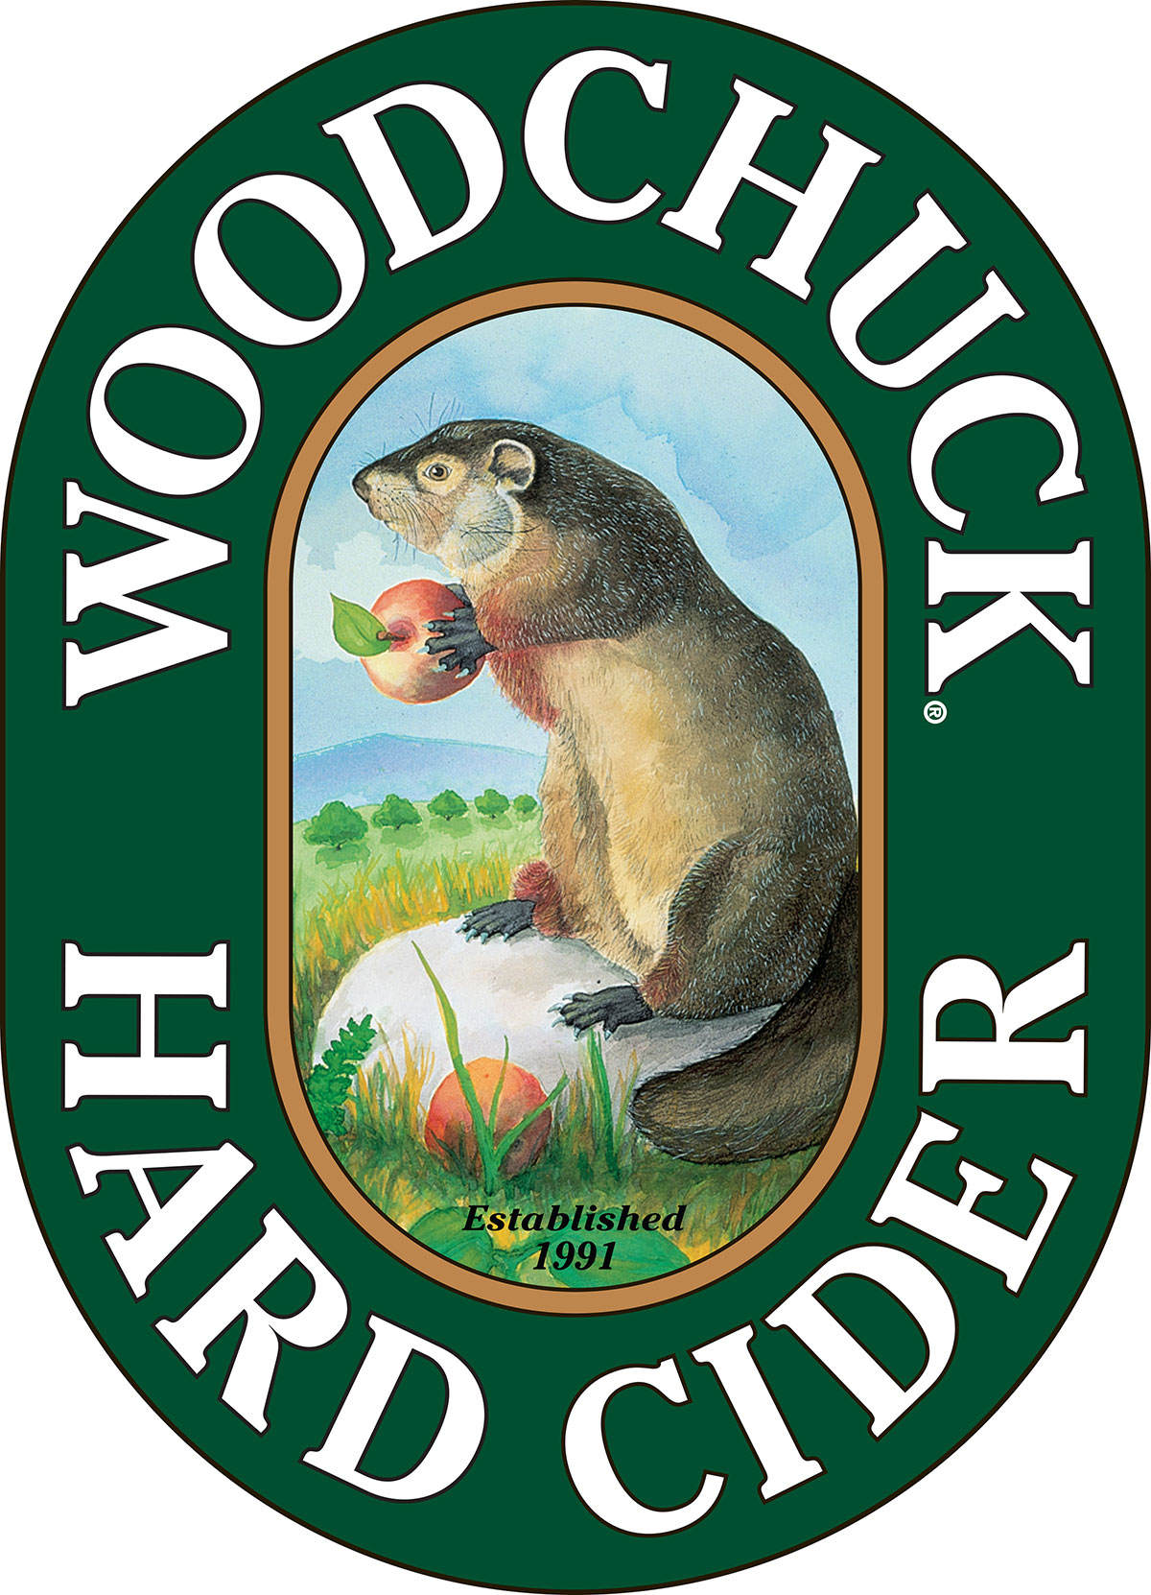

FOR IMMEDIATE RELEASE

Contact: Caitlin Stroupe
(802) 398-6958
cstroupe@vthardcider.com

Woodchuck® Hard Cider Releases Hot Cha Cha Cha as Winter Seasonals Return
~The Vermont-based hard cider introduces new Out on a Limb® style with the return of Winter Chill and Barrel Select~

November 4th, 2015 MIDDLEBURY, Vt. — Woodchuck Hard Cider is excited to announce the release of their newest Out on a Limb cider, Hot Cha Cha Cha. Out on a Limb is a rotating six-pack that features some of Woodchuck’s most creative cider varieties. Hot Cha Cha Cha is the sixth cider of this series and will be available while supplies last starting November 1st.

Hot Cha Cha Cha adds a spicy flare to the original Vermont-based hard cider, infusing bird’s eye chili peppers. The peppers complement a base crafted with bittersweet cider apples, bringing forward a sweet taste up front with a spicy bite at the finish. The semi-sweet style has a bright golden hue and will bring some extra heat to the changing seasons. Hot Cha Cha Cha has an ABV of 5.5% and the suggested six-pack retail price is $10.99.

“It was fun to add some spice to the newest Out on a Limb,” said Cider Maker John Matson. “The idea stemmed from working with cider during our local Middlebury Chili Festival.” Matson with fellow Cider Maker Ben E. Calvi creates new ciders to release in the series every 90 days.

The new hot pepper cider hits shelves as both Seasonal Winter Chill and Private Reserve Barrel Select come back into market. Both of the oak-aged variety, Winter Chill (SRP $9.99) is aged in premium French and traditional American oak, and Barrel Select (SRP $10.99) is aged for six months in genuine white oak Kentucky bourbon barrels. Both winter varieties are available from November through February nationwide.

Hot Cha Cha Cha will be available in limited quantities nationwide through January. For more information or to request hi-res imagery, contact Caitlin Stroupe at cstroupe@vthardcider.com or (802) 398-6958.

###
About Woodchuck® Hard Cider
Woodchuck Hard Cider introduced the U.S. to the craft cider category 24 years ago after it was first handcrafted in a 2-car garage in Proctorsville, Vermont. Staying true to its roots, Woodchuck is dedicated exclusively to cider making. In other words, we “Give a ‘Chuck” about authenticity and handcrafting the best cider possible. Innovation is at the core of everything Woodchuck’s cider makers do, which is why they continuously strive to create unique new ciders using the finest ingredients. That attention to detail has paid off and Woodchuck Hard Cider has recently received awards at the World Expo of Beer, The Great Lakes International Cider and Perry Competition and the New York International Beer Competition. For more information about Woodchuck Hard Cider visit www.woodchuck.com.

