 Contact: Richard Bendix
richard@bendixmarketing.com
206-972-7585

About Stillwater Dwellings
The Mission
Residential architects and a custom home builder founded Stillwater Dwellings in 2008. Their goal: a more affordable approach to contemporary design, premium materials and sustainable building practices.
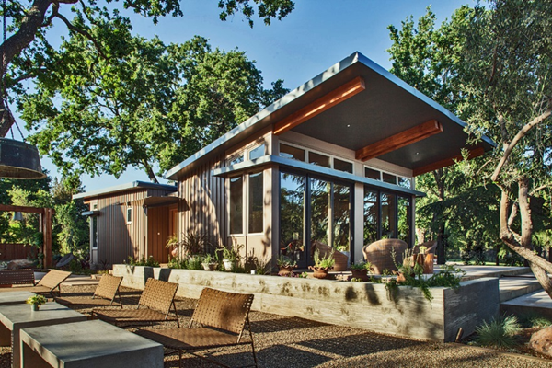
Stillwater Dwelling prefab homes embrace contemporary design. Their intelligent floor plans emphasize natural light and dramatic spaces. Stillwater homes use flexible, systems-based construction. This offers a high level of design and craftsmanship, while controlling costs and limiting unwelcome surprises.

Building a new home should be exciting and rewarding -- not stressful and open-ended. Stillwater streamlines design and building phases, shortening project time, reducing waste and saving money.

The Stillwater Process

The Stillwater process is built around personal service. Stillwater works closely with clients, from initial discussions to long after the move into their new homes.

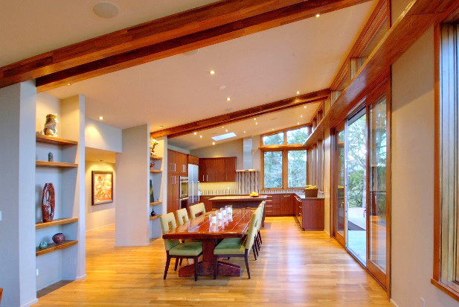
Stillwater's project managers, architects, and other professionals guide each client through the custom prefab home process. They handle the details, from defining site requirements to projecting a budget, with fixed prices for all supplied materials.

Stillwater Dwellings has developed a highly efficient three phase design and construction system. Our professional architects and production managers guide clients through a straightforward process.

Phase One - Site Analysis, Plan Selection and Pricing

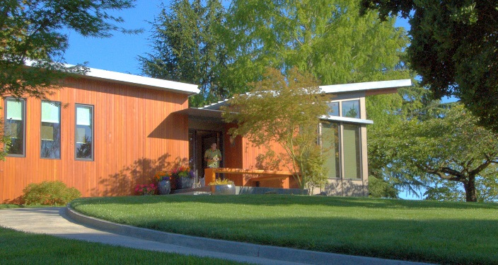
Clients work closely with Stillwater architects to select and develop a plan best suited for their site, budget and wish list. After a comprehensive site visit, a Stillwater architect analyzes zoning and building permit requirements and helps site the home on the client’s property. Architects develop complete plans with necessary modifications. A comprehensive specification document details materials, options and finishes. Next, Stillwater produces a fixed price for the components they provide and a cost estimate for all elements of the project—including those provided by others.

Phase Two - Engineering & Permitting

Upon formalization of a Home Purchase Agreement, based on the final fixed pricing established in phase one, the final design, engineering and permitting begin. Stillwater architects develop detailed floor plans and oversee the production of engineering and permit drawings. Project managers work with local building departments and agencies to apply for customary permits. The building contractor will use the final engineering drawings to refine many of the on-site related costs.

Phase Three - Fabrication & Construction
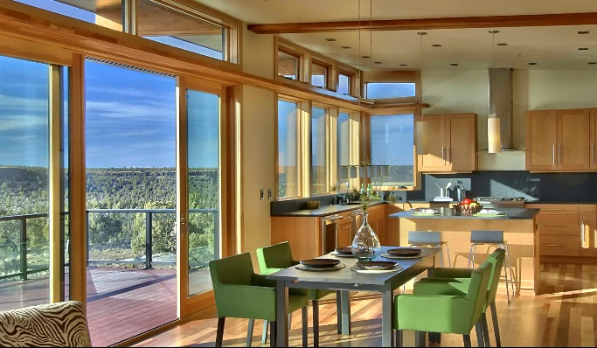
With Phase Three, Stillwater begins production at a climate controlled manufacturing facility. The Stillwater team will work closely with the local contractor to finalize all related costs. The contractor will develop the site schedule and begin work on the foundation, driveway, and utility hookups. Fabricated components will be shipped to the site and installed according to the plans.

The Environment

Stillwater Dwellings is dedicated to fabricating and designing prefabricated homes that remain sustainable, healthy; environmentally sound and energy sensitive. Energy efficiency is at the heart of our design philosophy. Stillwater prefabricated homes utilize state-of- the-art framing strategies to provide for superior insulation and tightly sealed finished structures. Environmental impacts are evaluated throughout the design and specification process. Our modern fabrication system reduces waste by up to 50%, compared to site built homes.

About Stillwater’s Founder
Matthew Stannard, AIA


Matthew was a senior associate with the prominent Seattle architectural firm of Olson Sundberg Kundig Allen Architects. There he participated in a wide range of residential projects before leaving in 2004 to form Stannard Conway Architects, and later Stillwater Dwellings. Prior to moving to Seattle, his professional career included stints with firms in Wellington, New Zealand and London, including Terry Farrell and Partners. Mr. Stannard is also the founder of Stannard Architects a Seattle based firm specializing in design of custom single and multi-family homes.

