FAQ’s

Why A Stillwater Home?
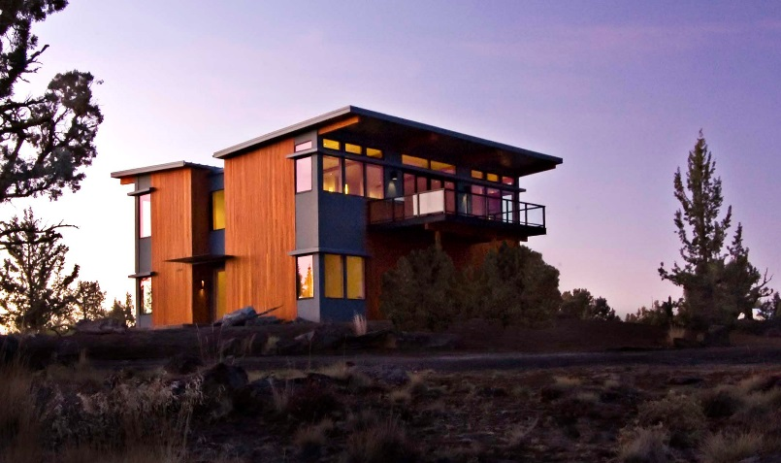
1. Contemporary design and sustainable custom architecture
2. Fixed, upfront pricing for Stillwater provided materials and estimates for the entire project—typically 25% to 30% less than traditional site built custom homes
3. Collaborative, straightforward design process that takes the stress out of custom design.
4. Predicable results – the Stillwater three-step system takes the mystery, and much of the stress, out of the custom home building process. 5. Faster occupancy, with homes ready to move in an average of 6-12 months faster than traditional custom homes.

Stillwater homes are designed with dramatic natural lighting, and intelligent floor plans for exceptional quality and value. Flexible, systems-based prefab construction supports a high level of design and craftsmanship, controls costs and reduces surprises. Stillwater believes building a new home should be exciting and rewarding, not stressful and open-ended. Stillwater streamlines the design and building process, shortening project time, reducing waste—and saving money.

Will Stillwater Revise A Plan Or Do A Custom Plan For Me?
The team of experienced architects is dedicated to crafting solutions for your unique needs. Many Stillwater clients start with one of our Detailed Plans and customize it to fit their needs. Others envision an entirely new plan—either way the company delivers high-end custom designed homes.

How Does The Process Work?
Stillwater has a highly efficient three phase design and construction process.
- Site analysis, plan selection and pricing
- Engineering and permitting
- Fabrication and construction
The entire process takes from 6 – 12 months on average, making move-in time 6-12 months faster than with traditional custom-designed home construction.

What do Stillwater Homes Cost?
Stillwater homes generally cost 30% to 50% less than typical site built custom homes with comparable professional design. The typical total project cost for a Stillwater home is between $250 and $325 per square foot, complete on your lot.

How Long Does It Take To Build A Stillwater Home?
The time from order placement to move-in averages six to twelve months—considerably faster than a site built custom home. Many variables in the process can impact timing. These include customization, local zoning, permitting and site work. Actual time in the fabrication facility is only 8-12 weeks.

What Is Included In A Stillwater Home?

Stillwater offers a choice of two prefab building systems. The modular option provides a complete, traditional modular home prefabricated and finished in a climate controlled factory and shipped to the building site in “modules” ready for quick assembly. Almost all elements are included: floor structure, roofing, lighting fixtures, plumbing fixtures, wood flooring, countertops and setting the home on a prepared foundation.

With the panelized prefab system, all major framing components are precision fabricated and assembled in a factory and shipped to the building site. Finishing work is done onsite by a local contractor. The price of both systems includes all architecture, structural engineering, and state building permit.

The modular option provides a nearly completed home shipped to your accessible site. The panelized system offers more flexibility in shipping, design modifications, and finishing options, plus, generally, lower total cost.

Where Do You Build Homes?

Stillwater Dwellings is based in Seattle, Washington and markets throughout the United States. Our portfolio includes homes in Bend and Portland, Oregon, Santa Barbara, and Dana Point in Southern California, as well as homes in Napa, the San Juan Islands of Washington, Colorado and even Louisiana.

What Finishes Packages Are Available?

To streamline the design process, Stillwater Dwellings’ modular line offers three base packages: The Natural Package (left) is simple, warm and refined, with abundant natural wood surfaces; the Modern Package (middle) is clean and minimalist with modern roots; and the Original Package (right) is stylish and smart: it’s Stillwater Dwellings most cost effective package. These packages are starting points, but all finishes can be customized.

