the world’s first biometric password

Biotect ID – mobile security app for ios and android devices

Biometrics are human body characteristics used for identity authentication. Iris, fingerprints or face scans are static and unchanging. If stolen, they’re gone forever. BioTect-ID is different.
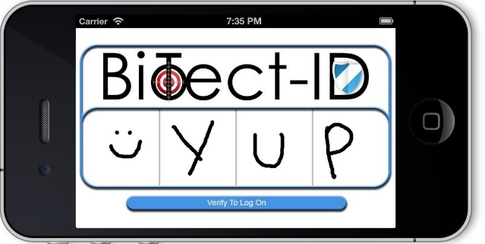

Introducing the Biometric with a Twist
BioTect-ID from Biometric Signature ID
- First biometric that requires no invasive body part information
- Locks down devices with biometric security (rated 99.97%)
- Users draw a password with finger, mouse or stylus that’s impossible to forge
- Drawing style is a gesture biometric that can’t be lost, stolen or borrowed
- Password format we’re already comfortable with
- Strongest identity authentication available (multi-factor)
- Passwords can be easily reset (unlike other biometrics)
- Takes seconds to unlock
- The only privacy-conscious biometric security app
- 3X better than standard for biometric accuracy set by National Institute of Standards for Technology (NIST)
Visit us on Kickstarter.com or BioSig-ID.com

