**Press Release Contacts:**

**For Immediate Release** Vinitaly International

International Media Dept.

+39 045 8101447

[media@vinitalytour.com](mailto:media@vinitalytour.com)

[www.vinitalytour.com](http://www.vinitalytour.com)

Twitter: @VinitalyTour

Join Vinitaly International Network on LinkedIn

**wine2wine sheds a light on the future of viticulture and wine making**

The second edition of wine2wine, the two-day forum on the business of wine organized by Veronafiere in collaboration with the Italian Trade Agency (ICE), opened its doors today to more than 1.000 members of trade and press who came to attend a packed full program of events and initiatives aimed at supporting Italian wine producers in their activity in Italy and abroad.

More than 150 speakers, 40 sessions and 26 workshops divided into six thematic areas including marketing, law and finance, export markets and viticulture. The latter was the topic of one of the day’s opening sessions centred on the importance of vineyard management as the primary factor in producing a cost effective and saleable product.

“Where is wine going? The future of viticulture and wine making” was presented by four influential researchers and writers who showed how both innovation and tradition will be shaping the future with technology improving the yield from vineyards and the quality of grapes.

Ian D'Agata, Scientific Director of Vinitaly International Academy, showed specifically how the agricultural past can have a bearing on the future. "The rediscovery of indigenous varieties is not only of cultural and historical importance but also of economic value" he explained, going on to give examples from Italy and the rest of the world.

Pedro Ballesteros Torres MW, Decanter WWA Panel co-Chair, took up this theme and together with Ian made predictions as to which wines would be commercially successful in the future, drawing on some current tendencies and tackling the issues of appellations of origin with classifications in a discussion on whether these were useful or not. He also identified wines from places with a story to tell as setting a trend, including so called "extreme" wines.

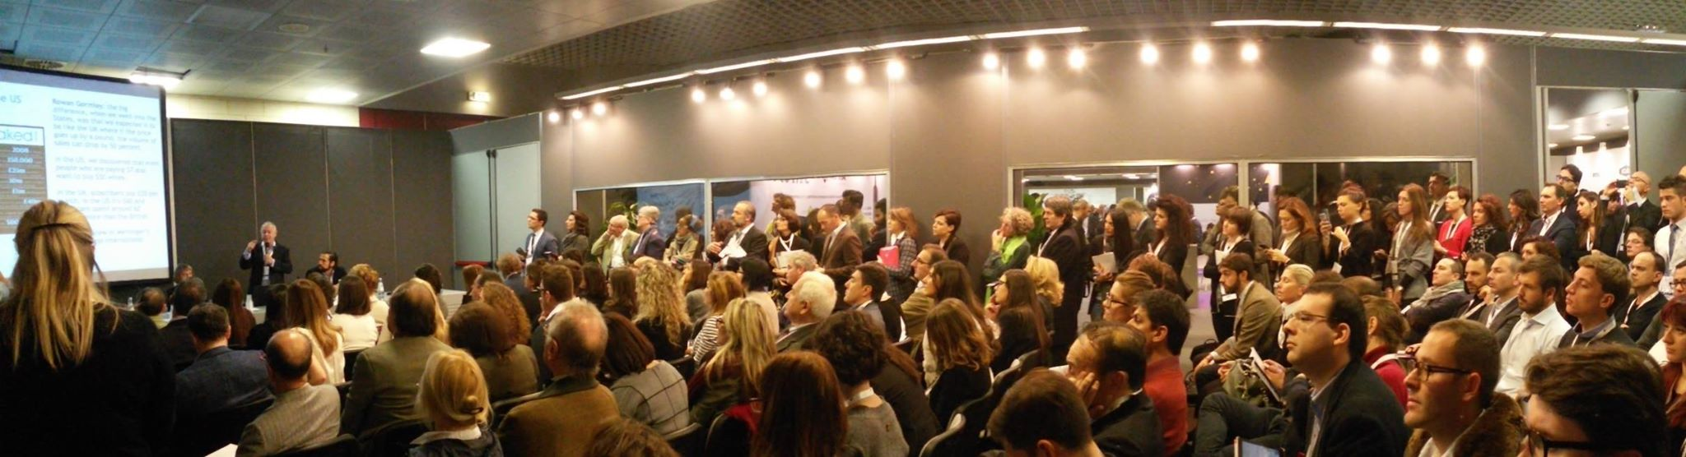

Returning to the field, Gurvinda Bhatia, Canadian wine columnist and editor of Quench magazine, spoke of how the future can reserve unpleasant surprises for those producers who allow their investments in the vineyard to be led by trends in the market. Mr Bhatia explained it like this: "The fact is that if wines are made according to trends, producers will always lag behind the market because by the time the wine is released, the trend will already be changing". Even if consumer tastes will inevitably move on to new varieties and styles, Mr Bhatia believes there are permanent changes, which will determine future markets. Citing his article entitled "Reserved no more" for Quench magazine he outlined the profile of a new generation of wine consumers unconcerned with pedigree and not caught up with pretence, eager to learn about wine rather than be intimidated by it and attracted to just those sorts of wines that have a sense of place and a story that can be shared.

Speakers agreed that as far as the business of wine production is concerned great wine comes from great grapes and the more attention given to viticulture the better the final product. Speaker Massimo Claudio Comparini, co-founder of an Italian wine and food magazine (Cucina&Vini) but also one of the country’s top space engineering experts illustrated how the wine grower's awareness and traditional expertise can be extended to systems of Precision Viticulture or PV. Satellite positioning and imaging systems together with sensors on the ground give the data to manage the vineyard as a whole. This supports decision making for variables such as rates of fertilizing, spraying, irrigation, and the precise timing of harvest. Mr Comparini provided some examples of ongoing experimentation and provided some insight about the satellite imagery and mapping in this interesting filed of research. Many PV research projects already exist in all the most relevant wine production areas of the world; including France, Spain, US, Chile, South Africa, New Zealand and Australia. Systems of this kind improve yields and quality at the same time as reducing environmental impact and costs and in line with the theme running through the session, a future where technology augments rather than replaces traditional wine growing skills was glimpsed by those attending.

**About:**

Veronafiere is the leading organizer of trade shows in Italy including Vinitaly (www.vinitaly.com), the largest wine and spirits fair in the world. During its 49th edition Vinitaly counted some 4.000 exhibitors on a 100.000 square meter area and 150.000 visitors including more than 2.600 journalists from 46 different countries. The next edition of the fair will take place on 10 - 13 April 2016.

The premier event to Vinitaly, OperaWine (www.vinitalyinternational.com) “Finest Italian Wines: 100 Great Producers,” will unite international wine professionals on April 9th in the heart of Verona, offering them the unique opportunity to discover and taste the wines of the 100 Best Italian Producers, as selected by Wine Spectator. Since 1998 Vinitaly International travels to several countries such as Russia, China, USA and Hong Kong thanks to its strategic arm abroad, Vinitaly International. In February 2014 Vinitaly International launched an educational project, the Vinitaly International Academy (VIA) with the aim of divulging and broadcasting the excellence and diversity of Italian wine around the globe. VIA has now also created its very first Certification Course with the aim of creating new Ambassadors of Italian Wine in the World.

###