**Press Release Contacts:**

**For Immediate Release** Vinitaly International

International Media Dept.

+39 045 8101447

[media@vinitalytour.com](mailto:media@vinitalytour.com)

[www.vinitalytour.com](http://www.vinitalytour.com)

Twitter: @VinitalyTour

Join Vinitaly International Network on LinkedIn

**US consumer trends unveiled at wine2wine 2015**

This year’s edition of wine2wine, the forum entirely dedicated to the business of wine organized by Veronafiere in collaboration with the Italian Trade Agency, opened on the 2nd of December with a tight succession of workshops dedicated to the USA covering topics both related to market and consumer trends as well as to new means of communication.

“This year’s edition of wine2wine is dedicated to the US as it still stands to be the number one priority market for Italian producers” explained Stevie Kim, Managing Director of Vinitaly International and the mastermind behind the event. “We wanted to open with a panoramic state of the art view of the US with a special focus on the much talked about millenials. The market is not as simple as it may seem, there are many Italian wines distributed in the US, some already consolidated, but the latest trends are important to keep in mind”.

The plenary session, “What's trending in U.S. Wine Market”, was conducted by Danny Brager, Senior Vice President of Nielsen’s Beverage Alcohol Practice Area in the United States, who started by pointed out some of the difficulties of operating in the U.S. “Doing business there is not easy” he commented, “the market is highly regulated but, more importantly, those regulations are very well enforced with business under the three tier system going through distributors. When it comes to selling alcohol the States are not united but rather behave like 50 separate countries. Some for example allow sales of alcohol in supermarkets, others don’t”.

Brager also went on to describe the consumer’s current mind-set and how this is affecting the market: consumer confidence has picked up since the great recession of 2009 but people still don’t go out to drink as much as they used to. Off-premises drinking is pursued more by the 21-26 millennial age group. The trend for on-premise consumption on the other hand is for craft beers and on the back of this, more wine is being sold on tap. Supermarkets are encouraging drinkers to sip wine while they do the shopping and even Starbucks has started serving its own wines to extend evening business.

Moving on to trending styles and varieties, although Prosecco is still driving the market, there's a definite colour shift to Rosè. Among varietals, chardonnay and cabernet sauvignon are popular and there is a segment coming to the fore called “red blends”, currently making up 40% of new items that are being introduced.

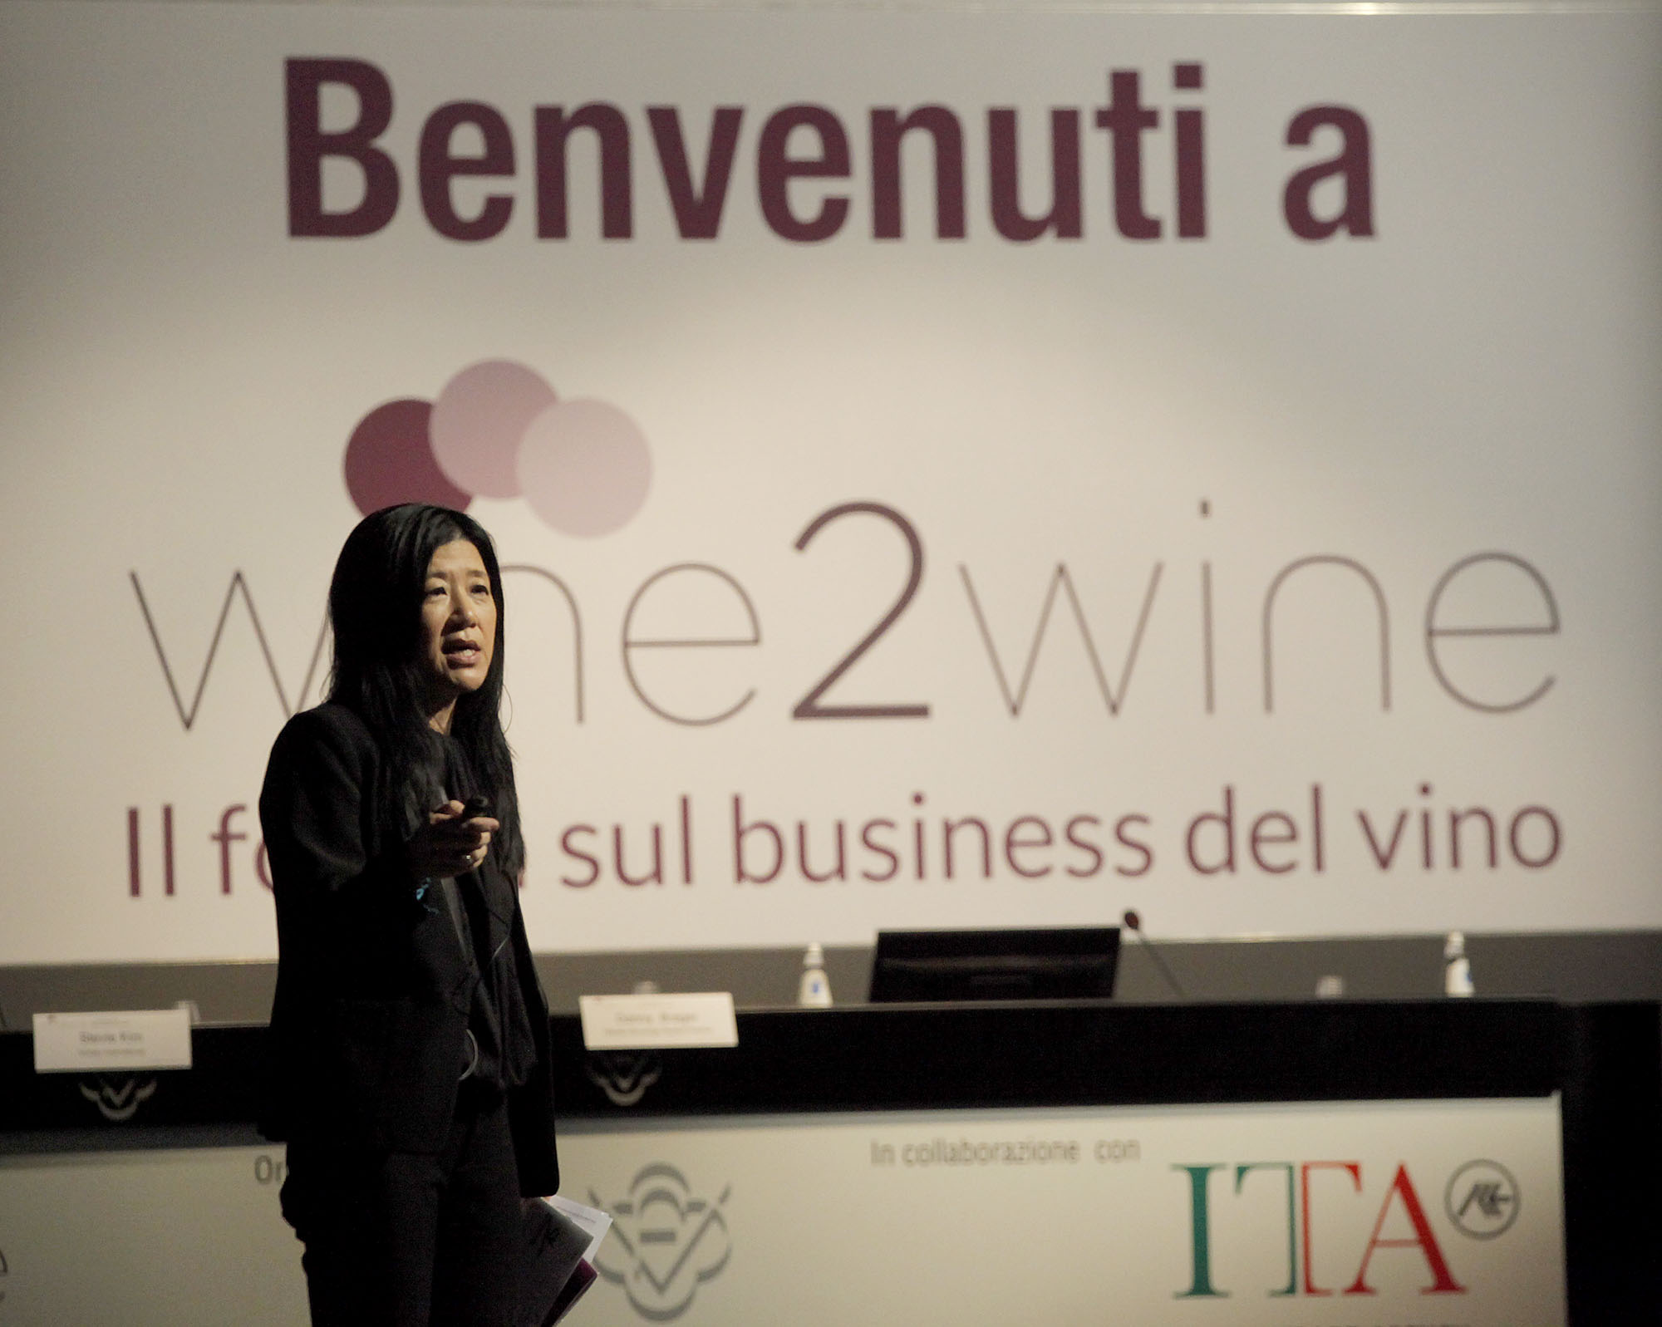

As far as targeting consumers is concerned, Danny went on to consider present and future markets in terms of the various generation labels: Swing, Baby Boomers, and Millennials. He gave further information about consumers, broken down by age, sex and race underlining, in each case, the challenges and opportunities for growth and pointing out that generation labels stay the same: “You'll always be a millennial, even 60 years from now. But right now millennials are becoming important for the business. This is the first year in which all 70 million of them will reach the legal age to drink with numbers boosted by immigration rather than birth-rate: one in two of this generation will be from an immigrant population by 2040 ”.

Despite the attention given to a younger wine drinker, the market's core consumer is getting older. The whole western world is becoming populated with increasingly older people and the number of America's senior citizens will swell in the next decade. However, it is most people’s experience that older people move from beer onto wine and in making predictions, Brager concluded that market research holds out “really good news for the wine industry and for Italian wine” and went on to give advice as how to make the most of future opportunities.

"Fish where the fish are" he told the audience made up predominantly of producers, “recruit younger consumers whilst valuing older ones. Host visitors at your Italian wineries: 37% of high frequency users have visited Italy. Look to on line business: 55% of the selection of wine.com is imported”.

**About:**

Veronafiere is the leading organizer of trade shows in Italy including Vinitaly (www.vinitaly.com), the largest wine and spirits fair in the world. During its 49th edition Vinitaly counted some 4.000 exhibitors on a 100.000 square meter area and 150.000 visitors including more than 2.600 journalists from 46 different countries. The next edition of the fair will take place on 10 - 13 April 2016.

The premier event to Vinitaly, OperaWine (www.vinitalyinternational.com) “Finest Italian Wines: 100 Great Producers,” will unite international wine professionals on April 9th in the heart of Verona, offering them the unique opportunity to discover and taste the wines of the 100 Best Italian Producers, as selected by Wine Spectator. Since 1998 Vinitaly International travels to several countries such as Russia, China, USA and Hong Kong thanks to its strategic arm abroad, Vinitaly International. In February 2014 Vinitaly International launched an educational project, the Vinitaly International Academy (VIA) with the aim of divulging and broadcasting the excellence and diversity of Italian wine around the globe. VIA has now also created its very first Certification Course with the aim of creating new Ambassadors of Italian Wine in the World.

###