**FOR IMMEDIATE RELEASE**

December 8, 2015

**Internationally Renowned Cuban Tres Guitarist**

**Franklin Darien Reytor**

**Descends Upon the US Classical and Latin Music Scene**

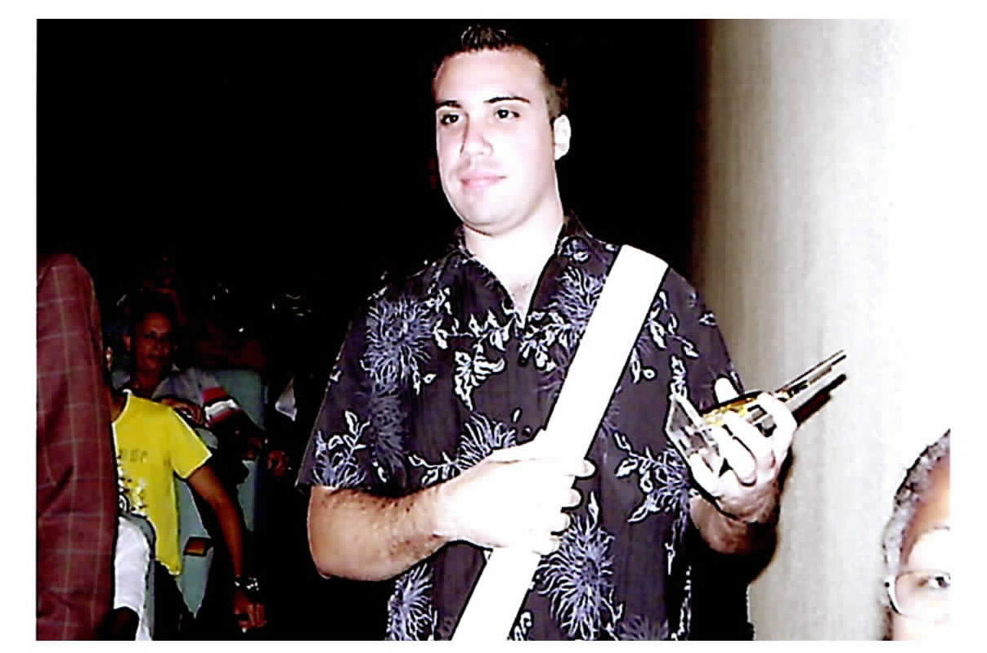

(Miami, FL.December 8, 2015) – Internationally renowned Cuban Tres guitarist Franklin Darien Reytor sets his sights to arrive into the United States after garnering numerous honors and prestigious awards in his native Cuba.

Franklin Reytor was born and raised in Santiago de Cuba. He studied classical guitar and graduated with multiple honors from the “Conservatorio Esteban Salas” in 2001. Reytor, known primarily for being a virtuoso with the “cuban tres” guitar, has also performed and worked on various musical projects as a prominent composer, instrumentalist, arranger and music producer. Many of his highly respected productions have been nominated and subsequently won awards in the acclaimed festival “Cubadisco,” among others.

Reytor’s repertoire is extensive and whether as a solo artist or as part of a classical ensemble, his style and lyrics are an eminent stand out, as he is noted as one of the most highly regarded composers in the province. He has toured Internationally throughout the world and participated in numerous distinguished festivals, among them the “World Music Festival” in the city of Oslo, accompanying famed vocalist Eva Griñan with the notable “Orquesta de Cámara de Noruega” The Norwegian Chamber Orchestra.

In 2007, Franklin Reytor garnered the grand and illustrious first place award in Cuba’s “Adolfo Guzmán” Music Awards (equivalent to a Latin Grammy) for his memorable production of “**La Araña**”.

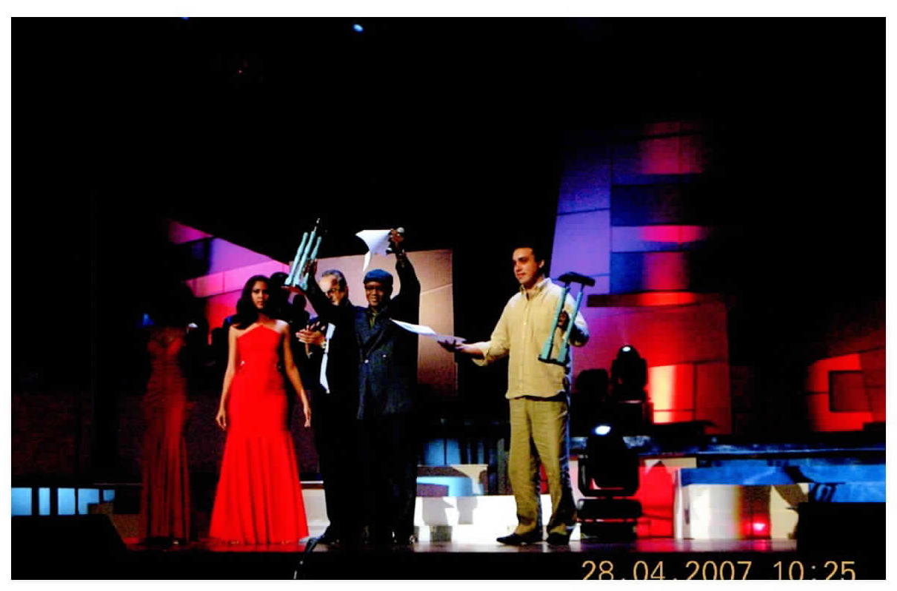

Reytor has also been honored with several other acclaimed awards garnering an illustrious “Chepin” of the year, in the Electo Rosell “Chepin” awards competition, for his boleros “**Restos de una vida**” and “**De espaldas al cielo**”.

Reytor is humbled with his achievements and notes his passion for music stems from his childhood, and from the passion of fulfilling his dream of performing and teaching; and for the opportunity to share this rare musical art form with the world. He is considered a connoisseur amongst his peers, and due to his immense talent is revered by those that have worked with him, stating that it is a “gift” to be able to work with this exceptional music prodigy.

Reytor’s opus of “**No hay otra igual**” garnered a first place award in the musical award carnival of Santiago de Cuba in 2013. That same year Franklin Reytor received an Honorable Mention in the XXIX Premio Mundial de Poesia Nósside 2013 with his epic “**Soñando contigo**”. In 2015, Reytor triumphantly garners his third grand prize “Chepin” award in the Electo Rosell “Chepin” awards ceremony, for his celebrated work “**Cubano de pura cepa**”.

This upcoming year ushers in new beginnings within Franklin Reytor’s musical trajectory with his pending travels to the United States. Whereupon Reytor has been invited by several US music conservatories and prestigious music schools to perform as well as teach. He is honored and humbled to continue to share his craft and love of classical, contemporary, tropical, Caribbean music.

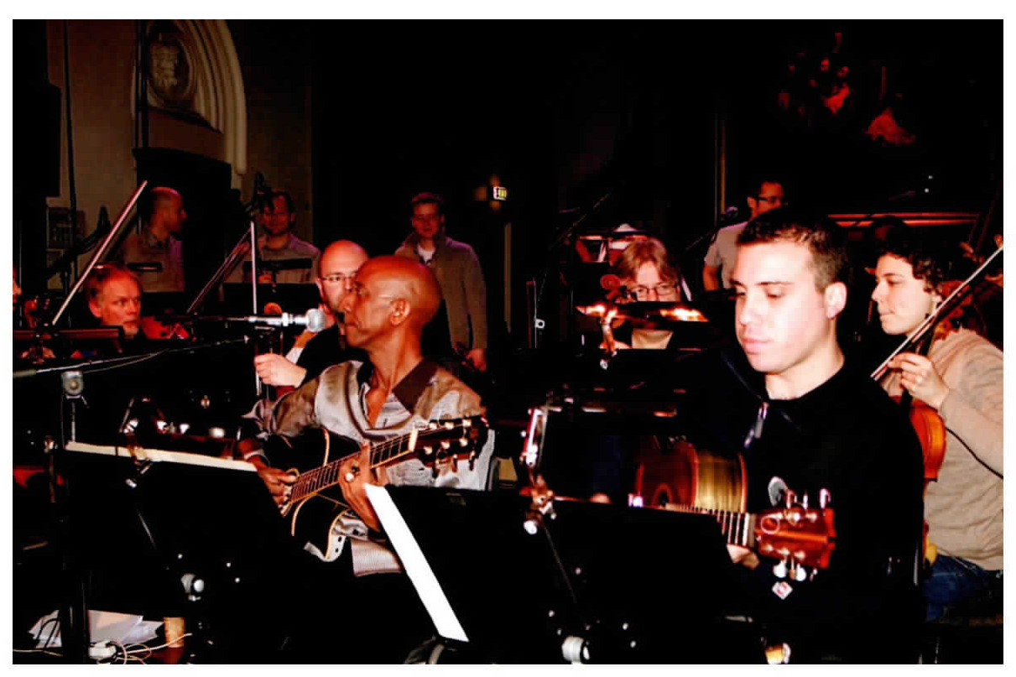

**For Further Information or Booking Inquiries, please contact:**

**Daisy Collado**

[**daisycollado@gmail.com**](mailto:daisycollado@gmail.com)

**(917) 557-1535 (Tel.)**

**Lou Bermudez**

[**drlou1@gmail.com**](mailto:drlou1@gmail.com)

**(786) 443-9090 (Tel.)**