Press
Sunnyvale, CA, December 8, 2015
New Osram LED is powerful light source for office projectors
Osram Ostar Projection Power: 12 mm² chip surface now in a new compact package

The new Osram Ostar Projection Power from Osram Opto Semiconductors enables users for the first time to equip even mainstream projectors rated at more than 2500 lumen (lm) exclusively with LED lighting. With a smaller package and more output, this LED is based on the latest chip technology and advanced production methods. As a monochrome LED, it is available in red (R), converted green (CG) and blue (B). This efficient new light source will be the successor to the existing LE x P3W in the Osram Ostar Projection Power Family.

The external dimensions of the new Osram Ostar Projection Power have been reduced to 27 mm x 16 mm x 2.1 mm and are now the same as those of its Projection Power sister LEDs, the Osram Ostar P1W and P2W. The latest UX:3, thin-film chip technologies and production methods are also used for the P3W 01 (for R and B) and P3A 01 (for CG). At 36 amps pulsed, the typical brightness of the Osram Ostar Projection Power is 4500 lumen (lm) for the red version, 11,000 lm for the green version and 33 W for the blue version. Until now, it has not been possible to generate such high luminous flux and radiant intensity from such a small surface area.

LED projectors now 100 times brighter than in 2005
Thanks to the new Ostar Projection Power LED, standard office projectors with luminous intensities of between 2500 and 3500 lm can now have LEDs as the sole light source for the first time. “In the past ten years, the brightness of projectors equipped solely with LEDs has been increased by a factor of 100, since the first LED Projector launched by our partner,” said Andrew Lin, Product Marketing, LED, at Osram Opto Semiconductors. “This is the result of years of research and development. Our customers have made huge progress in system development, while we continue to improve chips and packages.”

Huge brightness, small surface
One red, one green and one blue Osram Ostar Projection Power LED are used as the light sources in a projector. These monochrome LEDs each consist of six chips with an area of
2mm² and are operated in parallel. Osram developers are using a new type of connection between the chip and the heat sink, which results in a small thermal resistance (R_{th}) of <0.5 kW. Heat can therefore be dissipated better and the system can be operated up to its maximum output limit. The heat sinks can also be made smaller which, in turn, leads to a more compact design for the projectors.

The Osram Ostar Projection Power is already available upon customers’ request. Volume production is planned for start-up at the end of January 2016.

Press Contact:
Kate Cleveland
Tel. 248-277-8018
Fax 248-596-0395
Email kate.cleveland@osram-os.com

Technical Information:
Tel. 866-993-5211
Email: support@osram-os.com
Sales contact: www.osram-os.com/sales-contacts

Technical data:
Package | 27 mm x 16 mm x 2.1 mm
Chip size | 6 x 2 mm²
Thermal resistance R_{th} | <0.5 K/W
Electrical output  (pulsed at 36 A, 25° C) | Red (LE A P3W 01): typ. 121 W  Green (LE CG P3A 01): typ. 128 W  Blue (LE B P3W 01): typ. 128 W
Brightness  (pulsed at 36 A, 25° C) | Red (LE A P3W 01): typ. 4500 lm  Green (LE CG P3A 01): typ. 11,000 lm  Blue (LE B P3W 01): typ. 33 W

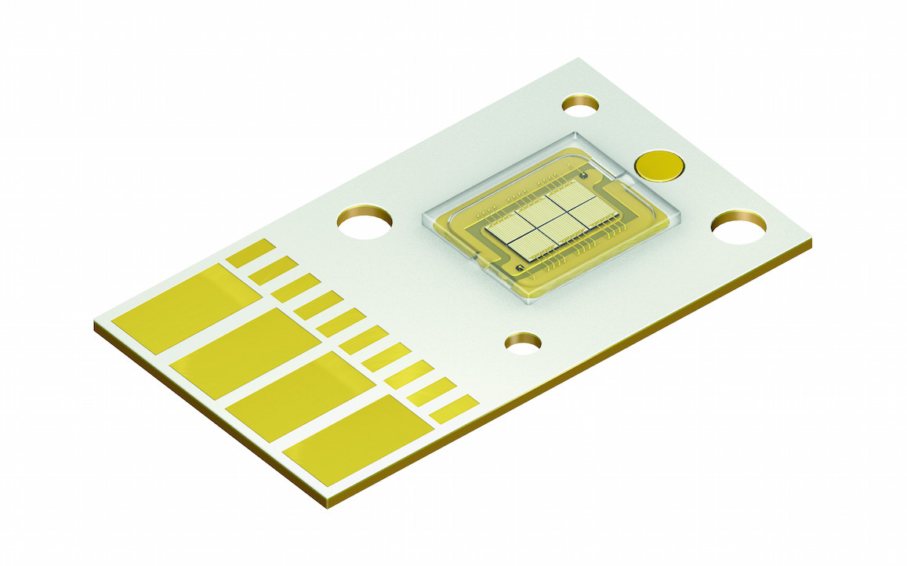
Osram Opto Semiconductors presents a new output class in its Osram Ostar Projection Power range for use in mainstream projectors. Picture: Osram

Projections are really bright with vibrant colors thanks to the new Osram Ostar Projection Power. Picture: Osram

http://www.osram-os.com/pr-power-projection

ABOUT OSRAM
OSRAM, based in Munich, is a globally leading lighting manufacturer with a history dating back more than 100 years. The portfolio ranges from high-tech applications based on semiconductor technology, such as infrared or laser lighting, to smart and connected lighting solutions in buildings and cities. OSRAM had around 33,000 employees worldwide at the end of fiscal 2015 (September 30) and generated revenue of almost €5.6 billion in that fiscal year. The company is listed on the stock exchanges in Frankfurt and Munich (ISIN: DE000LED4000; WKN: LED 400; trading symbol: OSR). Additional information can be found at www.osram.com.

