FOR IMMEDIATE RELEASE CONTACT: Clay Guillory  
December 8, 2015 337-277-5346  
 [cguillory@gmail.com](mailto:cguillory@gmail.com)

ATLAS 2.0: NEW INNOVATION IN THE LARGE FORMAT 3D PRINTER INDUSTRY  
*Titan Robotics’ largest 3D Printer increases build space to 36x36x48 inches; pushes the envelope with heated enclosures*

At the core of Titan Robotics, we believe in working towards continuous improvement and manufacturing the highest quality 3D printers possible. Since the inception of our large format 3D printer, [The Atlas](http://www.titan3drobotics.com/products-services/the-atlas/), over a year and a half ago, we have rigorously tested the machines and as a result made some upgrades to the already proven design.

We call it the Atlas 2.0. Our new offering to customers is a truly bombproof machine that utilizes the same quality of components with upgrades in CNC milled components, scorching hot heated beds, Yaskawa AC Servos, high temperature lubricants, and the utmost in free, 24/7 customer service.

The most requested feature which we have added is an optional heated steel enclosure which will attain constant temperatures of up to 85°C. This machine was recently installed at a customer’s facility in Brooklyn, NY and has been making ABS parts for them without flaw.

“Our customers need these machines for industrial production capabilities with ABS, and we provided a real solution to creating large format ABS parts without warping at any height,” explains Clay Guillory, CEO and Founder of Titan Robotics. “Government contractors, manufacturing shops, universities and 3D print shops are coming to us because they are looking for a machine that is tried and tested and will print 200+ hour print jobs consistently.”

From below zero Colorado temperatures to heated enclosures that top out at 85 degrees C, our machines have been undergoing constant usage in a variety of use cases and environments. As a result, we are finding ways in which we can push the envelope in the large format 3D printing industry and respond to customer feedback on the demands for an industrial machine to perform all day, every day.

Another big change brought about by Titan Robotics is a new, bigger standard size. Titan Robotics now offers a build space of 36x36x48 inch build space along-side their previous 30x30x45 inch machine. Additional improvements include the option to add dual extruders to increase the functionality of the machine.

Titan is also excited to announce we’ll be making our debut at the most influential trade show of the year, the [Consumer Electronics Show (CES)](https://www.cesweb.org/) in Las Vegas January 6-9th. Titan’s booth is number 72712 at the Sands, Hall A-C in the 3D printing marketplace. We invite anyone interested to stop by to look at our 3D printers, and to meet Clay Guillory and our staff.

**About Titan Robotics**

Titan is at the forefront in expanding industrial use of large format 3D printing. Our passion is to build the highest quality 3D printers that will last a lifetime. A startup out of Colorado, we're helping companies across the country use large format 3D printing to create new products and ideas.

**Additional Information**

Link to Titan Robotics’ Website: <http://www.titan3drobotics.com/>

Link to more information about The Atlas: <http://www.titan3drobotics.com/products-services/the-atlas/>

Below are pictures of The Atlas 2.0 for release.

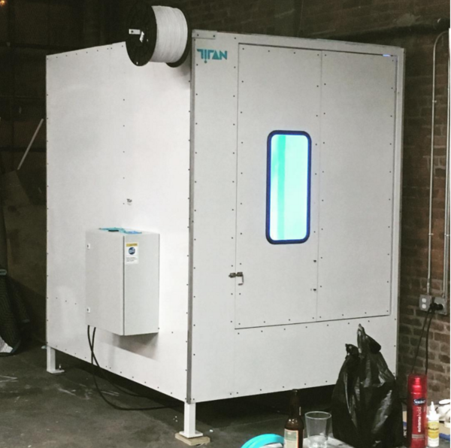  
*The Atlas (36x36x48 inch build space with full enclosure). Currently being used by a customer in Brooklyn, NY.* ***If interested in viewing the machine*** *in person, or speaking with the owners of this machine please request more information by contacting Clay Guillory.*

