Press Release Contacts:
For Immediate Release Vinitaly International
International Media Dept.
+39 045 8101447
media@vinitalytour.com
www.vinitalytour.com
Twitter: @VinitalyTour
Join Vinitaly International Network on LinkedIn

Chaos and Opportunity in the Digital Landscape

The focus on the US market continued on day one of wine2wine, the Italian industry forum dedicated to the business of wine organized by Veronafiere, with an overview of new digital communication tools used today to sell wine in the world’s largest wine market.
During the session “The changing media landscape in the US: how to reach your brand objectives through integrated communications”, panellists spoke of their experience in setting up new platforms and integrating them together with other media in systems sustained by new revenue models which are breaking down the traditional distinctions between news, entertainment and advertising.
Moderator Leslie Gevirtz, award-winning journalist for Reuters, introduced the audience to the digital landscape referred to in the session’s title with help of a quote from Mao Tse Tung: "There is great chaos under heaven and the situation is excellent."
“Print media is evaporating" she asserted adding that Gourmet, La Cucina Italiana and Newsweek are all dead and those publications that survive like The New York Times have done so by breaking down the wall that traditionally exists between editorial content and advertising.
Add up the circulation of Wine spectator, Wine Enthusiast and Wine and spirits Magazine and it makes a total readership of 675,000 readers a month compared to the online magazine Vinepair which has over 1.2 Million monthly views. “The key to survival is getting paid content” she stated, citing the recent launch of the Food and Wine website that allows a new kind of access to advertisers.
It was in this context that Gevirtz introduced two members of the panel, Adam Teeter, founder of Vinepair, and Pierrick Bouquet from ABLE who has used social media to involve thousands of people in large-scale wine tasting lifestyle events in New York, charging premium prices.
Ms Gevirtz called on them both to explain how they have gone from a few clicks to getting thousands of people to drink wine.

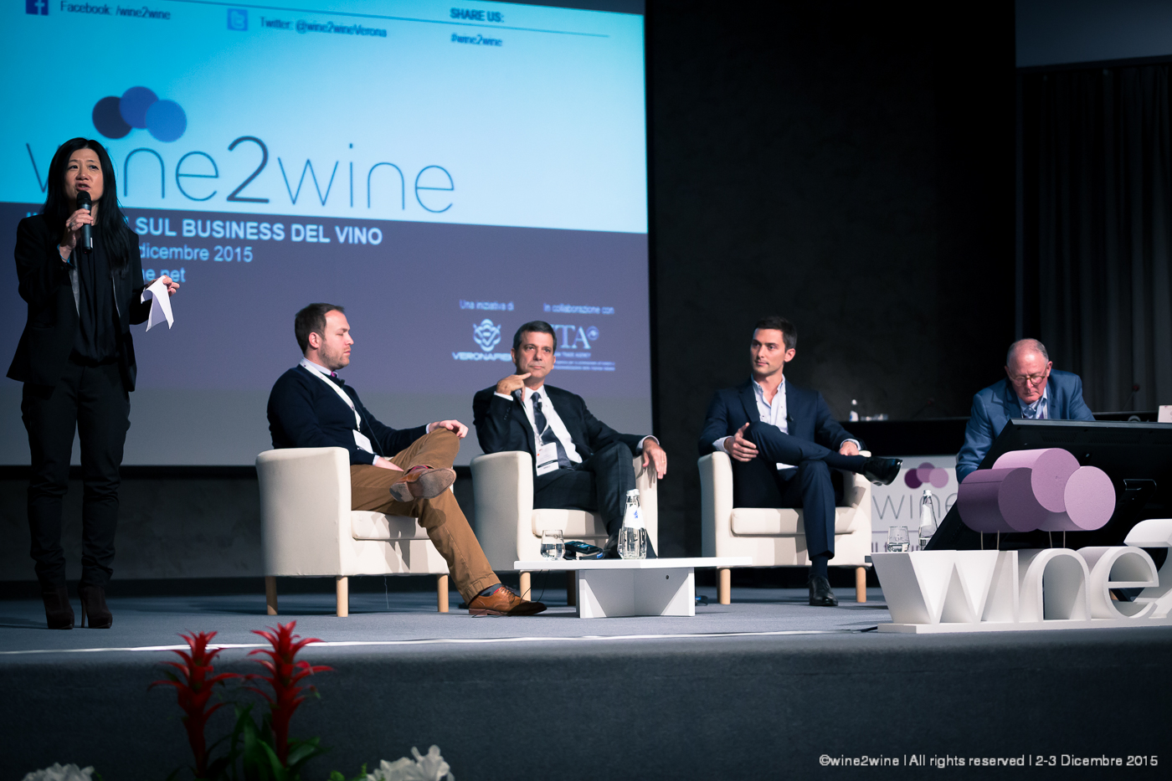

Both Mr Teeter and Mr Bouquet agreed that successful digital content is accessible and resonates with the consumer connecting them to the product in a way that makes them feel they actually own a piece of the property it came from. Vinepair readers don’t want to be told what to drink but be given the tools to find that out for themselves. Pierrick Bouquet, instead, explained that his success was based on creating a platform for millennials where they don’t feel intimidated by wine and getting them to share content about an event on social media so it grew exponentially in scale. He also talked specifically about the techniques he uses: Facebook audiences plugs into your email address book and it recognises if these are connected to a Facebook account, helping to build your network.
“You must be very specific about your target and audiences when sending out digital media” Mr Bouquet pointed out. “It’s no good getting through to lots of people if they aren’t interested in your message”.
Ms Gevirtz then brought in the other members of the panel more directly involved in publicity and media relations: Steve Ray owner of Bevology and creator of marketing campaigns based on social media selling to retailers and Gino Colangelo who was introduced as the founder of Colangelo & Partners Public Relations, essentially a storytelling agency that has identified how to integrate the different types of media Shared, Owned, Paid and Earned into tailor made systems for clients.
Different opinions where also brought forth about Native content or what used to be called in the States the “Advertorial”, where ads are dressed up like articles. Leslie Gevirtz, as a Journalist, confessed she has an instinctive dislike of this form of advertising but was philosophical about it quoting the old Wall Street saying “You can’t fight the tape” meaning, presumably, the trend in the market.
Mr Steve Ray pointed out that the whole revenue model for content such as in Adam's Vinepair is based on this type of native content which he calls “content population” explaining that everyone needs a story but they also have to have access to it and if you get the story right and put it through the right feed it will be "scraped" and redistributed for its value as such.
Mr Teeter justified his model pointing out that native advertising is part of the digital landscape and while bloggers might be happy to be paid in bottles, his writers are paid top rates.
The panel closed with a look to the future and the role of video in the digital landscape, a growth area where there is the most investment at the moment.

About:

Veronafiere is the leading organizer of trade shows in Italy including Vinitaly (www.vinitaly.com), the largest wine and spirits fair in the world. During its 49th edition Vinitaly counted some 4.000 exhibitors on a 100.000 square meter area and 150.000 visitors including more than 2.600 journalists from 46 different countries. The next edition of the fair will take place on 10 - 13 April 2016.
The premier event to Vinitaly, OperaWine (www.vinitalyinternational.com) “Finest Italian Wines: 100 Great Producers,” will unite international wine professionals on April 9th in the heart of Verona, offering them the unique opportunity to discover and taste the wines of the 100 Best Italian Producers, as selected by Wine Spectator. Since 1998 Vinitaly International travels to several countries such as Russia, China, USA and Hong Kong thanks to its strategic arm abroad, Vinitaly International. In February 2014 Vinitaly International launched an educational project, the Vinitaly International Academy (VIA) with the aim of divulging and broadcasting the excellence and diversity of Italian wine around the globe. VIA has now also created its very first Certification Course with the aim of creating new Ambassadors of Italian Wine in the World.

###

