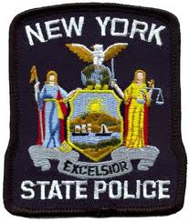
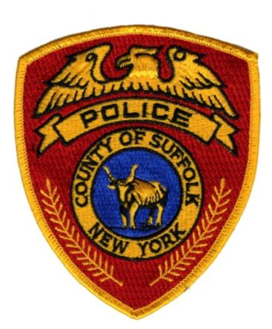
8th Annual 
Cops Who Care
Food Drive
A partnership between the
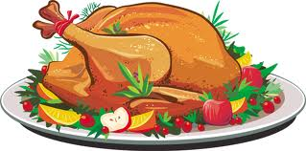
Suffolk County Police Department & the New York State Police
Tuesday, December 22nd
1:00pm – 2:00pm
175 2nd. Ave, Bay Shore
FREE hams & turkeys will be distributed to families in need.
Limited supply, one item per family.

Generous sponsorship from
Gacovino $ Lake Law Office


For more information, please contact:
D/Lt. Bob Donohue: donohrob@suffolkcountyny.gov

