

Media Contacts:

Pat Monroe  
 [pmonroe@aem.org](mailto:pmonroe@aem.org)

(414) 298-4123

**U.S. Retail Sales of Small Tractors Increased Slightly in November, Large Tractor Sales Continued to Decline**

**MILWAUKEE** (December 14, 2015) – U.S. retail sales of small farm tractors under 40HP increased 1.7 percent in November 2015 compared to the same period last year, according to the Association of Equipment Manufacturers (AEM), the leading trade organization for off-road equipment manufacturers and suppliers. Year-over-year, total retail sales of two-wheel drive farm tractors, including under 40HP, were down 8.9 percent, a reversal from last month’s 5.8 percent growth. This is mostly due to a lower year-over-year growth in less than 40HP and a reversal in growth for the 40-100HP categories. Four-wheel drive tractors sales decreased by 43.9 percent, down from a 29.5 percent decrease in October. These growth number are now back in line with the trends seen earlier in the year.

Year-to-date sales of the smaller, less than 40HP tractors increased 7.7 percent compared to 2014, while sales of 40 to 100HP farm tractors turned negative again. In a more long-term comparison, retail sales in units for agriculture tractors and combines are reporting slightly below the five-year average.

“Sales of large production tractors and combines have been impacted this year by some significant trends that we have been seeing all year,” said Charlie O’Brien, AEM senior vice president. “In many cases, the farmer’s profits have evaporated due to low corn and soybean prices, resulting in projected Net Farm Income for the year to be $55.9 billion, which is 38 percent down from last year.”

“What’s more, the tremendous volume of equipment sales in 2012 and 2013 has created a glut of used equipment on dealer lots, which has greatly impacted the sales of new equipment. In addition, ongoing uncertainty about the impact of the Renewable Fuels standard and Section 179 continue to negatively influence buying decisions,” continued O’Brien.

[Click HERE](https://www.youtube.com/watch?v=NDePjRPKuW4) to view video.

**U.S. Agriculture Equipment Retail Sales – November 2015 Report:**

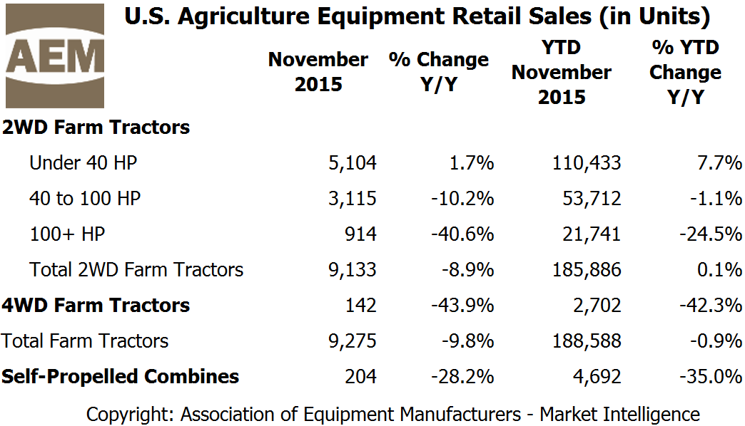

**U.S. Agriculture Equipment Retail Sales – 5-year Average and Unit Trends:**

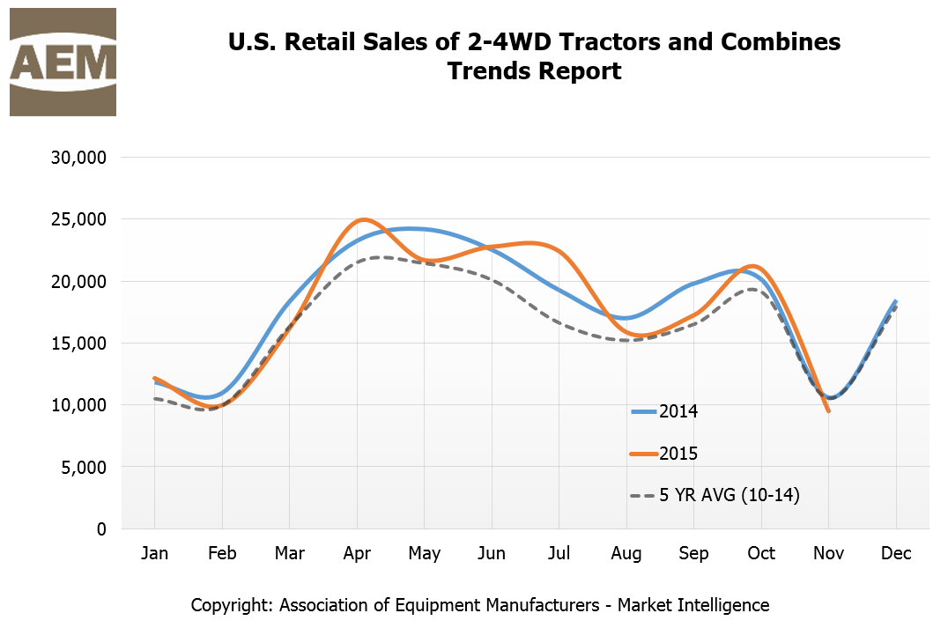

**About the Report**

Data from AEM’s Agriculture Equipment Retail Sales Flash Report is provided monthly and is derived from AEM member companies through our proprietary statistical reporting programs. The analysis of the data is provided by AEM’s [Market Intelligence department](http://www.aem.org/MarketInfo/MarketIntel/). Visit [www.aem.org/agreports](http://www.aem.org/agreports) to view the reports, as well as reports from Russia and Canada.

**About the Association of Equipment Manufacturers (AEM)** - [www.aem.org](http://www.aem.org/)  
AEM is the North American-based international trade group providing innovative business development resources to advance the off-road equipment manufacturing industry in the global marketplace. AEM membership comprises more than 850 companies and more than 200 product lines in the agriculture, construction, forestry, mining and utility sectors worldwide. AEM is headquartered in Milwaukee, Wisconsin, with offices in the world capitals of Washington, D.C.; Ottawa, Canada; and Beijing, China.

###