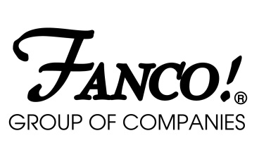

PUBLIC NOTICE

Unauthorized use of UL Label on Surface-Mount Ceiling Luminaires – Label should be the following Intertek ETL:
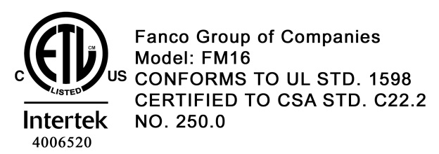

The following is a notification fromFanco Groupthat the ceiling mount luminaire identified below bears an unauthorized UL Label for the United States and Canada. The luminaires have been evaluated by ETL to the appropriate Standards for Safety and it is known that these luminaires comply with ETL (Intertek) for Canada and United States safety requirements.

Please click on the following link to read the appropriate ETL (Intertek) testing and approval reports:

http://www.fancogroup.com/GZ12121150.pdf

Listing Constructional Data Report (CDR)

1.0ReferenceandAddress
ReportNumber | GZ12121150-1
Standard(s) | UL1598Issued:2008/09/17Ed:3Rev:2012/10/17Luminaires  CSAC22.2No.250.0Issued:2008/09/17Ed:3(R2013)Luminaires;Gen.Inst.No.1:2010,Gen.Inst.No.2: 2012
Applicant | FancoGroupofCompanies |  | Manufacturer | FancoGroupofCompanies
Address | 10#BaoyuanRoad,XinhuiEconomicDevelopmentZone,JIANGMENCITYGuangdong529100CHINA |  | Address | 10#BaoyuanRoad,XinhuiEconomicDevelopmentZone,JIANGMENCITYGuangdong529100CHINA

Name of Product:Surface-Mount Ceiling Luminaire

Item Number: FM416SS; 3 x 60 Watt Lamps

Units: Approximately 150

Manufacturer: Fanco Group of Companies
Guangdong China

Dates of Manufacturer: Unknown

Identification: The product bears an unauthorized UL Listing Label depicted in the photo below.

Photos of the Luminaire Bearing an Unauthorized UL Mark

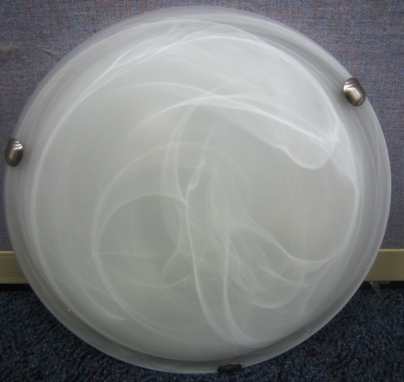 | 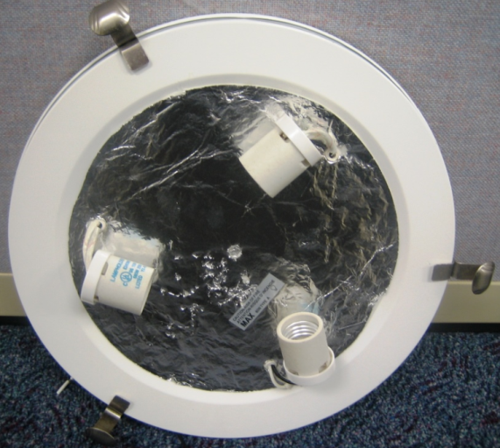
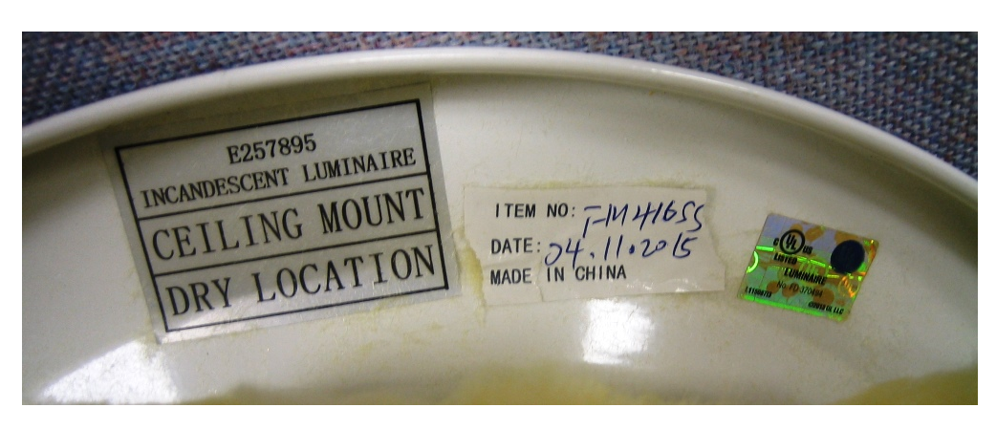

The proper ETL (Intertek) listed Label should be the following:
