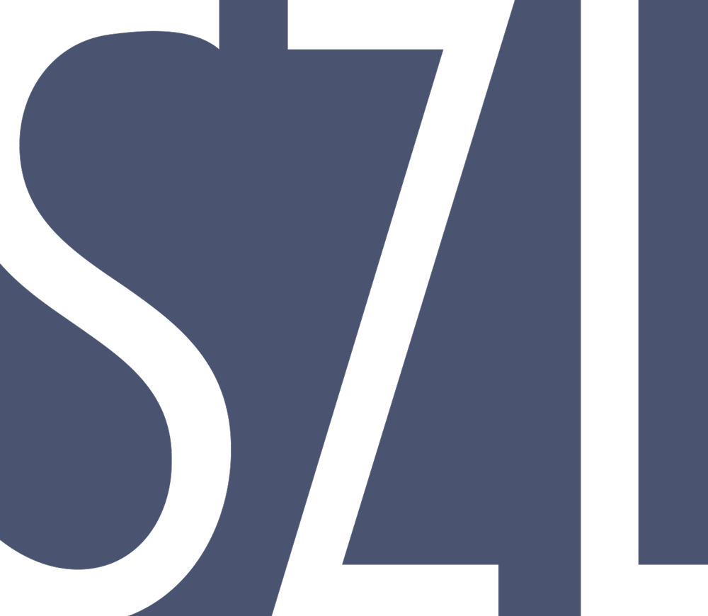
 | FOR IMMEDIATE RELEASE  January 6, 2016
  Contact | Richard Boyd
  Telephone | 910.616.6439
  Email | Richard@szl.it
  Website | www.szl.it

SZL.IT Inc Releases Tanjo.ai

Launches North Carolina-based technology platform to augment collective intelligence
Raleigh, NC, January 6, 2016– SZL.IT who last year raised a multi-million dollar investment from North Carolina-based Drake Enterprises, releases its newest application to help individuals and teams of people manage knowledge and augment their intelligence.
“The dream of computing, since the 60s when Douglas Englebart and Alan Kay envisioned it, has been what Engelbart called “augmentation of collective intelligence.” Said Richard Boyd, SZL.IT CEO and co-founder, “for a long time personal computing forgot about this dream. Connectedness and balance between machines and automation like Tanjo.ai will finally fulfill that dream.”
The service is free and available at www.tanjo.ai The system uses a neural net artificial intelligence engine to reach, find and deliver only content that it learns is of interest to SZL users. “It is like having an army of robot minions at your service just getting you stuff you want”, said Los Angeles-based musician Stuart Bullard.
“When we learned about what the SZL.it team was doing here in North Carolina we wanted to get involved,” Said Josh Drake, Vice President of Drake Enterprises, “Drake Software has enjoyed tremendous success as a software company here in North Carolina and we want to encourage more innovation and success in the state.”
Tanjo.ai is an automated personalized web content discovery engine driven by a human-powered neural net. This is accomplished with complex proprietary artificial intelligence and neural network algorithms that perpetually deliver and improve user-relevant content. The engine sources, analyzes, and matches content to specific users, constantly tracking end-user engagement and improving these recommendations. This is especially relevant given the current information overload on the web (90% of the world’s data has been created in the last two years). With all this amassed data, it is becoming more and more fundamentally challenging for users to access content that is most relevant to them. SZL.it Inc is based in Durham, NC at the renowned startup hub The American Tobacco Campus.

About Drake Enterprises
For 34 years, Drake Enterprises has been committed to providing tax professionals the tools they need to build their businesses and attract new clients. Drake maintains a steady focus on value, consistent excellence in federal and state programming, and free electronic filing. In addition to tax preparation software, Drake offers real-time web reporting, preparer websites, free online tax research, free bank product software, and free state software for all states.# # #
About Szl
Szl builds smart personal apps using powerful machine learning technologies, connecting users with personalized content based on their interests and likes. Szl envisions a world where humans experience seamless integration with their digital experiences to improve collective intelligence. Based in the Raleigh-Durham Research Triangle of North Carolina, Szl is a lean technology startup backed and managed by veterans in the gaming, entertainment, big data and AI fields. For more information, please visit www.szl.it.

Keep up with Szl announcements and news on Facebook and Twitter.

If you would like more information about this topic, please contact Richard Boyd at 910.616.6439 or email at Richard@szl.it.

