The Bottom-line to Quality is the Bottom-Line
What constitutes world class quality control has been constantly evolving since the early 1900’s when measurement standards were first applied in production of the Model T at the Ford and Statistical Process Control (SPC) was developed at Bell Laboratories. Long before these tools existed, the importance of eliminating serious product problems was recognized. Although our modern cars still have wheels and engines, and our modern phones have the same function of communication, these products are fundamentally different today than they were a century ago. In a similar way, our quality control tools have been evolving, and acceptable results in the past, will not be acceptable tomorrow. Every day more companies are achieving essentially defect free products, so it doesn’t take a crystal ball to predict that these results will need to be achieved in the future at lower cost with less effort. If two companies make products of similar quality, but one company can achieve these results at significantly lower cost than the other, they have a long term competitive advantage.
There have been two fundamentally different views of quality control. On the one hand, the companies emphasizing statistical methods have the general view that quality control is expensive while those companies that have emphasized mistake-proofing believe that quality control is free. These two views are reflected in a bench marking study performed by the Xerox Corporation in the 1990’s [1]. They examined the defect rates of quality control leaders in the US (including Six Sigma companies) and found that their defect rates were consistently in the range of 1000 to 10,000 defects per million parts, and that their expenditures for scrap, rework, repair, warranty and quality control costs were in the range of 6 to 24 percent of their production budget.
In contrast, Xerox estimated at this time that Toyota’s defect rates were below 30 defects per million parts, and that the cost of scrap, repair, rework, warranty, and quality control was less than 3 percent of Toyota’s production budget, consistent with Toyota’s view that quality is free. These two views of the cost of quality control are shown in Figure 1. Note that, even though Six Sigma may reduce the cost of scrap, rework, repair, and warranty expenses, until it virtually eliminates these costs, along with the costs of SPC it cannot match the cost benefit achieved by the Toyota method.
Figure 1. Defects per million parts (logarithmic scale) versus the quality costs as a percentage of production costs per a Xerox Benchmarking Study [1]
The next generation of quality control will upset both the paradigm that quality is expensive and even the paradigm that quality is free, by achieving world-class quality while achieving dramatic cost savings and improvements in productivity.

Virtually Every Modern Quality Problem is Caused by Mistakes
To understand why existing quality paradigms must evolve, a better understanding of modern quality control is needed. In 1993 research at Stanford University directed by Professor Phil Barkan set out to determine what product designers could do that would be the most effective in eliminating nonconformances [2]. The goal was to identify cause and effect relationships between various attributes of the product, production, and quality. While a correlation between attributes does not prove a cause and effect relationship between them, the lack of correlation demonstrates that a cause and effect relationship does not exist.
Seeking to find a link between Process Capability Indices (C_{pk}) and system-level defects, Stanford researchers were surprised to find that no such correlation existed, and were even more surprised that they could not find a single company that had actually attempted to predict system-level defects from a combination of Process Capabilities Indices. Unable to show a cause and effect relationship between process control and system level defect rates, they examined the potential for other correlations between product and process attributes and defects per unit. In general, the results were extremely disappointing. To illustrate, there is a strong anecdotal belief that automation is one of the keys to quality control, but many large sets of data show that even significant increases in the level of automation generally result in a minor reduction in system level defect rates [3].
After many attempts, the only strong correlation (r=.96) that was ever demonstrated was the link between the product complexity measured in the time it took to assemble the product at a standard work pace and the defects per unit as illustrated in Figure 2 [1]. In this plot, each point represents a product or subassembly, and the defect rate is determined for long periods of time (6 months or more) to minimize temporary fluctuations in nonconformance rates.
Figure 2. Defects per Unit versus Assembly Complexity (Total Assembly Time (TAT) minus a constant times the total number of assembly operations (TOP)) for Motorola and a disk drive manufacturer. Note the log-log scales. [1]
Although the link between defects and complexity is interesting, there was one major problem in this study, namely, that the data comes from only a couple of companies. The data also reveals a major problem in any attempt to generalize the results. Note that there is a significant difference in the level of quality control between the disk drive company and Motorola, thus, any effort to find a correlation involving many companies has the problem that differences in quality control from one company to another will confound the results.
In 2010, under the direction of Mark Thomas and Dr. Hinckley a team of MBA students at Utah State University engaged in a Sub-Tier Supplier Management study for an aerospace company [4]. As part of this study, the Utah State team requested and received a report of every quality problem observed by the company in 2009. This data identified each manufacturer, the product, a description of the quality problem, and a description of the root cause of the problem. The data addressed over 300,000 defects, involving more than 10,000 quality reports. The cost of the part was used as a surrogate measure of complexity because assembly analysis could not be done for such a large sample.
Figure 3 plots the results for just over 600 companies that supply products and services to this aerospace company. For each company, the average defects per unit sold by suppliers to the aerospace company are plotted versus the average price of the product sold by the company. Note that the tick mark labels on each axis are omitted to assure that proprietary information is not revealed. Overall, the correlation is weak (r=.55) because of the large difference in quality control from one company to another, however, this is the very best correlation ever observed for studies of companies making very dissimilar products ranging from software, to mechanical parts, to electro-mechanical products, to electronics. The line represents the least squares linear fit to this log-log data. Even though the correlation coefficient is less than ideal, the F-statistic is remarkably large because of the impressive number of data points, proving that this is a validated cause and effect relationship. The companies in the study used a broad range of quality control methods such as Six Sigma, traditional SPC, ISO standards, and many other quality tools. This relationship identified applies to every company independent of every quality control method.
Figure 3. Average defects per unit versus average product cost for 600 aerospace suppliers. Note the log-log scale. [4]
The relationship shown is important for several key reasons:
- It is the best correlation for defect rates ever identified
- It is an extremely strong trend (log-log)
- It shows that simplifying processes and products is one of the most important ways to improve quality, which also dramatically reduces cost, time, and effort
Reviewing every quality report revealed that 35 percent of the defects occurred in processes where SPC had no application such as transportation or handling. This illustrates why system level defects can never be correlated with Process Capability Indices. In 10,000 quality reports, covering over 300,000 defects, the word “variation” only appeared five times! Almost every defect was described in such terms as:
- Missing Part,
- Wrong Part,
- Misrouted,
- Design error,
- Drawing error….
Virtually every quality problem in modern production is caused by mistakes, not variation, and mistakes cannot be predicted or controlled statistically, meaning that mistake-proofing is the most important quality control tool that can be used today.
Now, the results for 800 companies that could not be plotted on this chart they did not have a single defect, and a zero values cannot be plotted on a log-log chart. As quality control improves, companies reach a point where defects just disappear!

World-Class Quality Creates Revenue

Simplify
The pattern in the data shown in Figure 3 reveals how changing the quality control process can achieve world-class results while saving enormous amounts of time, money and effort. Predetermined Motion Time Systems used in industrial engineering, and tools that help in assembly planning such as Boothroyd Dewhurst’s Design for Assembly ™ reveal that every activity is comprised of a series of actions that collectively constitute the complexity of the task. Typically, a small fraction of the actions take the most time and contribute the most to the complexity of the task. In most cases, by just identifying and fixing a small fraction of the process or product problems the complexity of the task measured by the time of execution at a standard pace can be cut in half, dramatically reducing the product cost, development time, and eliminating half the mistakes that cause defects. Note that while these changes complements Lean methods, the benefit is much greater than any Lean method alone, and less expensive to implement. The return on investment for this is huge.
There is a substantial amount or research that shows that product and process complexity is never fixed and can be significantly reduced. Research at Stanford, AT&T, and Boothroyd and Dewhurst demonstrated that Design for Assembly and similar assembly analysis methods could cut assembly time on the average in half [] [] []. In the 1990s, Toyota had the goal of building their assembly tooling and equipment for 1/10th the price that they could by it commercially, and Shingo stated that in many cases they succeeded []. On the Pit Reuse project at Sandia National Laboratories, the firing set was assembled in 1/7th the production time estimate, tooling and fixtures were made often made for 1/10th the cost of prior projects, and one part purchased by Sandia Livermore was procured at 1/9th the cost of an identical part purchased by Sandia Albuquerque where each part was purchased to the same quality standard []. The link between defects and complexity demonstrates that these changes have a more predictable and measurable impact on quality than any SPC method.

Mistake-Proof
After simplifying the product, process, tooling, and equipment, it is critical to focus then on comprehensive mistake-proofing. Illustrating the importance of this, companies that are very good a mistake-proofing typically have about one mistake-proofing device for every 5 seconds of Takt time.
While there are many organizations that provide training in mistake-proofing, most training in this field is not as effective as is needed, and poorly implemented mistake-proofing is just ignored [5]. The traditional training approach for mistake-proofing is to share many mistake-proofing examples. Unlike statistical methods where one approach fits all, good mistake-proofing solutions must be adapted to fit each specific problems, which reveals the weakness of traditional training. Examples shown in training, even if they may contain useful principles, can be forgotten when the participants need to develop a solution. If the example comes from another industry, it is difficult for participants to translate this solution into their work. Finally, the examples shown may not be an ideal match for the problem the user will face at a future date. As a result, even after having been shown many mistake-proofing examples, most individuals and teams struggle to find true mistake-proofing solutions because such solutions are complete departures from their traditional methods of solving problems. In contrast, even novices can find great mistake-proofing solutions when they can quickly find useful, relevant examples to their problems.
Methods for preventing omitted parts are similar in every environment but differ significantly from methods that prevented putting a part in the wrong orientation. Classifying quality problems grouped by similar solution methods makes it easier to find useful, relevant examples. Thus, an online database of mistake-proofing examples was created.
To find a useful, relevant example, the user first classifies the problem according the outcome that must be prevented. Then users can quickly look through a few solution methods to identify approaches that may help them solve their problem, and then quickly call up examples that are a good match for their problem. The solutions generated tend to be dramatically better, less expensive and easier to deploy. Examples are also searchable by title, keywords, team, date, and location.
Instead of extensive documentation, our goal should be to document every problem in an easy to read, single page report. On a single page can be shown the problem title, start and end date, team solving the problem, location where the problem occurred, a description of the root cause with a picture, a description of the solution with a picture, the classification of the problem, and the solution method used to solve the problem.
A free multi-platform software was created for companies willing to share their non-proprietary examples with other companies and can be accessed through https://assuredquality.com. An additional fee-based version is also available for companies wanting to add proprietary examples or create a private internal database.
Figure 4. Screen shot of the new database for searching Mistake-Proofing examples.

Converting Adjustments to Settings
While variation is still an issue that needs to be addressed, the role of variation in quality is significantly different that it was a century ago. Production equipment has dramatically improved, it is better maintained, it is less sensitive to wear, and can hold dramatically tighter tolerances. Most importantly, variation can be controlled better by converting adjustments to settings while removing SPC from the factory floor as Toyota has done. A common misconception is that Toyota is a Six Sigma company. This is not true. Applying concepts that Toyota developed, the data collection of SPC and the data analysis, and adjustments, and errors made in most adjustments can be completely eliminated. Process variation can be cut in half, meeting or exceeding the controls of the Six Sigma method while cutting the setup times by 97 percent or more.

The Fortunes of Quality
The next generation of quality control is a blend of
- Simplifying products, processes, tools, and equipment,
- Mistake-proofing, and
- Settings – converting adjustments to settings
This is the only combination of methods that can assure outstanding levels of quality control while assuring substantial cost savings. Simplification alone can cut defect rates in half while achieving major cost savings. Mistake-proofing improves productivity sufficiently to repay every investment when seeking low cost-solutions. Converting adjustments to settings also achieves major savings while eliminating as much as 98% of the setup and adjustment time and errors. This approach offers the very best return on investment (ROI) possible, and the fastest way to reaching zero defects.

References
- Hinckley, C. Martin, Make No Mistake-An Outcome Based Approach to Mistake-Proofing, Productivity, Inc., Portland, 2001.
- Hinckley, C. Martin, A Global Conformance Quality Model – A New Strategic Tool for Minimizing Defects caused by Variation, Error, and Complexity, Ph.D. Dissertation, Stanford University, Department of Mechanical Engineering, 1994.
- Hinckley, C. Martin, The Quality Question - Simply automating an assembly process does not necessarily improve product quality, Assembly Magazine, November, 1997.
- Purser, Forrest, Peter Richardson, Jon Rowley, Mark Torrie, Martin Hinckley, Mark Thomas, Sub-Tier Supplier Management, Utah State University, June 18, 2010.
- Hinckley, C. Martn “Controlling Red Screen Warnings,” Pharmaceutical Manufacturing Cover Story, September, 2009.

Figures

Figure 1

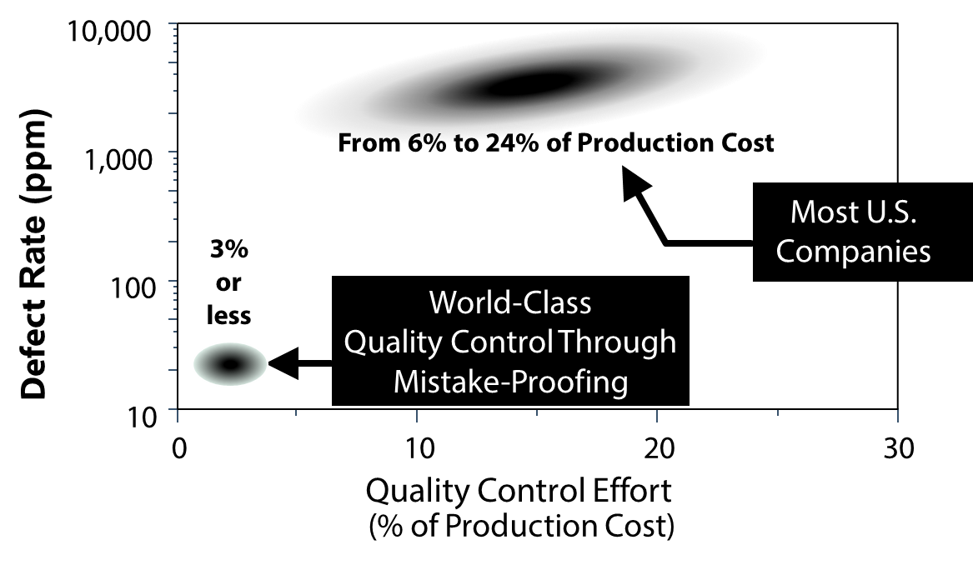

Figures

Figure 2

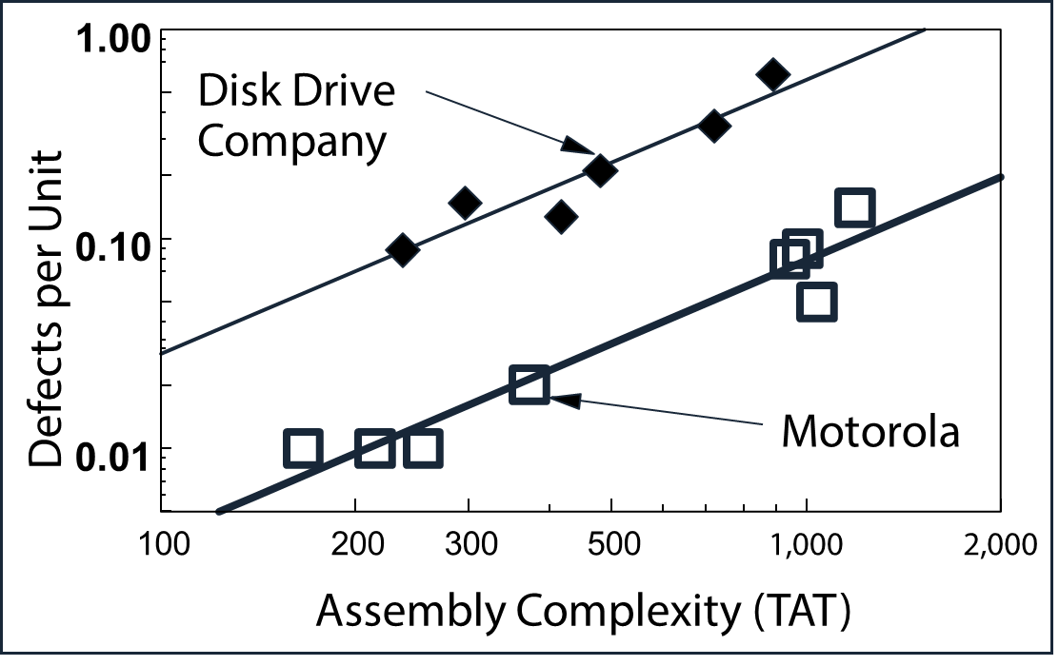

Figure 3

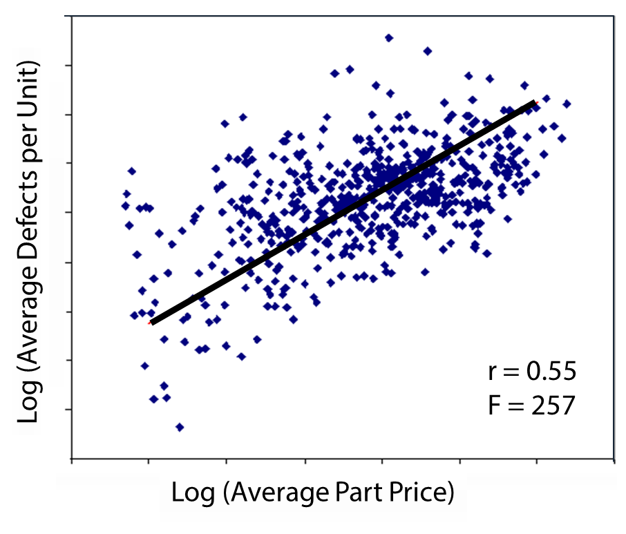

Figure 4

