Press Release Contacts:
For Immediate Release Vinitaly International
International Media Dept.
+39 045 8101447
media@vinitalytour.com
www.vinitalytour.com
Twitter: @VinitalyTour
Join Vinitaly International Network on LinkedIn

Vinitaly International Academy renews its focus on the US market with three stops in two months

Vinitaly International confirms its strong focus on the US market by kicking off the new year with a tight succession of events organized by the Italian Trade Agency (ICE) as part of a project supported by the Italian Ministry of Economic Development (MISE) with the aim of developing the Italian agro-industrial sector through the involvement of three major Italian trade fairs: Fiere di Parma, Fiera di Milano and Veronafiere. As always, Vinitaly International will participate with the Vinitaly International Academy (VIA) in its capacity as global ambassador of Italian wine, with the goal of leading members of the mature US market through in-depth explorations of some great Italian vintages.
The U.S. Wine Market, already the world’s largest in both value and volume, is continuing to grow, with its 536.000 on and off trade wine selling outlets and 120 million “several times a year” wine drinkers (roughly the same size as the entire population of Italy and France together). Italy wine imports in the U.S. still exceed all other countries in terms of both size and absolute sales growth with Prosecco leading the way.
(Source: Nielsen Report, 2015 - http://www.vinitalyinternational.com/sites/default/files/Nielsen_wine2wine.pdf)
On Sunday, January 17th, the Vinitaly International Academy (VIA) will take center stage at the Moscone Centre in San Francisco on the occasion of Winter Fancy Food Show (WFFS), the largest specialty food trade event on the West Coast, with the first of four Executive Wine Seminars, “Grignolino, or the incredible lightness of wine being” (11 am – 12.15 pm).
“The world of Italian wine is fascinating but extremely complex because of its over 500 different native grape varieties and many different official appellations” explains Doctor Ian D’Agata, VIA Scientific Director, who will be holding the four Seminars during the
three-day event. “Vinitaly International Academy, with its Executive Wine Seminars and Certification Course for Italian wine Ambassadors and Experts, would like to help forward increase the understanding and knowledge of Italian grapes and terroirs. This is why in San Francisco VIA will be leading a tasting on Grignolino of Monferrato Casalese, a lovely but relatively unknown wine made from Piedmont’s Grignolino grape. Grignolino is a light almost pink wine that offers crisp and fresh red fruit aromas and flavours. With a relatively low alcohol level, it’s perfect for modern everyday lifestyles”.
The second day of the event will see a tight succession of three Seminars that will open with an introductory focus on artisanal wines with the aim of leveraging a relatively new trend that has been building in recent years based on the importance given by US consumers to all that is natural and GMO-free. According to a January 2015 research carried out by Nielsen of 1,000 US wine drinkers, 65 % of 21- 34 year-old respondents are interested in natural wine (Source: BloombergBusiness, 14 May 2015, http://tinyurl.com/o7ep92d).

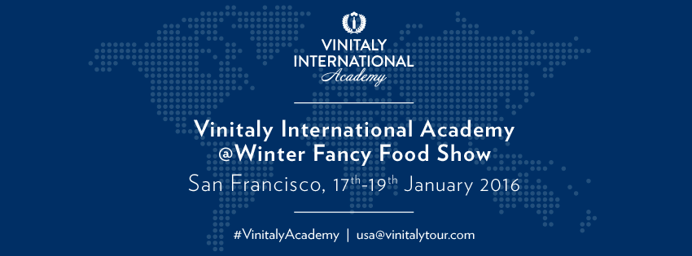

Wines presented during the seminar “Are Artisanal wines the new Italian icons?” (11 am – 12.15 pm) will be supplied by the Italian Federation of Independent Winegrowers (FIVI), a high quality organization of small artisanal wine producers in Italy. “VIA is both happy and proud to be able to showcase these delicious wines made from both little known and famous estates all over Italy,” says Doctor D’Agata.
From 1.30 pm to 2.45 pm VIA will be offering attendees an overview of different types of
Chianti, one of the world’s names in wine. “Few realize that there are many different facets to Chiant though” Doctor D’Agata points out. “Although all speak mainly of the Sangiovese variety, the many different terroirs of Chianti lead to similar yet very distinct wines each with a tale to tell. For example the Rufina area of Chianti gives high acid refined and age worthy wines while the Colli Senesi give softer more structured wines.
Dr. D’Agata will be concluding the seminar series with an Advanced level course from 3.30pm to 4.45pm on the 19th of January, “Etna, volcanic magic”, Italy’s hottest viticultural area today, and currently home of much sought after wines. “Both Etna rosso (made with a blend of nerello mascalese e cappuccio) and Etna bianco (manly made with the carricante variety) have fans the world over for their bright minerality and pure penetrating delivery of mountain herb and orchard fruit nuances.
On hand to present the Academy to San Francisco for the first time will also be Vinitaly International Managing Director Stevie Kim: “Every time we get to touch base with both wine professionals and wine lovers in the US, in addition to spreading the gospel about Italian wines, is also a great opportunity for us to engage and recruit potential candidates wishing to become Ambassadors of Italian wine for our Vinitaly International Academy. To date we have two Italian Wine Experts and 30 Italian Wine Ambassadors from around the world. We’d love to increase the visibility of Italian wines in the US, the most significant market for many Italian Wine producers, through the creation of more ambassadors and experts”.

In addition to the three educational VIA seminars, Vinitaly International will also host a Winebar for three days of the event where attendees will have the opportunity to taste some of the wines selected for the Executive Wine Seminars and get to know the great diversity of Italian wines.
For further information email usa@vinitalytour.com or visit the website http://www.vinitalyinternational.com/events/sanfrancisco2016

About:
Veronafiere is the leading organizer of trade shows in Italy including Vinitaly (www.vinitaly.com), the largest wine and spirits fair in the world. During its 49th edition Vinitaly counted some 4.000 exhibitors on a 100.000 square meter area and 150.000 visitors including 2.600 journalists from 46 different countries. The next edition of the fair will take place on 10 - 13 April 2016. The premier event to Vinitaly, OperaWine (www.vinitalyinternational.com) “Finest Italian Wines: 100 Great Producers,” will unite international wine professionals on April 9th in the heart of Verona, offering them the unique opportunity to discover and taste the wines of the 100 Best Italian Producers, as selected by Wine Spectator. Since 1998 Vinitaly International travels to several countries such as Russia, China, USA and Hong Kong thanks to its strategic arm abroad, Vinitaly International. In February 2014 Vinitaly International launched an educational project, the Vinitaly International Academy (VIA) with the aim of divulging and broadcasting the excellence and diversity of Italian wine around the globe. VIA has now also organized its very first Certification Course with the aim of creating new Ambassadors of Italian Wine in the World.

