AutoRABIT launches the latest version of its leading Salesforce release management suite, AutoRABIT 3.9 GA


AutoRABIT is a cloud based Release Automation suite specifically designed for Salesforce.com. It helps businesses with out-of-box automation of Version Control, Testing, Advanced Data Loading and Sandbox Management. AutoRABIT launched the latest 3.9 GA release with customer-first approach based on inputs from several consultants, developers as well as CSA and platform architects of Salesforce via customer interactions , meet-ups, chatter as well as DreamForce ’15.
One of the key improvements with the 3.9 GA release related to data migration is to reduce the time and effort spent in setting up data for environments. Be it setting up a training or UAT environment or Production Org itself, one of the biggest hurdles with setting up data for Salesforce environments is the complexity with relationships which can lead to circular references between the Objects. With self-lookups, multiple references and circular references between numerous objects, it can take days and several manual steps for teams to set up the data for an environment. However, with AutoRABIT, data migration between orgs with numerous objects having parent-child relationships is a breeze. The Circular reference resolution feature of AutoRABIT’s DataLoader Pro is the best in industry for Salesforce Data Migration.
Another salient feature launched with the 3.9 GA release is Deployment Roll back. This empowers developers to revert changes that are made to the destination org during deployments. In a case when deployment fails or raises functional issues, programmers can now easily revert back to the original metadata, with a single click.
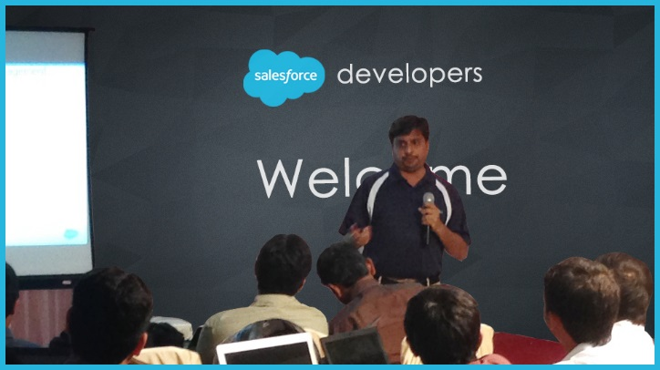

“Save your data setup time by upto 70% with faster data migrations and stop worrying about deployment failures with AutoRABIT’s Rollback” –
Niranjan Gattupalli, Sr. Program Architect, AutoRABIT.

The new GA release of AutoRABIT comes with several features that expedite and simplify release management and ensure effective Salesforce continuous integration.
Salesforce Metadata Deployments
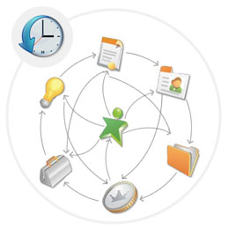
- Back-up and Rollback – Take back-ups of destination metadata before deployment, the deployment can be rolled-back in case of functional issues.
- Smart Profile Deployments – Deploy profiles with an option to Skip Visibility settings for the metadata members that are missing in the destination.
- Metadata API Support for the Winter ’16 release components.

Salesforce Data Migration Enhancements
- AutoRABIT advanced dataloader pro has become more powerful with its comprehensive circular reference resolution algorithm. The Sandbox environment set up is a breeze now with the records of an object along with the parent-child relationships transferred, all at once.
- Filters on Record Types are provided to give more flexibility in restricting what records can be transferred to the destination.
- Incremental Migration to ensure that you can synchronize your environments by migrating records on a schedule.
- Chatter Data Migration support.

Version Control
- Thin Client for TFS – Salesforce Teams can now check-in to Team Foundation Server, Register repositories, and Create Branches in addition to deployments right from AutoRABIT.
- Thin Client for Perforce – Salesforce Teams can now check-in to Perforce, Register repositories, Create Branches in addition to deployments right from AutoRABIT.

ALM Integration – “No Deployment” Theme supported for Jira
- Automated deployments can now be scheduled into multiple environments based on the Jira User Story Status with AutoRABIT.
- Attach the metadata changes to Jira tickets for User Story based deployments.

Test Automation Factory
- Special Automation Templates to automate many manual steps with Orchestra CMS deployments, Apptus and Skuid.

Administration Enhancements.
- Org Level ACL’s – Org Administrators can now set access control levels for various operations in AutoRABIT at the Salesforce Org level for the team members.
- User Profiles – Users logged into AutoRABIT can now map their Salesforce Org user and their SCM user details making it simple for the administrators during the Salesforce Org Mapping.
You can log onto www.autorabit.com for more information or write to sales@autorabit.com to review AutoRABIT.

