Press Release Contacts:
For Immediate Release Vinitaly International
International Media Dept.
+39 045 8101447
media@vinitalytour.com
www.vinitalytour.com
Twitter: @VinitalyTour
Join Vinitaly International Network on LinkedIn

Judges announced for the new Vinitaly 5 Star Wines Award

Vinitaly International has announced the team of expert judges from 17 different countries who will be taking part in the new Vinitaly 5 Star Award to be held from the 1st to the 3rd of April 2016 (www.vinitaly.com/en/exhibitor-area/vinitaly-international-competitions/5-Star-Wines/judges/). This new competition represents the evolution of Vinitaly’s International Wine Awards, founded 23 years ago and that has had a long and distinguished history of awarding medals to both Italian and international wines.

The new competition features:
- An entirely new scoring system (the 100 point scale that is used in most other world wine competitions)
- Only those wines that have scored 90 or more points will be selected for the 5 Star Wines award; gold, silver, and bronze medals will no longer be awarded
- The top scoring red, white, sparkling and sweet wine will receive a special award
- The two (Italian and International) wine estates that record the highest average score (computed by averaging out the scores of all their wines scoring 90 or more points) will also receive a special prize
- The judging panels will be composed of four to five judges of international renown, recognized experts on international wines but who are especially knowledgeable about Italian wines. For this reason, the 5 Star Wines competition is uniquely characterized by the presence of many graduates (Ambassadors and Experts) of the Vinitaly International Academy certification course in Italian wines.
- Other judges include some of Italy’ foremost winemakers, as well Masters of Wine, Master Sommelliers, Michelin starred restaurant sommeliers, and educators.

The competition will be headlined by a special selection of four 50th Anniversary General Chairmen, who will be retaste all those wines presenting a large range in scores and all those wines scored 90 points only. New judges and general chairmen will be invited to the competition each year, making for a dynamic set of invited judges that will not be the same year to year.

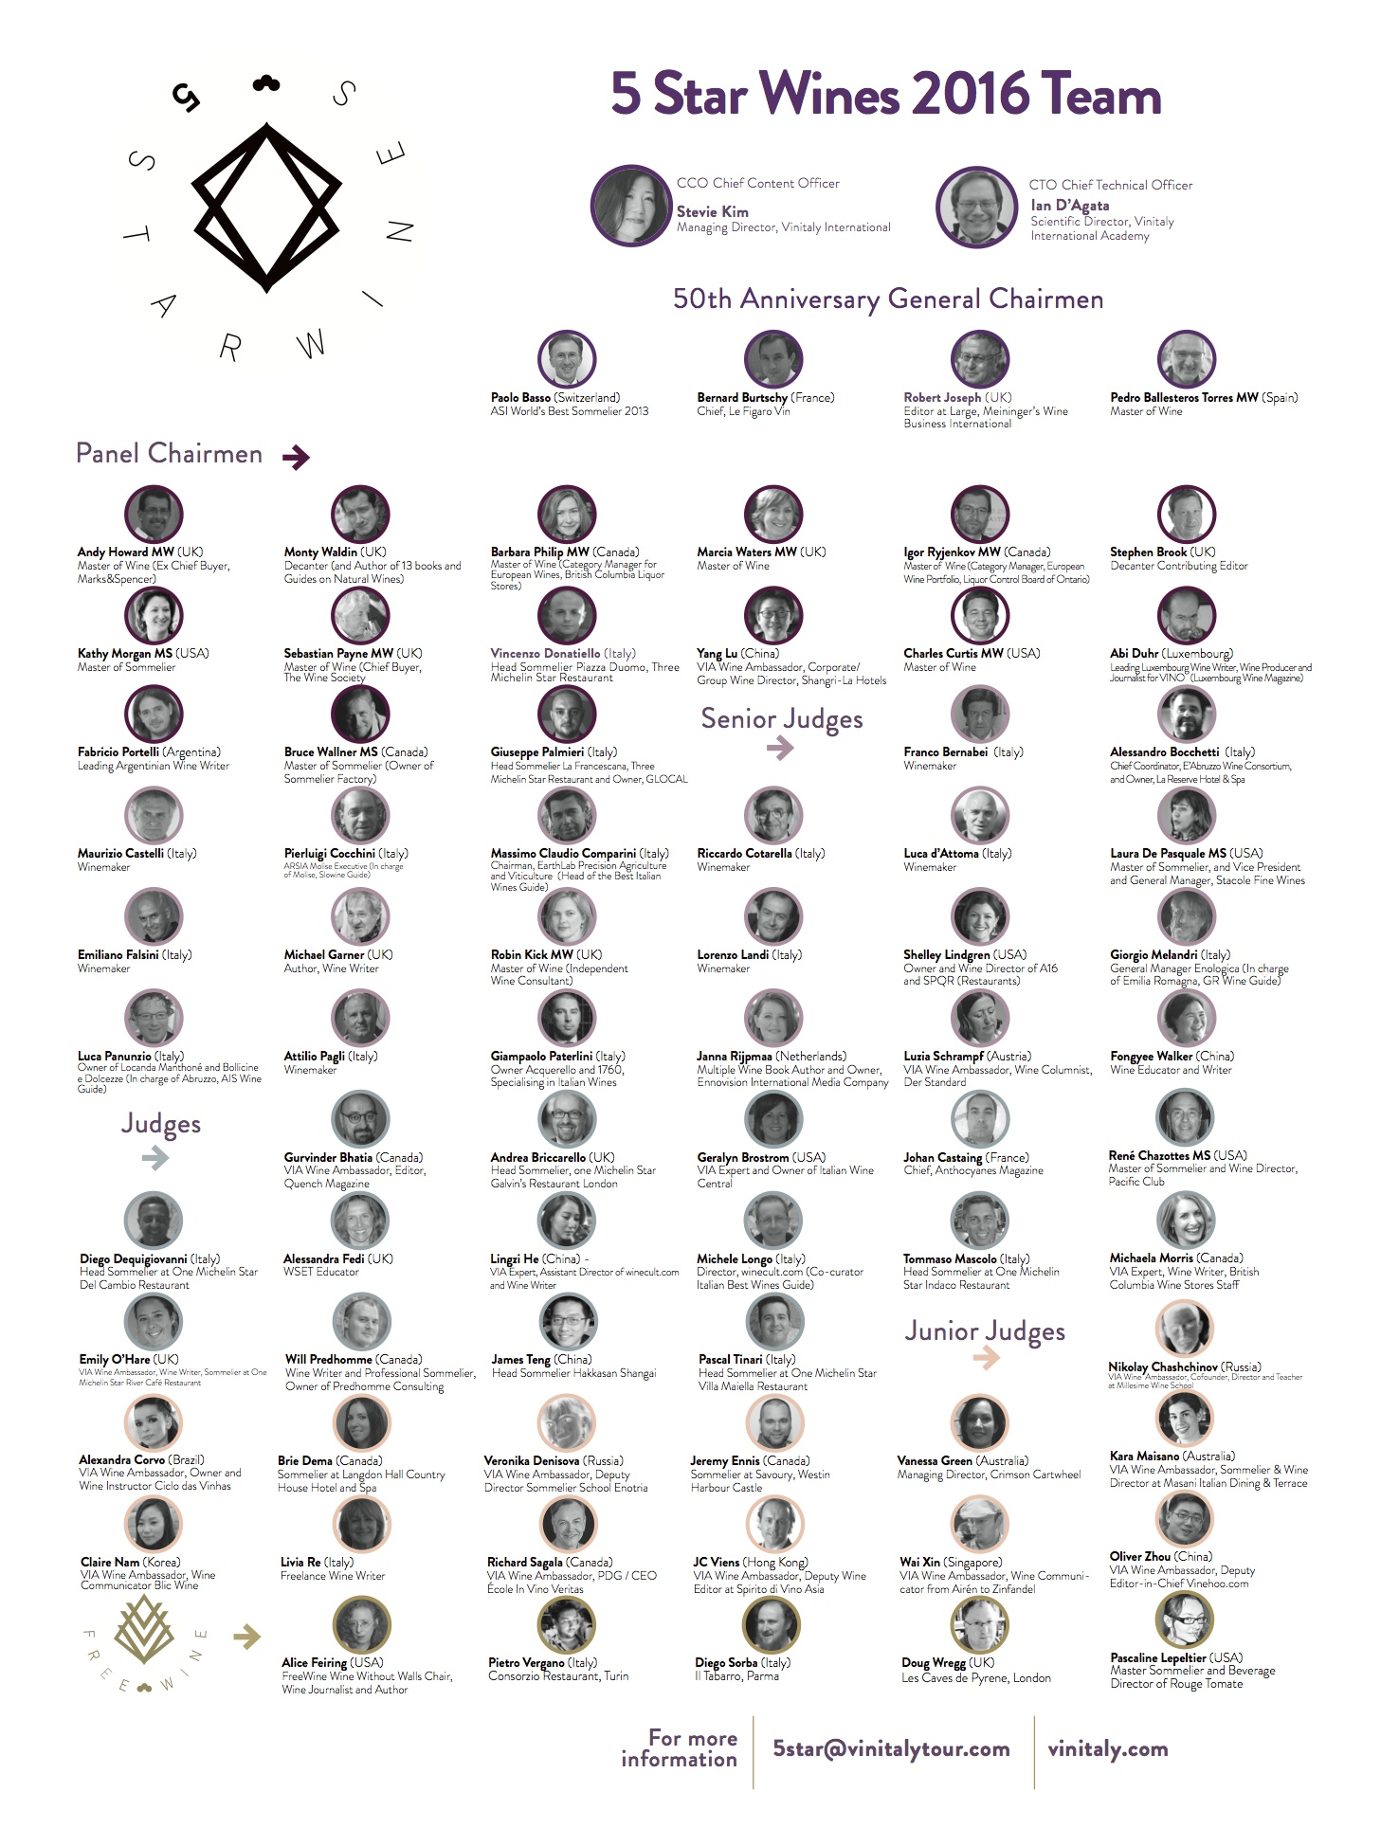

The entire competition is overseen by Stevie Kim, Managing Director of Vinitaly International and Ian D’Agata, Scientific Director of the Vinitaly International Academy, who will be on hand to address queries and help resolve differing viewpoints on any of the wines.

Registration and delivery of samples opens on 1 February and closes on 18 March 2016. More information is available on the Vinitaly website at http://vinitaly.com/en/exhibitor-area/vinitaly-international-competitions/5-Star-Wines/

JUDGE LIST

 | Chief Content Officer
Italy | Stevie | Kim | Managing Director, Vinitaly International
 | Chief Technical Officer:
Italy | Ian | D'Agata | Scientific Director, Vinitaly International Acadamy
 | 50th Anniversary General Chairmen
Switzerland | Paolo | Basso | Association Sommelerie Internationale, World’s Best Sommelier 2013
France | Bernard | Burtschy | Chief, Le Figaro Vin
UK | Robert | Joseph | Editor at Large, Meininger's Wine Business International
Spain | Pedro | Ballesteros Torres MW | Master of Wine
 | Panel Chairmen
UK | Stephen | Brook | Decanter Contributing Editor
USA | Charles | Curtis MW | Master of Wine
Italy | Vincenzo | Donatiello | Head Sommielier, Piazza Duomo - Three Michelin Star Restaurant
Luxembourg | Abi | Duhr | Leading Luxembourg wine writer, wine producer and journalist for VINO (Luxembourg wine magazine)
UK | Andy | Howard MW | Master of Wine (Ex Chief Buyer, Marks&Spencer)
USA | Kathy | Morgan MS | Master Sommelier (Independent Wine Consultant)
UK | Monty | Waldin | Decanter (and Author of 13 books and Guides on Natural Wines)
China | Yang | Lu | VIA Wine Ambassador, Corporate/Group Wine Director, Shangri-La Hotels and Resorts
Canada | Barabara | Philip MW | Master of Wine (Category Manager for European Wines, British Columbia Liquor Stores)
UK | Marcia | Waters MW | Master of Wine
Italy | Giuseppe | Palmieri | Head Sommelier, La Francescana - Three Michelin Star Restaurant and Owner, GLOCAL
UK | Sebastian | Payne MW | Master of Wine (and Chief Buyer, The Wine Society)
Argentina | Fabricio | Portelli | Leading Argentinian Wine Writer
Canada | Igor | Ryjenkov MW | Master of Wine (Category Manager, European Wine Portfolio, Liquor Control Board of Ontario)
Canada | Bruce | Wallner | Master of Sommelier (and Owner, Sommelier Factory)
 | Senior Judges
Italy | Franco | Bernabei | Winemaker
Italy | Alessandro | Bocchetti | Chief Coordinator, E'Abruzzo Wine Consortium and Owner, La Reserve Hotel & Spa
Italy | Maurizio | Castelli | Winemaker
Italy | Pierluigi | Cocchini | ARSIA Molise Executive (in charge of Molise, Slowine Guide)
Italy | Massimo Claudio | Comparini | Chairman, EarthLab Precision Agriculture and Viticulture (Head of the Best Italian Wines Guide)
Italy | Riccardo | Cotarella | Winemaker
Italy | Luca | d’Attoma | Winemaker
USA | Laura | De Pasquale MS | Master Sommellier and Vice President and General Manager, Stacole Fine Wines
Italy | Emiliano | Falsini | Winemaker
UK | Michael | Garner | Author, Winewriter
UK | Robin | Kick MW | Master of Wine (Independent Wine Consultant)
Italy | Lorenzo | Landi | Winemaker
USA | Shelley | Lindgren | Owner and Wine Director, A16 and SPQR Restaurants
Italy | Giorgio | Melandri | General Manager, Enologica (In charge Emilia Romagna, GR wine guide)
Italy | Luca | Panunzio | Owner, Locanda Manthoné and Bollicine e Dolcezze (Head Abruzzo, AIS wine Guide)
Italy | Attilio | Pagli | Winemaker
USA | Giampaolo | Paterlini | Owner, Acquerello - Specialising in Italian wines
Netherlands | Janna | Rijpmaa | Multiple Wine Book Author and Owner, Ennovision International Media Company
Austria | Luzia | Schrampf | VIA Wine Ambassador, Wine Columnist, Der Standard
China | Fongyee | Walker | Senior Wine Consultant, Dragon Phoenix Wine Consulting
 | Judges
Canada | Gurvinder | Bhatia | VIA Wine Ambassador, Editor, Quench Magazine
UK | Andrea | Briccarello | Head sommelier, One Michelin Star Galvin’s Restaurant London
USA | Geralyn | Brostrom | VIA Wine Expert, Owner, Italian Wine Central
France | Johan | Castaing | Chief, Anthocyanes Magazine
USA | René | Chazottes MS | Master Sommelier and Wine Director, Pacific Club
Italy | Diego | Dequigiovanni | Head Sommelier, One Michelin Star Del Cambio Restaurant
Italy | Alessandra | Fedi | WSET Educator
China | Lingzi | He | VIA Wine Expert, Wine Writer and Assistant Director, winecult.com
Italy | Michele | Longo | Director, Winecult.com (Co-curator Italian Best Wines Guide)
Italy | Tommaso | Mascolo | Head Sommelier, One Michelin Star Indaco Restaurant
Canada | Michaela | Morris | VIA Wine Expert, Wine Writer, British Columbia Wine Stores Staff
UK | Emily | O’Hare | VIA Wine Ambassador, Wine Writer and Sommelier, One Michelin Star River Café Restaurant
Canada | Will | Predhomme | Wine writer, Professional Sommelier and Owner, Predhomme Consulting
China | James | Teng | Head Sommelier, Hakkasan Shangai
Italy | Pascal | Tinari | Head sommelier, One Michelin star Villa Maiella Restaurant
 | Junior Judges
Russia | Nikolay | Chashchinov | VIA Wine Ambassador, Cofounder, Director and Teacher, Millesime Wine School
Brazil | Alexandra | Corvo | VIA Wine Ambassador, Owner and Wine Instructor, Ciclo das Vinhas
Canada | Brie | Dema | Sommelier at Langdon Hall Country House Hotel and Spa
Russia | Veronika | Denisova | VIA Wine Ambassador, Deputy Director, Sommelier School Enotria
Canada | Jeremy | Ennis | Sommelier at Savoury, Westin Harbour Castle
Australia | Vanessa | Green | Managing Director, Crimson Cartwheel
Australia | Kara | Maisano | VIA Wine Ambassador, Sommelier & Wine Director, Masani Italian Dining & Terrace
Korea | Claire | Nam | VIA Wine Ambassador, Wine Communicator, Blic Wine
Italy | Livia | Re | Freelance Wine Writer
Canada | Richard | Sagala | VIA Wine Ambassador, PDG / CEO, École In Vino Veritas
Hong Kong | JC | Veins | VIA Wine Ambassador, Deputy Wine Editor, Spirito di Vino Asia
Singapore | Wai Xin | Chan | VIA Wine Ambassador, Wine Communicator, winexine.sg
China | Oliver | Zhou | VIA Wine Ambassador, Deputy Editor-in-Chief, Vinehoo.com
 | FreeWine
USA | Alice | Feiring | FreeWine Wine Without Walls Chair, Wine Journalist and Author
Italy | Pietro | Vergano | Consorzio Restaurant, Turin
Italy | Diego | Sorba | Il Tabarro, Parma
UK | Doug | Wregg | Les Caves de Pyrene, London
USA | Pascaline | Lepeltier | Master Sommelier and Beverage Director of Rouge Tomate

About:
Veronafiere is the leading organizer of trade shows in Italy including Vinitaly (www.vinitaly.com), the largest wine and spirits fair in the world. During its 49th edition Vinitaly counted some 4,000 exhibitors on a 100,000 square meter area and 150,000 visitors including 2,600 journalists from 46 different countries. The next edition of the fair will take place on 10 - 13 April 2016. The premier event to Vinitaly, OperaWine (www.vinitalyinternational.com) “Finest Italian Wines: 100 Great Producers,” will unite international wine professionals on April 9th in the heart of Verona, offering them the unique opportunity to discover and taste the wines of the 100 Best Italian Producers, as selected by Wine Spectator. Since 1998 Vinitaly International travels to several countries such as Russia, China, USA and Hong Kong thanks to its strategic arm abroad, Vinitaly International. In February 2014 Vinitaly International launched an educational project, the Vinitaly International Academy (VIA) with the aim of divulging and broadcasting the excellence and diversity of Italian wine around the globe. VIA has now also organized its very first Certification Course with the aim of creating new Ambassadors of Italian Wine in the World.

###

