FOR IMMEDIATE RELEASE
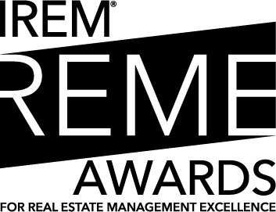
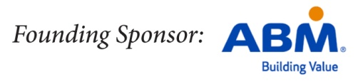

IREM Invites Innovative Companies and Individuals to Submit to 2016 Real Estate Management Excellence (REME) Awards
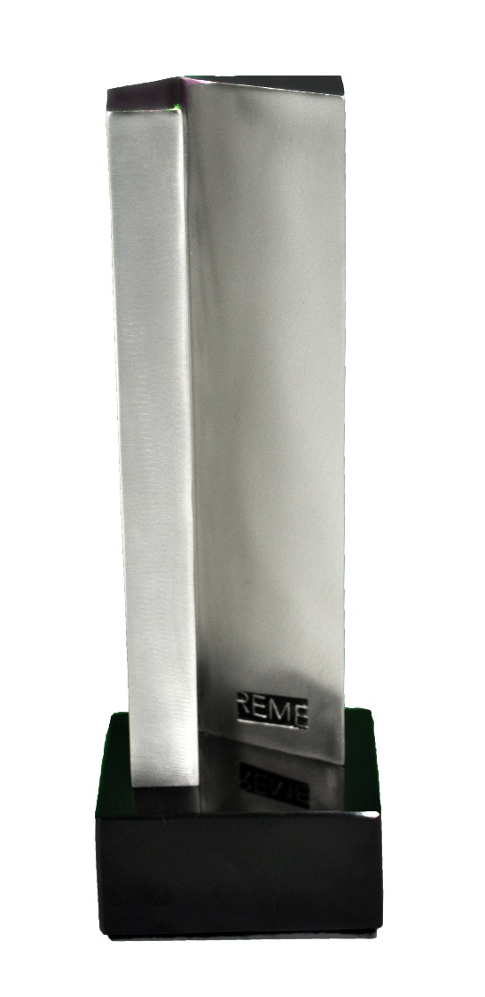
(Chicago, Jan. 15, 2015) The REME Awards presented by the Institute of Real Estate Management (IREM®) are unique recognitions of professional achievement in property management because they honor companies and professionals who advance the profession and deliver exceptional service and value. The REME Awards celebrate real estate management excellence by:
- Recognizing real estate management companies and individual practitioners for innovative, leading-edge, business practices and initiatives
- Sharing successful initiatives and fostering innovation within the real estate management industry
- Recognizing companies and individuals of all asset classes – commercial and residential – and of any size, whether local, regional, national, or international
Learn more about the 2016 REME Awards – see below for new company categories this year!

Deadline for submissions is June 1, 2016. Finalists and recipients of all awards are honored during the Inaugural Gala and REME Awards event during the IREM® Fall Conference October 21, 2016, in San Diego, California. Contact pr@irem.org for more information.

REME Award winners are featured in Real Estate Management News, the IREM® blog, the Journal of Property Management, and in the media. Explore videos of past REME Award Winners. View blog posts about past REME Award Winners.

2016 REME Award Categories

Company REME Awards

Workplace Environment: Employee and Leadership Development
Exemplary practices that are transformational for the company as a whole, a team, or a program related to one or more of the following:
- Leadership development/succession planning
- Employee engagement
- Onboarding of new employees
- Wellness programs
- Internships or other initiatives engaging young professionals and newcomers to the industry
- Corporate culture

Workplace Environment: Sustainability Programs
Innovative company business practices for sustainability programs within the workplace or across a portfolio

Corporate and Social Responsibility
Exemplary corporate responsibility and contributions to the community that enhance the reputation of the real estate management

Corporate Innovation
Innovative programs related to technology or marketing that are transformational for the company as a whole, a team, or a program

AMO® of the Year
Outstanding performance by an AMO® Firm that is dedicated to:
- Advancing the real estate management industry
- Providing superior service to clients, tenants, and residents
- Aligning business practices with IREM’s Best Practices for Real Estate Management Service
- Demonstrating ethical business practices based on the AMO® Code of Professional Ethics, and instills these practices within its workforce
- Supporting employee participation in IREM® activities
- Supporting employee professional development on industry-specific knowledge
- Executing leadership development and soft skill training for employees
- Promoting AMO® status to public, clients, tenants, and residents

Individual REME Awards

CPM® of the Year
Outstanding performance by a CPM® who is dedicated to:
- Advancing the real estate management industry
- Providing superior service to clients, tenants, and residents
- Demonstrating personal commitment to community service
- Demonstrating leadership through innovative initiatives, programs, or business practices that resulted in business advancement and/or property success
- Demonstrating leadership by mentoring of others
- Demonstrating commitment to ethical business practices based on the IREM® Code of Professional Ethics
- Engaging in IREM®, either directly or through support of employees, colleagues, and industry peers
- Promoting the CPM® through personal and business relationships

ARM® of the Year
Outstanding performance by an ARM® who is dedicated to:
- Advancing the real estate management industry
- Providing superior service to clients and residents
- Demonstrating personal commitment to community service
- Demonstrating leadership through innovative initiatives, programs, or business practices that resulted in business advancement and/or property success
- Demonstrating leadership by mentoring of others
- Demonstrating commitment to ethical business practices based on the IREM® Code of Professional Ethics
- Engaging in IREM®, either directly or through support of employees, colleagues, and industry peers
- Promoting the ARM® through personal and business relationships

About IREM®
IREM® is an international community of real estate managers dedicated to ethical business practices, maximizing the value of investment real estate, and promoting superior management through education and information sharing. An affiliate of the National Association of REALTORS®, IREM® is the home for all industry professionals connected to real estate management – and the only organization serving both the multi-family and commercial sectors. IREM® believes good management matters, and well-managed properties pay dividends in terms of value and in the quality of life for residents, tenants and customers. IREM® offers a variety of membership types for professionals of every experience level, from on-site managers to high-level executives. IREM® credentials, earned by meeting high standards of education, experience, and ethical business practices, include: CPM®, ARM®, ACoM, and AMO®. To learn more about IREM®, call 800-837-0706, ext. 4650 (outside the United States, call 312-329-60000), or visit www.IREM.org.

###

CONTACT
Jessi Narducci
Manager, Corporate Communications
pr@IREM.org
312-329-6067

