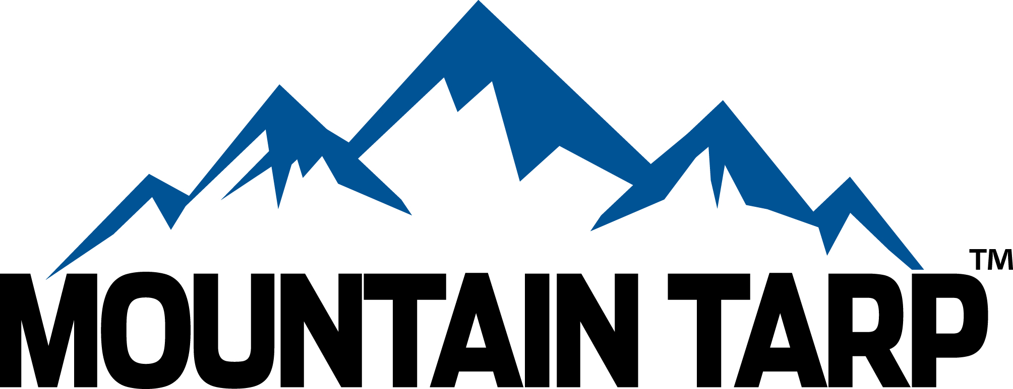

**for immediate distribution**

**Mountain Tarp Hits the Road**

*New Mobile Program to Serve Ohio, Eastern Kentucky, and West Virginia Tarping System Users*

**CHARLOTTE, N.C. [February 4, 2016]** — [**Mountain Tarp**](http://www.mountaintarp.com/)™, a [**Wastequip**](http://www.wastequip.com)® brand, and one of the most trusted manufacturers of quality tarping solutions for the construction, agriculture, transportation, waste, and recycling industries, announces the debut of a mobile service program to handle on-site inspection of truck and trailer tarping systems, as well as turn-key parts delivery.

Mountain Tarp recently outfitted two Ram ProMaster® 2500 cargo vans to serve tarping customers across Ohio, eastern Kentucky, and West Virginia with service for flip tarps, flat bed systems, cable systems, side-roll tarps, and rack-and-pinion tarps. In addition, common parts and components will be available right off the van, and special order parts will be delivered directly to the customer’s location.

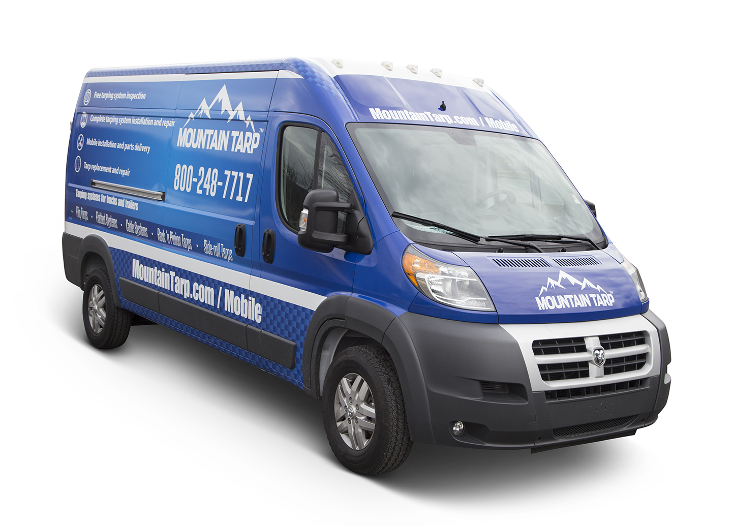

Department of Transportation (DOT) regulations require truck and trailer loads to be securely covered. Ensuring that fleet tarping systems remain in top working order keeps trucks on the road, avoiding fleet downtime and/or fines for non-compliance. A truck that’s off the road due to a malfunctioning tarping system is both costly and aggravating. It also can be challenging for users to get a truck into a service shop for inspection and simple repairs – this new program brings the parts and service directly to the user.

Mountain Tarp’s new mobile program offers:

* Free tarping system inspection
* Assessment and consultation for light repairs
* Deployment/coordination of Mountain Tarp’s existing mobile team for major repairs and installation
* Parts delivery

“Reliable, secure tarps are critical for keeping trucks and trailers on the road,” said John Defenbaugh, president of Wastequip’s mobile products division, which includes the Mountain Tarp brand. “Tarps take a lot of abuse, in all sorts of extreme environments, and timely repairs and/or replacements reduce downtime and boost productivity. With this new mobile service program, we’ll be able to service our customers right at their own facilities, diagnosing potential problems before they sideline their trucks, as well as provide onsite parts delivery to get trucks and trailers back on the road quickly.”

Mountain Tarp offers a comprehensive line of hydraulic, electrical, semi-automatic, and manual tarping systems, including flip tarps for trailers and dump bodies, cable-style solutions for trailers and roll-off systems, and a variety of specialty tarp systems for the waste, construction, paving, landscaping, scrap, and oil/gas industries.

Photos can be downloaded at: <https://flic.kr/s/aHsksDyQ9z>

# # #

**ABOUT THE MOBILE PRODUCTS DIVISION**

Wastequip’s mobile products division includes products from industry-leading brands including Galbreath, Mountain Tarp, Pioneer, and Cusco. The mobile division includes multiple manufacturing and installation facilities in the U.S. and Canada dedicated to hoists, tarping systems, container handlers, vacuum trucks,   
and more. To learn more about Mountain Tarp, visit [www.mountaintarp.com](http://www.mountaintarp.com).

**ABOUT WASTEQUIP:**

Wastequip is the leading North American manufacturer of waste and recycling equipment, with an international network of manufacturing facilities and the most extensive dealer network in North America. Wastequip’s broad range of waste and recycling equipment and systems is used to collect, process and transport recyclables, solid waste, liquid waste and organics. The company’s brands include Wastequip, Toter, Galbreath, Pioneer, Accurate, Cusco, Mountain Tarp and Go To Parts. For more information, visit [www.wastequip.com.](http://www.wastequip.com)

Media Contact:

Kelly Rouse

Marketing Manager

Wastequip

704-501-8207

[krouse@wastequip.com](mailto:krouse@wastequip.com)