“The Best in Mexico - A Year of Excellence”

CANCUN, Mexico (February 11th, 2016) - Taking the All-Inclusive Luxury concept to a new level, Excellence Group Luxury Hotels & Resorts continues its commitment to delivering a five-star guest experience. The result has been a slew of new awards, positive travel reviews and, best of all, nearly one-third of visits are return guests. Not surprisingly, all of our Resorts are highly ranked within their respective destinations on TripAdvisor traveler reviews (Playa Mujeres in Cancun, Puerto Morelos in Riviera Maya and Punta Cana in Dominican Republic). Excellence Playa Mujeres shines over all, being #1 Resort in the entire country of Mexico at the end of 2015.

Awards Galore!

Travel professionals and the public have spoken. TripAdvisor's Traveler's Choice, AAA, Conde Nast Travel Readers' Choice Award, Travel & Leisure World's Best are just a few of the accolades received by our Resorts. “We are very proud of how our hotels are ranked in TripAdvisor, and we work hard improving ourselves to deliver the best service and experience our clients could expect “, says Domingo Aznar Vice President of sales and marketing.

Mexico and the Dominican Republic:

Only the top popular destinations for travelers is where you will find Excellence Group various brands; Excellence Resorts Adults only in Cancun and Riviera Maya (Mexico), and in Punta Cana (Dominican Republic). There's more though; the boutique Beloved and Finest All-Inclusive for all ages, both in Playa Mujeres, Mexico.

What's New?
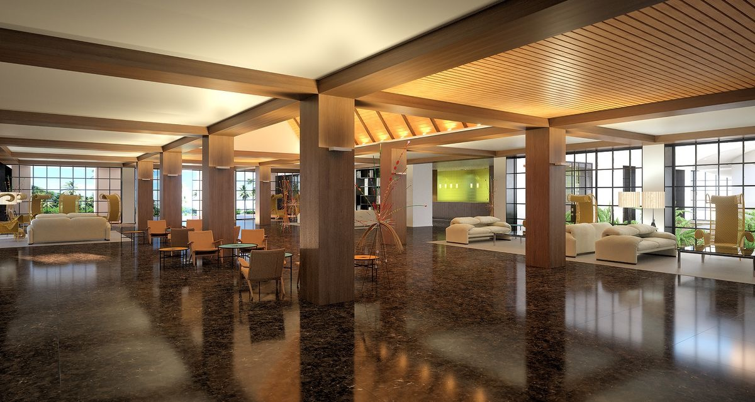
Excellence Riviera Cancun completed its multi-million dollar renovation in 2015. Additionally, the opening of their newest resort, Excellence El Carmen in Punta Cana, Dominican Republic Is on schedule to open in September 1st 2016.

Ongoing:

All-inclusive Luxury at Excellence properties features luxury suites, gourmet cuisine, 24-hour room service, a wide array of bars, world class Spas, fitness center, multiple pools, daily activities and entertainment each every evening. And of course, pristine beaches and a friendly, attentive staff, a perfect combination for honeymoons, anniversaries and destination weddings.

About Excellence Group Luxury Hotels & Resorts:

Excellence Group Luxury Hotels & Resorts is a family owned and operated resort group specializing in hotel management and worldwide real estate development, with a primary geographic presence in the Caribbean. Excellence Group Luxury Hotels & Resorts is the result of a joint investment between Medieval Times and ETI (Explotacions Turistiques de les Illes). The group owns and manages five star award winning resort properties in Dominican Republic and Mexico under 3 brands encompassing the world of ultimate All-Inclusive Luxury: AdultsOnly Excellence Resorts in Cancun, Riviera Maya, and Punta Cana, Boutique All Inclusive at Beloved Hotels, and Modern All-Inclusive-Luxury for all ages at Finest Resorts.

For more information on The Excellence Group and its brands of resort properties, go to www.excellencegroupluxuryresorts.com corporate website.

Press contact:
Elsie Mendez
Email: pr@marketingzentral.com

Excellence Group contact:
Alejandro Lazcano
Marketing Director
Email: alazcano@grupoexcellence.com
Phone: +52 998 872 8636

