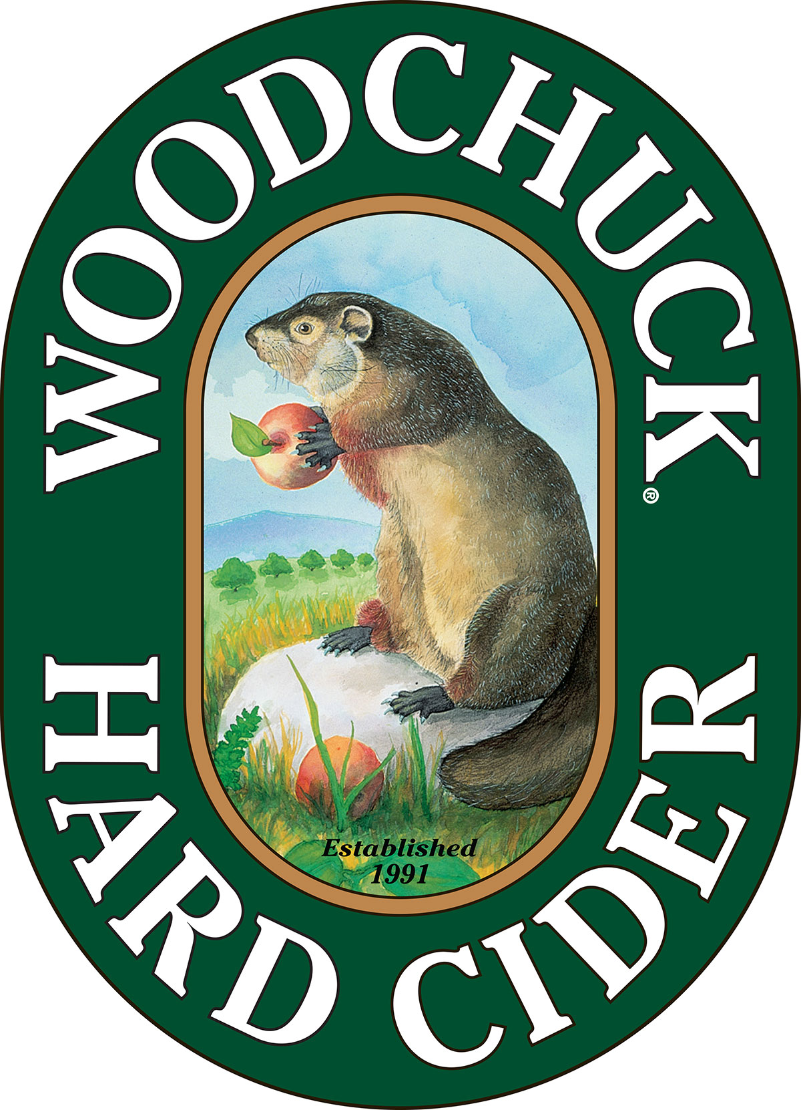

**FOR IMMEDIATE RELEASE**

**Contact:** Caitlin Stroupe

(802) 398-6958

cstroupe@vthardcider.com

**Woodchuck® Hard Cider Unveils Day Chaser and new Private Reserve Cherry**

*~The Vermont-based hard cider introduces semi-dry year-round option, and first cider of new barrel-aged series ~*

**February 17th, 2016 MIDDLEBURY, Vt. —** With the 25th Anniversary in full swing, *Woodchuck* Hard Cider is excited to announce the release of their two newest innovative ciders. Day Chaser joins the core lineup, and Private Reserve Cherry introduces a new barrel-aged series. Both styles have started shipping and will be available to the market starting March 1st.

Embodying the lifestyle of its dynamic home state, Day Chaser comes on board as a drier cider option from the Woodchuck line. Celebrating those adventure seekers that never let a minute slip by, this style combines bitter and sweet apples, yielding a semi-dry taste. With an ABV of 5.5%, this style is built for any on-the-move activity with availability in 6-packs of both 12 oz. bottles and cans with a suggested retail price of $9.99.

“We’re excited to round out our portfolio with this semi-dry offering,” explains Terry Hopper, Vice President of Sales. “Day Chaser not only delivers on the demand for drier ciders, but is crafted for those who make the most of each day.”

Private Reserve Cherry ignites a new barrel aged series within the *Woodchuck* family. Our small batch hard cider was infused with the juice of Michigan cherries, then aged in the finest Cabernet Sauvignon barrels from the Napa Valley. This premium craft cider delivers a sweet and tart taste that finishes with notes of smooth oak.

“Based on an overwhelming response to both our sour cherry cider and Out on a Limb® series, we brought the tart style to our Private Reserve line with an added twist.” Hopper explain that Cherry will be the first of three high end barrel-aged ciders that will make up the series. With an ABV of 6.9%, this Private Reserve will be available from March to August seasonally, with a suggested retail price range of $10.99 - $11.99.

For more information or to request hi-res imagery, contact Caitlin Stroupe at [cstroupe@vthardcider.com](mailto:cstroupe@vthardcider.com) or (802) 398-6958.

**###**

***About Woodchuck® Hard Cider***

Woodchuck Hard Cider introduced the U.S. to the craft cider category 25 years ago after it was first handcrafted in a 2-car garage in Proctorsville, Vermont. Staying true to its roots, Woodchuck is dedicated exclusively to cider making. In other words, we “Give a ‘Chuck” about authenticity and handcrafting the best cider possible. Innovation is at the core of everything Woodchuck’s cider makers do, which is why they continuously strive to create unique new ciders using the finest ingredients. That attention to detail has paid off and Woodchuck Hard Cider has recently received awards at the World Expo of Beer, The Great Lakes International Cider and Perry Competition and the New York International Beer Competition. For more information about Woodchuck Hard Cider visitwww.woodchuck.com.