MEDIA RELEASE
Friday 19th February 2016

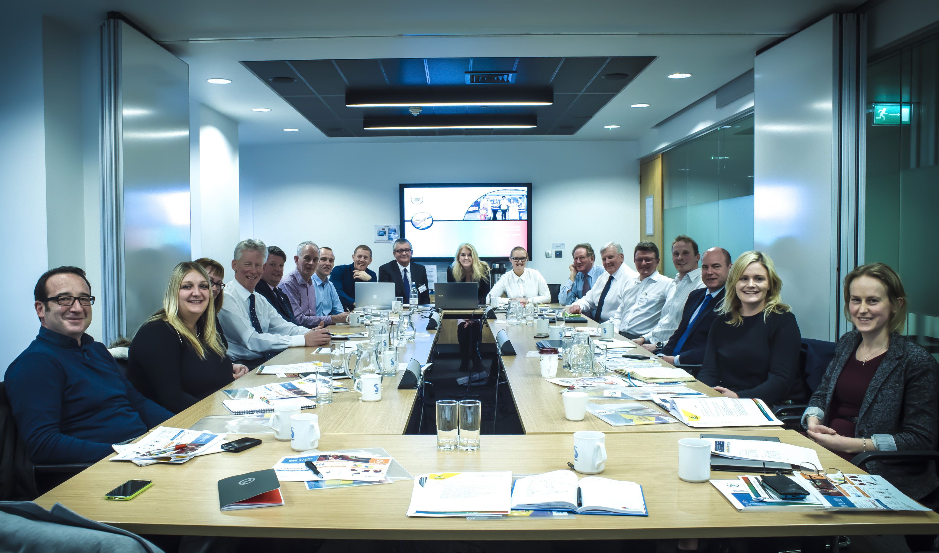

Leading child seat manufacturers, retailers and road safety organisations have joined forces for the first time to help improve in-car child safety following alarming results from Good Egg Safety’s latest annual car seat checks which showed that over three quarters of children and babies in the UK are in potential danger.

Good Egg Safety Chief, Jan James explains; “over the last fifteen years we have checked more than 24,000 child car seats and it is a major concern to us that vulnerable little passengers are still at risk of injury or worse due to the incorrect fitting of their child seats. They deserve better.

Last year alone, 71% of child seats either didn’t fit the car/s they were used in or were not suitable for the child using them. We urgently need to align all stakeholders to help tackle this problem and the fact that so many enlightened
organisations have put aside competitive differences to work collaboratively with Good Egg Safety is extremely encouraging.

A summary of the key actions agreed upon included:

- General acceptance among industry leaders that the new Isize legislation, which is running concurrently with existing R44.04 legislation is causing some confusion among parents, carers and road safety practitioners alike and needs to be simplified so everyone understands it better.
- The importance of using the same terminology industry wide so the advice given from all retailers’ manufacturers and child seat professionals is consistent.
- The importance of high quality training / accreditation for all those who work in this field. Good Egg Safety can now offer CPD accredited ‘Advanced Expert Training’ in partnership with TRL
- The importance of reaching new parents before the birth of their children so they are fully informed about the choices they make.
- The importance of eradicating booster cushions which give little protection to children’s head, neck and hips in a side impact.
- Explore innovative ways to help parents, grandparents and carers avoid collisions (often caused by distractions) in the first place.
- Encourage parents to rear face their babies for longer.

Further meetings have been planned and it is hoped that the end result is a significant reduction in the number of incorrectly fitted seats across the UK.

Partner Quotes:

Mark Bennett, Senior Technical and Training Manager Europe, Britax.
“Good Egg Safety and RoadSafe have done a great job in bringing together the key car seat manufacturers and retailers for an open and productive discussion. Clearly there are still some steps to be taken to improve car seat fitments across the country but working together towards a common objective with the focus on quality training will no doubt increase general awareness on car seat safety”

Andrew Ratcliffe MD Dorel
It was encouraging to see representatives from retail, industry and safety organisation together discussing child safety in cars, particularly correct fitting and use. Retailers are taking staff training ever more seriously and new safety standards like i-Size are raising the protection level and ease of fitting for new car seat models, however ultimately it’s down to parents and carers to ensure their child is correctly fitted in a car seat for every trip and that the seat is adjusted as the child grows”.

“Private sector innovation has led the way in child safety for car passengers – this initiative which brings the industry together with road safety professionals with a common aim of making young passengers even safer is most welcome and long overdue”
Rebecca Carson, Brand Supremo Cosatto Ltd
Cosatto are honoured to be a part of such a worthwhile campaign. The meeting highlighted how big of a problem incorrectly fitted car seats are and also the consequences of this. It was fantastic to discuss as an industry with other manufacturers, retailers and safety officers what we can do jointly to help to educate on correct fitment. The passion around the table regarding this issue and to learn that we all have the same end goal was inspiring.I'm very excited to be involved in this process of making a difference and look forward to our next meeting.

James Ellway Euro NCAP
‘Good egg safety is continuing its valuable work in raising awareness of in car child safety issues. By gathering those organisations around the table who are in a position to inform and educate parents of how they can keep their children as safe as possible, positives steps can be taken to reduce child casualties in vehicle accidents.’

Claire Askew Category Manager - Halfords
'This is a fantastic opportunity for retailers, manufacturers and industry leads to come together to discuss the important issues on child travel safety. Halfords is dedicated to providing expert knowledge and advice to all customers on this matter and is proud of its heritage of doing so on safety critical products such as child seats. I’m looking forward to working closely with this group led by Good Egg Safety, to drive forward new initiatives in this area that will further improve our customers experience'
Debbie Kemp, People Development Manager, Mothercare
“This meeting was the first time all interested parties sat at the table together to explore how we can improve the knowledge and advice for parents and carers to help them make informed choices about how they transport their children safely. It was the first step towards an Omni channel approach however all involved had the same objectives. We now need to harness all of the good intent. I’m very excited to be part of this group and look forward to taking these all important first steps”

Michael McDonnell Director Road Safety Scotland
We’ve been working for a number of years on this campaign, during which we have seen a number of major milestones, and I firmly believe that the public are much better-informed about the issues surrounding the correct fitment of child restraints. The round-table discussion held at the beginning of the year, which brought together retailers, manufacturers and road safety professionals, is a major achievement and presents a great opportunity to move towards the eradication of child in-car fatalities in the UK.

Adrian Walsh Director RoadSafe

"Child safety in cars is a very important issue, in particular for parents, due to the complex nature child safety seats and fitting. The coming together of the manufacturers, retailers, campaigners, and road safety experts, is a huge step taken in progressing towards national standardisation of seat types and training for car seat checkers.

Alan Kennedy Road Safety GB
Our debate has also highlighted the urgent need for the dissemination of vital information before baby is born to ensure safety is embedded in parents’ minds at the earliest stages. There is still much to do, but this leading industry group will no doubt help overcome some of the difficulties currently experienced more efficiently and effectively"
Neil Greig, IAM
Parents, grandparents and carers often feel they need that extra boost of confidence when carrying their most precious cargo and the IAM is currently developing new driver training products to meet that demand. In car distraction is also a growing issue and a priority topic for our ongoing research programme.

Notes to Editors:

For more information contact Jan James on 07980 851360 / 01234 834 580

From left to right in picture –Mark Bennett, Senior Technical & Training Manager Europe Britax, Rebecca Carson, Brand Supremo Cosatto, Debbie Kemp, Product Development Manager Mothercare, Paul Sirett, Country Manager UK, Besafe, Chris Beeley Head of Quality & Compliance, Mamas & Papas, Kevin Lowe Child Accident Prevention Trust, David Mallinson,
Head of Product, Technology & Innovation John Lewis Partnership, Dominic Goodwin, Product Trainer Cybex,
Andrew Ratcliffe, CEO Dorel, Jan James Chief Executive, Good Egg Safety, Kat Furlong Good Egg Safety Manager,
Adrian Walsh, Director RoadSafe, Michael McDonnell, Director Road Safety Scotland, Alan Kennedy, Business & Operations Manager Road Safety GB, James Ellway, Technical Manager, Euro NCAP, Mike Pittman, Principal
Consultant TRL, Claire Askew, Category Manager, Halfords, Caroline Holmes, Communications Manager, IAM

