**Two Letter License Plate Auction – Ends February 25, 2016**

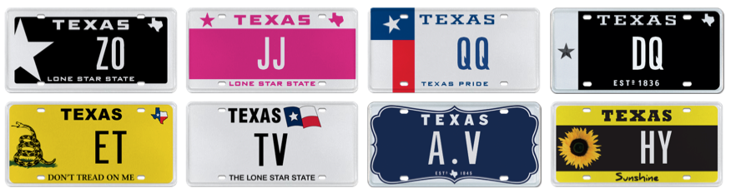

21 February 2016 (Austin, TX) – My Plates has opened their latest online auction, making available 20 new official Texas license plate messages. All of the plate messages are truly unique and far different from the every-day general issue random license plate messages. The plate messages being auctioned all feature only two letters.

With only two letters, all are easy to remember! There is a great selection on offer like repeating letter messages including **JJ** & **QQ,** plus abbreviations like **FB** for Facebook or **TV** for television.

Other notable messages include: **ET, AV, BE, DQ, HY, I.E, LV, NA, SP & UC.**

The winning bidders will own each plate for 5 years, with first dibs on renewing it at the state’s everyday pricing. That means once the message is won at auction, it could be gone forever!

**Auction Details:**

My Plates 2-LETTER Plate Auction dates:

* Begin Bid Date: Monday, 02-15-16 at 8:00 am
* End Bid Date: Thursday, 02-25-16 at 8:00 pm

Unlike other Texas license plates, plates sold by My Plates at auction are legally transferable. The plate owner then has the right to sell the plate message to another person with the same ongoing rights or gift it to a family member or friend. Transferability also means these plates could make great investments. A participant who won three of the plates in Round One of the Two-Letter Auction held in January, including one message for which he paid $3100 for, stated “*The Two-Letter plates do present an intriguing investment. I plan to hold on to the plates, and at a later time re-sell for a profit”*.

As to what these plates will go for, Texans should register at www.myplates.com/auction to find out. In a 2015 auction, the two-character plate message F1 went for $4,300, whereas SA sold for only $750.

My Plates is also releasing for auction the one, and only, plate message ALAMO. The auction for ALAMO will open February 23, 2016 at 8am and close on March 6th at 8pm. Proceeds from the auction sale will benefit both the Alamo Endowment Fund and the state General Revenue Fund, therefore benefitting this cherished shrine of Texas liberty, and all the citizens of the State of Texas.

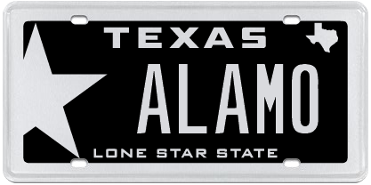

To find out more information about the plate auctions, simply visit My Plates home page or visit [www.myplates.com/auction](http://www.myplates.com/auction).

____________________________________________________________

**Image download**. Hero Image - Two Letter plate messages:

<https://ce9a9387e1bc258c3cfa-af7906f4e771b24864bbfa3048e4a635.ssl.cf2.rackcdn.com/Two%20letter%20auction%20images.png>

**Download ALAMO hero image**: <https://ce9a9387e1bc258c3cfa-af7906f4e771b24864bbfa3048e4a635.ssl.cf2.rackcdn.com/ALAMO_PR%20Image.jpg>

**My Plates** designs and markets new specialty license plates as a vendor for the Texas Department of Motor Vehicles. Texans have bought more than 260,000 My Plates since November 2009, putting more than $37M in the state general revenue fund. My Plates’ goal is to create a long-term, mutually beneficial relationship designed to maximize revenues for the state through the sale of My Plates specialty plates. [www.myplates.com](http://www.myplates.com).

**The Texas Department of Motor Vehicles (TxDMV)** serves protects and advances the citizens and industries in the state with quality motor vehicle related services. For every $1 it spends, the TxDMV returns $11 to the state. Each year the agency registers nearly 24 million vehicles; issues more than 7 million vehicle titles; licenses more than 38,000 motor vehicle dealers and distributors; credentials nearly 60,000 motor carriers; issues more than 800,000 oversize/overweight permits; investigates more than 15,000 complaints against dealers and motor carriers; and awards grants to law enforcement agencies to reduce vehicle burglaries and thefts. Learn more at [www.TxDMV.gov](http://www.TxDMV.gov).

Contact Steve Farrar at (512) 633-7978 or [steve@myplates.com](mailto:kristy@myplates.com)

TERMINOLOGY

-“Specialty” plate refers to any official license plate other than the state’s general issue plate.

-Specialty plates can be “personalized” plates, but they don’t have to be.