Ocean by H10 Hotels opens the Ocean Casa del Mar, its fourth hotel in Cuba

The five-star resort stands on the beachfront in Cayo Santa María, in the north of Cuba

Mexico, February 22nd 2016. Ocean by H10 Hotels has opened the five-star Ocean Casa del Mar, a newly-built resort with an ideal beachfront location. It stands in Cayo Santa María, the largest of the Villa Clara Keys located in the north of Cuba. The 800-room resort has direct access to a stunning beach that runs for almost 1 kilometre along the coast. “This five-star resort offers a wide range of services, including its large pools, extensive selection of cuisine, a 24-hour All-Inclusive service and a full program of entertainment for both adults and children, with the sole objective to guarantee our costumers satisfaction” pointed Oscar Serrano, Vice President Sales & Marketing for Ocean by H10 Hotels.

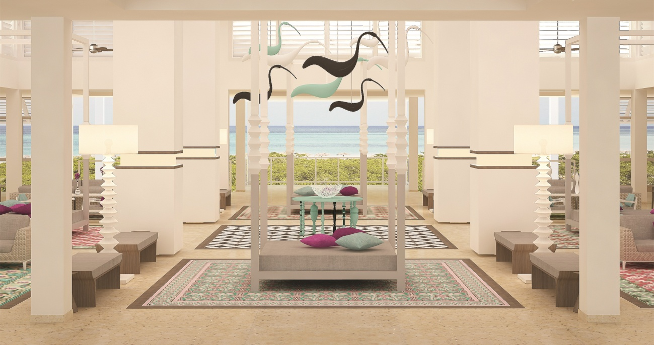
Click here to download the images in high definition

Cayo Santa María is an increasingly popular tourist destination in the UNESCO Biosphere Reserve of Buena Vista Bay, a natural paradise with stunning white sandy beaches and crystal-clear waters. This island also hosts a large diversity of endemic plants and animal species.
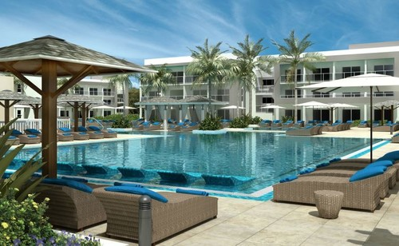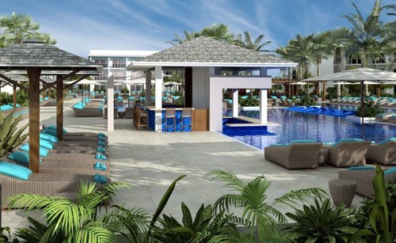

Decorated with an elegant, modern design that reflects the natural environment, this complex is arranged around two large swimming pools and offers beautiful views of the sea and the surrounding landscape as well.

Rooms:
The Ocean Casa del Mar has 800 bright, spacious rooms. All of them have a balcony or terrace and are equipped with all the services you need for the most pleasant stay: LCD television with international channels, coffee machine, minibar, safe box, air conditioning, ceiling fan and fully-equipped bathroom.

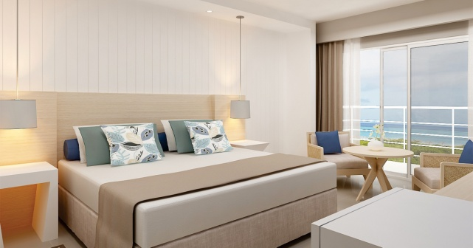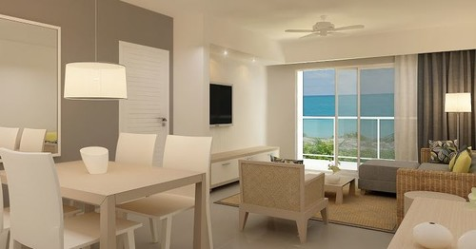
Deluxe Ocean View Room Suite / Lounge
The newly-build five-star Resort, offers Deluxe Rooms, Privilege Rooms, spectacular Suites and the Privilege Suites that include lounge, toilet, fully-equipped bathroom with Hydro-massage Bath, shower and each one with a magnificent view.

Dining options:
The Ocean Casa del Mar has several restaurants and bars. Its eight restaurants, six of which are à la carte, serve different types of cuisine: international, Italian, Asian, Mediterranean, Cuban and fish and seafood. They include El Ranchón Playa Concha Restaurant, near the beach, El Cocotal Restaurant, with themed evenings, and the Blue Moon Restaurant for over-18s, the ideal place for a romantic meal.

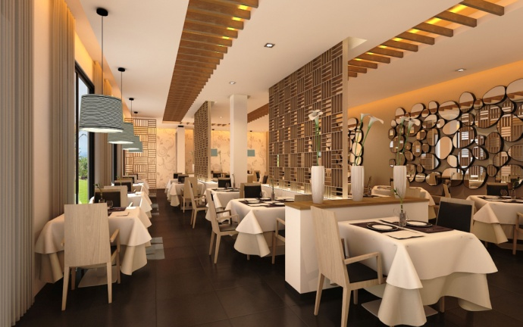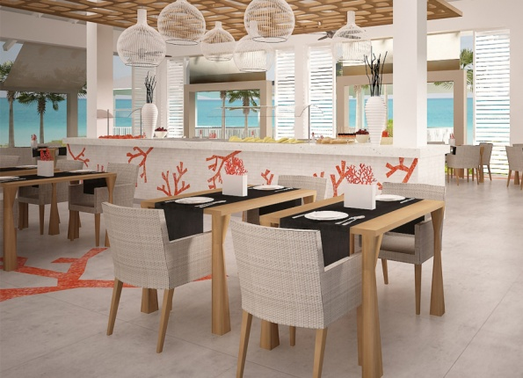
Blue Moon Restaurant / El Ranchón Playa Concha Restaurant

The resort has ten bars spread around the complex, one of them, Mike’s Coffee, serves speciality teas, coffees and homemade cakes. Three of these bars have spectacular settings: two in the pool and one on the beach.

Special services:
“The Ocean Casa del Mar always committed with its clients comfort, offers Ocean’s Privilege Service, for those in search of an extra touch of exclusivity, with always the best rooms, great views and special services” says Oscar Serrano, Vice President Sales & Marketing for Ocean by H10 Hotels. The Privilege Rooms includes a free hour of Wi-Fi per room during the stay, a table reserved in restaurants and exclusive amenities. Guests can also enjoy the Privilege Lounge, which serves premium brand wines and spirits and à la carte breakfasts and evening meals.

Entertainment:
The resort is designed to ensure a great and sound rest or a great time adventure on your spare time.Children amusement is also one of our priorities; this is why we have children’s pool and paddling pool, a games area and the Daisy Club entertainment program. For adults, the Ocean Casa del Mar offers a full program of sports and other activities organized by its team of entertainers, the Blue Team. The Ocean Casa del Mar also include services like theatre, fitness centre, Wi-Fi throughout the hotel, an internet corner and free outdoor parking.

The opening of the Ocean Casa del Mar gives the chain a total of four resorts and 2000+ rooms in Cuba. Ocean by H10 Hotels already has two hotels in Varadero, the Ocean Vista Azul (opened in December 2015) and the Ocean Varadero El Patriarca, and another one in the capital, the H10 Habana Panorama. All four resorts belong to the Gaviota Group and are managed by H10 Hotels.

OCEAN CASA DEL MAR *****
Cayo Santa María
52610 Municipio Caibarién
Villa Clara Province, Cuba
www.oceancasadelmar.net

About Ocean by H10
Ocean by H10 Hotels was founded in 2007 as a joint venture between Spain-based H10 Hotels and Vacances Air Transat, a leading Canadian tour operator and charter carrier. The company currently operates resorts in Mexico, the Dominican Republic and Cuba
For more information on Ocean by H10 Hotels or to make a reservation, go to www.oceanhotels.net or call 1-888-531-8927 from within the U.S. and Canada.
To download high-resolution images please CLICK HERE
For further information contact:
Press contact: Elsie Mendez pr@marketingzentral.com
Ocean by H10: David Muñoz marketing@oceanhotels.net

