POPS! Diabetes Care Raises $500K to Improve Diabetes Management

Minneapolis, MN / February 26, 2016

POPS! Diabetes Care – a 2015 MN Cup Finalist – has completed a half-million dollar capital raise led by TreeHouse Health, an innovation center designed to invest in emerging healthcare companies and help accelerate their growth. POPS! is creating a new diabetes care model for improved outcomes. The funds are being used to further develop a mobile solution for patients to better self-manage, and for healthcare providers to efficiently expand their reach to patients.

Using smartphone technology, combined with a glucose-testing device connected to the back of the user’s smartphone, POPS! Diabetes Care is creating a unique, simple testing experience that 90% of patients report as less painful. “Too many diabetic patients are experiencing multiple complications as a result of poor glucose control,” said Lonny Stormo, CEO of POPS! Diabetes Care. “Our investors are enabling a major change through empowering patients to better self-manage their condition and create a new type of engagement from their support.”

Globally, 387 people are living with diabetes and millions of blood glucose tests are performed each day. Monitoring blood sugar throughout the day is a vital tool to control diabetes, and yet 75% of diabetes costs are due to complications from poor glucose control. Mobile and personalized healthcare is part of the solution. Diabetes management care represents the biggest market for mobile health apps in the coming years, according to data from Research2Guidance (2014). “Patients often have difficulty knowing and managing their blood glucose throughout the day,” said Victor Corbett MD. “This system will enable patients to test more reliably and provide me with a more complete picture of their glucose management.”

About POPS! Diabetes Care

Founded in 2010, POPS! Diabetes Care is creating a new, personalized healthcare model of blood glucose management for patients. Novel innovations simplify glucose testing for patients, making them more likely to complete the rigors of daily testing. Smart devices will enable patients to use their data to better manage their condition. Cellular connectivity will enable the results to be shared and reviewed by care providers who can easily note issues or trends and take the appropriate action before problems arise. This product is not yet FDA approved.

To learn more about POPS! Diabetes Care, please visit www.popsdiabetescare.com.
For more information, email Kari Kahl at karikahl@comcast.net.

About TreeHouse Health LLC
TreeHouse Health, established in 2013, is an innovation center that helps emerging healthcare companies accelerate their growth by facilitating collaboration with Anchor Tenants while simultaneously providing investment, expertise and guidance around business development and brand exposure. To date, TreeHouse Health has invested in ten early-stage healthcare companies and has two Anchor Tenant relationships with Hennepin County Medical Center (HCMC) and Blue Cross and Blue Shield of Minnesota (BCBS). To learn more, visit TreeHouse-Health.com.

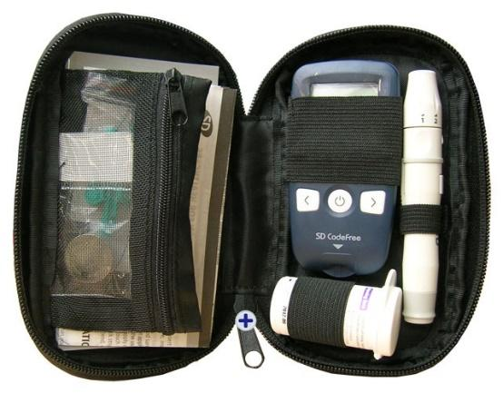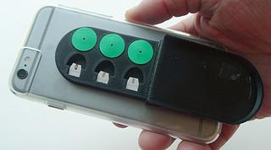

Traditional Testing Kit POPS! SmartMeter

Click HERE for a video demonstrating how the device works.

Related Links:
Twin Cities Pioneer Press, Stillwater Startup Tackles Smartphone Diabetes Testing, Julio Ojeda-Zapata, 2/3/16
"Inside Health Care” with Jodi Ritacca, 2/2/16
Stillwater Gazette, Stillwater Startup Works to Improve Diabetes Care, Alicia Lebens, 1/10/16

##

DISCLAIMER: This device has not been evaluated, cleared or approved for use by the FDA, and is not for sale in the US. Safety and effectiveness have not been established.

