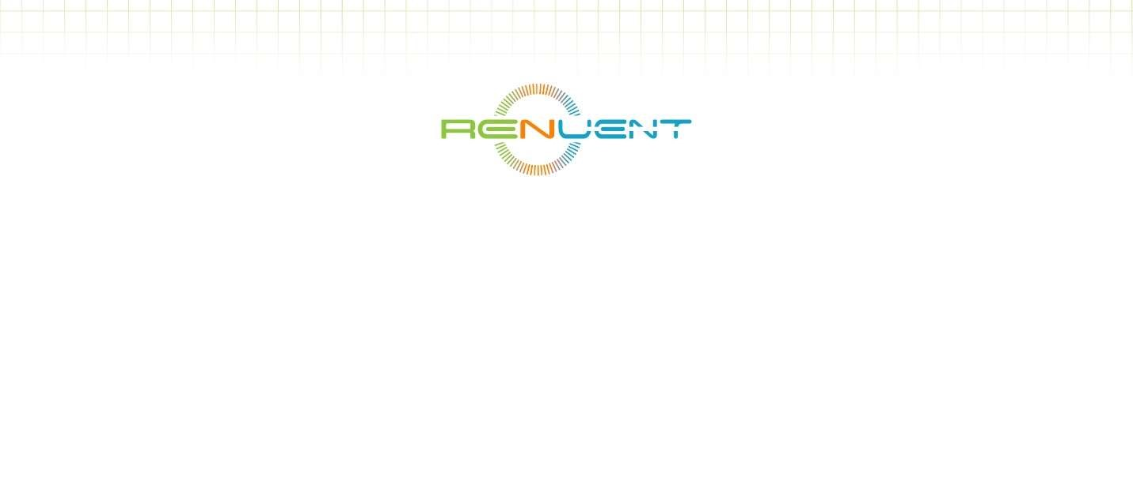

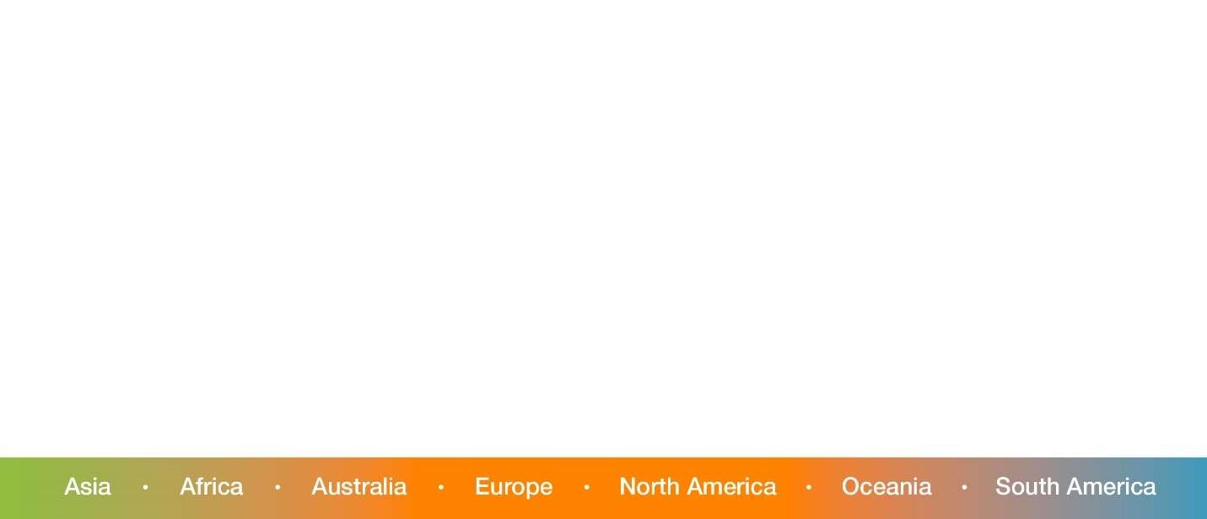
People everywhere want to be healthy and live in clean environments. Diseases come from microbes, insects and other pests. There is a need to deal with these without the negative effects that current practices bring – environmental poisoning, toxicity for people, animals and plants, the need to retreat and reapply frequently and MOST IMPORTANTLY, creating resistant varieties of these pests that require stronger, and more toxic chemicals to compete.
The Solution: Renuent Group Worldwide
…a Service Company specializing in application of eco-responsible, ultra-low toxicity, nonmutagenic technologies to control microbes and insects, in agriculture, commercial, hospitality, institution, medical, and transportation markets.
Opportunity
Antimicrobial supply companies including Katan Technologies, Salvis and Duraspada recommend Renuent cleaning, disinfection, protection and pest control services for those clients who do not have the expertise or staff in-house. Additionally, the cost of electrostatic and specialized sprayers, often the preferred and most effective form of application, is a cost that clients do not want to bear for equipment that will only be used on a quarterly or semi-annual basis
.
Application of these technologies is a specialized process that requires training and knowledge of how each product works and this expertise is often not easily available or communicated to the client’s work staff. Most importantly, incorrect application can reduce the effectiveness of the treatment and create a bad impression with clients. To overcome these issues, clients use Renuent’s services.

Products
One of Renuent signature products is a broad-spectrum antimicrobial based on cutting-edge bionanotechnology that continuously kills for up to one month or longer with just one – a level of sustained antimicrobial protection which management believes to be superior to comparable products available in the marketplace. Another product is a FDA-approved, food-safe rapid kill antimicrobial Other products organic soap, detergents and cleaners; a long-lasting hand sanitizer and a revolutionary cleaner+disinfectant+protector in one. In addition, Vectorcide Pty Ltd. Renuent USA Pte. Ltd has access to a proprietary, long-lasting insecticide that has proven efficacy against a very wide array of insects and pests. The unique advantage of these formulations is a low-toxicity, food-safe, long-lasting insecticide with proven efficacy of over two years against mosquito vectors responsible for malaria, dengue fever, and West Nile virus. Additionally, durable treatment against bed bugs is proving to be a rapidly growing commercial opportunity
.
A key benefit of the product range is that it is water-based and Shari’ah- and Kosher- compliant providing a significant advantage in markets where this positioning is of significance. For example, the USA, Canada, Brasil and Argentina have very large export contracts for food and agricultural products to the Middle-east and Asia where such compliance is not only an advantage, but often a prerequisite for contracts or sale.

Renuent Group Worldwide has a proven two-phase mosquito eradication and management protocol system. Phase one is to spray and fog predetermined high risk areas while simultaneously implementing phase two, which adds our proprietary time-released pellets. In this way we manipulate the life cycle of the mosquito larvae, by immobilising them using time-released nano technology to prevent the larvae from maturing into adulthood. This practice renders the mosquitoes impotent.

Contact information: Renuent@yahoo.com

