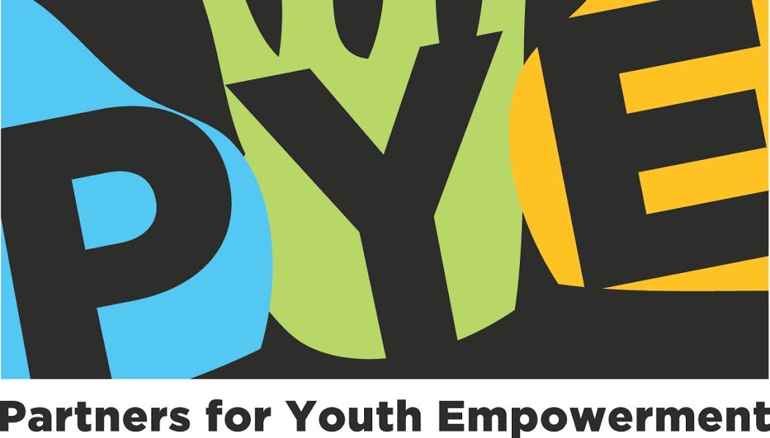

**ABOUT PARTNERS FOR YOUTH EMPOWERMENT (PYE GLOBAL)**

Around the world, PYE trains community leaders, youth workers, mentors, educators, executives, artists and others who lead groups to ignite creativity for increased impact. The aim is to create rich, transformative environments that unlock potential and leadership across generations. In 2015, PYE and partners trained over 3,700 practitioners in eight countries. As a result, over 220,000 young people were inspired to become collaborative leaders and proactive contributors to thriving communities. Learn more at [pyeglobal.org](http://www.pyeglobal.org).