Skyline Eco-Adventures Awarded #1 Zipline Company in Hawaii for 2016
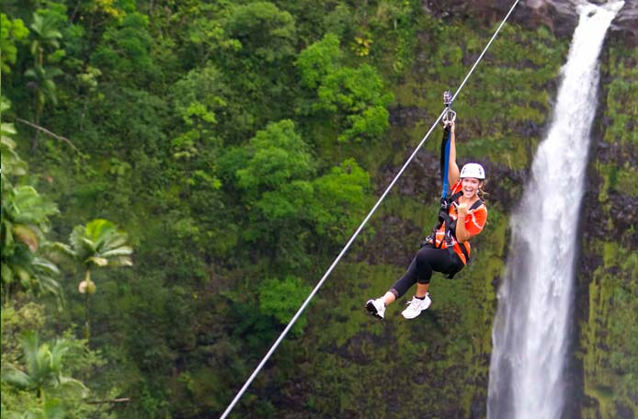
MAUI, HAWAII (March 14th, 2016) – Skyline Eco-Adventures, Hawaii’s award-winning zipline company and operator of the first zipline course in the United States, has been awarded the #1 Zipline Company and the #1 Land Activity/Adventure Tour Company in Hawaii for 2016 by Hawaii Magazine’s fourth-annual Best of the Best Reader’s Choice Awards. This is the fourth year in a row that Skyline has been awarded the #1 Land Activity/Adventure Tour Company in Hawaii and the third year in a row Skyline has been awarded the #1 Zipline Company in Hawaii.

Featured in the March/April 2016 issue, Hawaii Magazine tallied thousands of reader’s votes in 98 categories for Hawaii’s “Best of the Best” in hotels and resorts, places to eat and shop, activities, attractions, and more.

Skyline Eco-Adventures earned three No. 1 rankings for 2016:
- No. 1 Zipline Company in Hawaii
- No. 1 Zipline Course in Hawaii: Skyline Akaka Falls, Big Island
- No. 1 Land Activity/Adventure Tour Company in Hawaii

Skyline’s Award Winning Big Island Akaka Falls zipline tour features 7 amazing ziplines with a line that soars over a 250’ waterfall, Kolekole Falls.

Last summer and fall, the magazine polled thousands of its mainland U.S., Hawaii and international readers, asking them to share their selections. More than 100,000 picks were tallied and compiled into the magazine’s Readers’ Choice Awards lists, covering more than 98 categories – from best Hawaii hotels and resorts, beaches, indoor and outdoor activities, to scenic road trips, fashion designers, and coastlines. Hawaii Magazine is published bi-monthly, reaching subscribers around the globe with stories that explore the best of Hawaii.

Skyline Eco-Adventures is a leading commercial zipline company that thrills more than 90,000 guests annually with “knock-your-socks-off” experiences. As the first commercial zipline operator in the United States, Skyline operates three Maui zipline tours at Ka‘anapali and Haleakala, in addition to the Akaka Falls Skyline Adventure on Hawaii Island, and the Poipu Skyline Adventure on Kauai. Call (888) TO-GO-ZIP or visit www.zipline.com.

###

