Texas releases the new Classic Black license plate!

21 March 2016 (Austin, TX) – For the first time since 1968, a full black background license plate with white lettering is now available on the streets of Texas. My Plates, the official license plate vendor for the state of Texas proposed the Classic Black plate design for TxDMV Board approval last November. Following a unanimous approval, My Plates then had to reach 200 pre-orders in order to move the plate to production and final release.

My Plates reached the 200 pre-orders in record time and the Classic Black plate is scheduled to have the first Classic Black plate order manufactured this week, so it will not be long before these plates are being seen on Texas roads.

“We’ve received over 1400 orders for this plate, more than any other design on record, it has already proven to be very popular” said Steve Farrar, President of My Plates. “We expect this new Classic Black design to be Texas’ most popular license plate,” he said.

The last time a full black plate was available in Texas was in 1968 as a general issue pattern. Since that time, Texas has moved to a number of other designs with the most recent being the full white plate with black lettering.

Texans will start seeing the new Classic Black plate vehicles this week.

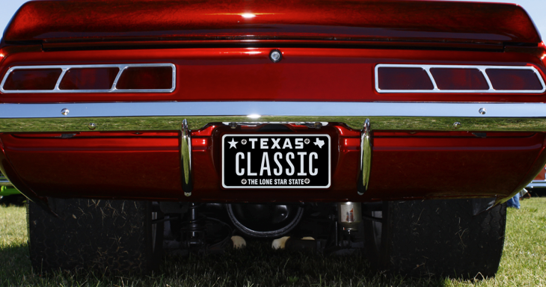

In other news, My Plates recently auctioned the license plate message ALAMO to celebrate Texas’ Independence Day. This unique plate was sold at auction for $10,250.00 with proceeds benefitting both the Alamo Endowment Fund and the state General Revenue Fund. My Plates is donating their share to the Alamo Endowment Fund.
____________________________________________________________

Image download: Classic Plate on car:
https://ce9a9387e1bc258c3cfa-af7906f4e771b24864bbfa3048e4a635.ssl.cf2.rackcdn.com/ClassicCarImage.jpg

Image download: Classic Plate
https://ce9a9387e1bc258c3cfa-af7906f4e771b24864bbfa3048e4a635.ssl.cf2.rackcdn.com/ClassicBlack.jpg

My Plates designs and markets new specialty license plates as a vendor for the Texas Department of Motor Vehicles. Texans have bought more than 260,000 My Plates since November 2009, putting more than $37M in the state general revenue fund. My Plates’ goal is to create a long-term, mutually beneficial relationship designed to maximize revenues for the state through the sale of My Plates specialty plates. www.myplates.com.

The Texas Department of Motor Vehicles (TxDMV) serves protects and advances the citizens and industries in the state with quality motor vehicle related services. For every $1 it spends, the TxDMV returns $11 to the state. Each year the agency registers nearly 24 million vehicles; issues more than 7 million vehicle titles; licenses more than 38,000 motor vehicle dealers and distributors; credentials nearly 60,000 motor carriers; issues more than 800,000 oversize/overweight permits; investigates more than 15,000 complaints against dealers and motor carriers; and awards grants to law enforcement agencies to reduce vehicle burglaries and thefts. Learn more at www.TxDMV.gov.

Contact Steve Farrar at (512) 633-7978 or steve@myplates.com

TERMINOLOGY

-“Specialty” plate refers to any official license plate other than the state’s general issue plate.
-Specialty plates can be “personalized” plates, but they don’t have to be.

