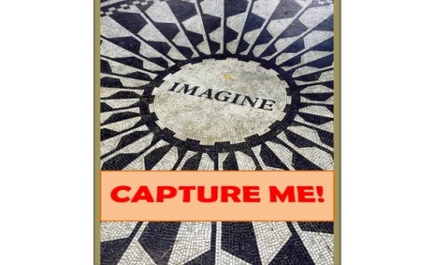  www.CaptureBookstore.com  - Hard Cover published March, 2016, Mister B charms the bejeebies out of the Great Generation memoir! Male friendly, yet reminiscent of Mayberry, mushroom collectors also delight in Polish practices. Lovers of life inspiration become devoted to Mister B honors NASA, Lockheed, Martin Marietta employees, celebrating their scientific roles.  - FREE copies to: Social Studies and math teachers who promote this book to their students on www.CaptureBookstore.com .  - Active with Google Adwords, & radio interviews, Capture Books and the author, Lynn Byk, are actively promoting :“Countdown to 100” year on on social media.  - Mister B is gaining excellent book reviews on Amazon!  - Author speaks publically and online to aging concerns.  - Lynn Byk is promoting in local print media, presenting at book club events & sending copies to book bloggers for reviews.  - Radio interviews are airing on talk radio and Salem Radio.  - We are committed to content marketing. Ingram, IBPA, HARO and PRWeb media. | ^{HONEST-TO-GOODNESS BOOKS}  Lynn byk  M.I.s.t.e.r Bᴥ  March 25, 2016  Classification: LCC HQ1063.6 .B95 2016 (print) | LCC HQ1063.6 (ebook) | DDC 306.8740846-dc23 | BISAC HUM011000 HUMOR / Marriage & Family A. Lynn Byk’s hilarious memoir: MISTER B. Living With a 98-Year-Old Rocket Scientist. (hard cover) ISBN 0997162503 (Print) Ingram 9780997162509 www.CaptureBookstore.com ISBN: 13: 9781516845293, (eBook/ePub) ISBN: 978-0-9971625-1-6 Pages: 352 $34.99, Hard Cover, Ingram $19.99 Amazon $2.99- $9.99 Kindle with 50 historic photos LCCN: Aging/Family/Humor Aerospace/Philosophy  Phone: 720.210.7107 5856 S. Lowell Blvd, Suite 32-202, Littleton, Colorado 80123  Lynn Byk offers timely subject matter for adult children taking care of parents and grandparents. With aging couched in the pillows of wit and kindness, MISTER B inspires us to learn from history, to give a little more to family relationships, and to seek scientific answers to life’s little perplexities. MISTER B rolls through controversies of old age with comedy appealing to a variety of social circles.  The LCCN/PCIP puts MISTER B onto shelves with aging older men or family humor. A fully discounted and returnable print book through Ingram, MISTER B reads much like Tuesdays With Morrie ISBN:76790592X and Forrest Gump ISBN:0385231342 and Mayberry. (See Library Works & LJ) Is there is room on your library shelf for the landmark events of a 98-year-old stress engineer? If so, I will send you one free copy of MISTER B.  Laura Bartnick  Publishing Agent, Capture Books  CONTACT: Lb.CaptureBooks@aol.com

