Association of Pediatric Hematology Oncology Educational Specialists

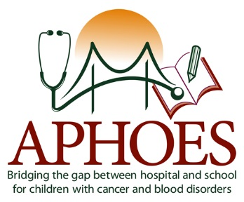

Endorsement of Psychosocial Standards
News – The Association of Pediatric Hematology Oncology Educational Specialists (APHOES) has endorsed the Standards for Psychosocial Care for Children with Cancer and Their Families published in the 2015 December special issue of Pediatric Blood & Cancer. The 15 Standards of Care developed by pediatric oncology psychosocial professionals provide critical justification for comprehensive psychosocial care, including dedicated educational support for pediatric patient populations. The evidence-based standards align with the APHOES mission to standardize methods, provide support, and encourage research for the purpose of improving educational outcomes for children with cancer. Broadly, the Standards of Care establish a valuable framework for providing psychosocial support along the continuum of care beginning with diagnosis through survivorship or end of life.
Mary Kay Irwin, EdD, Chair of APHOES and Megan Elam, EdD, Chair of the APHOES Legislative Committee represented the educational expertise in this important project. Irwin and Elam were both invited authors and collaborated with other multidisciplinary psychosocial experts in the development of the Academic Continuity and School Reentry Support Standard of Care.
APHOES commends the work and commitment of the Mattie Miracle Cancer Foundation as the driving force behind the conceptualization and development of the Standards or Care. In collaboration with the team of pediatric oncology psychosocial experts, Mattie Miracle intends to encourage the rapid adoption of the Standards in clinical sites across the country. APHOES is proud to officially endorse the Standards for Psychosocial Care for Children with Cancer and Their Families.
About APHOES:
The Association of Pediatric Hematology Oncology Educational Specialists is a professional, multidisciplinary organization dedicated to addressing the educational needs of pediatric hematology and oncology patients. APHOES membership is inclusive of a wide range of disciplines such as nursing, psychology, social work, child life, school and hospital-based education, and medicine.

