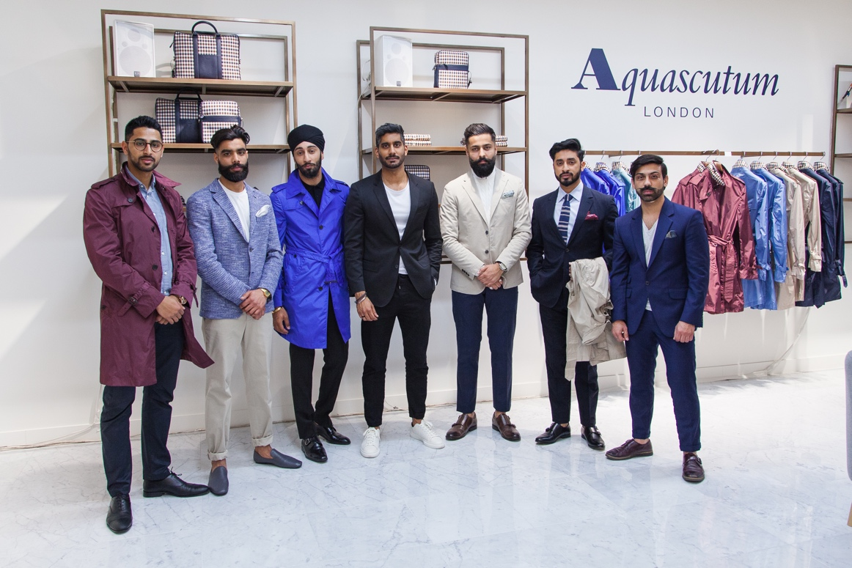

ONLINE FASHION MAGAZINE ENTOURAAJ.COM COLLABORATES
WITH LUXURY BRAND AQUASCUTUM

British heritage brand partners with Asian men’s online magazine
[London, 8 April 2016] Last Thursday men’s online fashion magazine Entouraaj.com took a Westfield store by storm with an exclusive event for their readers. Joining forces with luxury clothing brand Aquascutum to ‘define the smart-casual look’, the evening comprised of drinks, networking and shopping.
Given the full Entouraaj treatment, the store was filled with some of the style site’s best dressed and most devoted readers. The event treated guests to a private shopping experience and offered up a generous discount on Aquascutum clothing. Taking place in Westfield London’s most elegant and elite quarter, The Village, the evening was truly a celebration of fashion, style and glamour.
Proving British Asians are as stylish as their white counterparts, the store teemed with sartorial wit. The evening showcased Aquascutum’s luxury, heritage clothing on four lucky readers, who were chosen as Entouraaj’s ambassadors for the evening. Styled in the men’s spring/summer range, the group become real-life models for the brand’s signature looks. Sharp suits, smart knitted jumpers and tailored trousers featured in each of the outfits; topped with an Aquascutum essential, the trench coat, selected from the brand’s latest Voyager range.
Following the drinks reception, presentations were given by stylists Saran Kohli (Entouraaj) and Paul Higgins (Aquascutum). Discussing the ambassadors’ outfits in detail, the fashion-conscious audience was even treated to an exclusive insight into next season’s trends. With fashion and elegance being the order of the evening, the

speeches constructively informed guests on how to piece outfits together while maintaining Aquascutum’s signature style.
This collaboration follows Entouraaj’s successful partnership with Duchamp London, last year. Founder of Entouraaj.com Gary Singh says of the evening:

“Entouraaj is an inclusive brand, not exclusive. While our readership is primarily stylish British Asian gentleman, we welcome participation from all backgrounds. Partnerships with prestigious brands such as Aquascutum are important because it allows British Asians to explore and express their style in a unique environment. In addition to this, our collaborations ensure luxury and fashion brands gain visibility in previously untapped communities.”
-ENDS-
For further information, images or interviews, please contact:
Gary Singh: garysingh@entouraaj.com 07830 124470

