Press Release Contacts:
For Immediate Release Vinitaly International
International Media Dept.
+39 045 8101447
media@vinitalytour.com
www.vinitalytour.com
Twitter: @VinitalyTour
Join Vinitaly International Network on LinkedIn

Why is Vinitaly International So Obsessed with Native Grapes?
Part III: The Vinitaly International Academy

Friday in Verona, the Vinitaly International Academy (VIA) concluded its second Italian wine certification course, an initiative launched in 2015 to educate wine professionals in the finer points of Italian varietals. Graduates of the course, Italian wine “Experts” and “Ambassadors” are able to return to their home markets and help develop the caliber of Italian wine culture around the world.

“We still have experts today who regularly confuse Prosecco and Franciacorta, and this is a situation that must change,” says Dr. Ian D’Agata, the Scientific Director of VIA, whose Native Wine Grapes of Italy is considered the “bible” of Italian grapes and wines. “That’s not good for Italian wine or Italian wine producers.”

The first edition of the course, in 2015, welcomed 55 candidates, 26 of whom passed the extremely rigorous written test to become Italian Wine Ambassadors. Several candidates re-sat the exam, eventually yielding a total of 32 Italian Wine Ambassadors, and 3 Italian Wine Experts, who passed a blind tasting test. Despite a pass rate below 50%, the course is already in high demand; this year’s edition included Master of Wine candidates, Master Sommelier candidates and sommeliers working in three Michelin star restaurants.

This year, 25 of the 57 candidates passed the written test to become Italian Wine Ambassadors, though none have yet succeeded in achieving the distinction of Expert. The newly minted Ambassadors will return to their home countries of Canada, China, Brazil, Venezuela, Hong Kong, Russia, France, the UK and the US, armed with a new depth of knowledge of Italian wine, and in particular, Italian native grapes.

This specialization is what sets the course apart from other wine certification courses, as Lin Liu, a Master of Wine student who works as a wine writer and export manager in France, explains, “The difference between VIA and MW is a matter of depth vs breadth; Master of Wine covers everything, and it’s very mainstream. This course also takes on the project of promoting and preserving interesting traditional varieties – like protecting a part of our civilization. The work that Ian D’Agata and VIA are doing is very inspiring, and it’s great to gain more information about the diversity of Italian wines.”

Liu passed yesterday’s exam to become an Italian Wine Ambassador, as did Roddy Ropner, a Hong Kong based wine merchant and wine educator. “One of the reasons I wanted to join the course is that compared to WSET or MW courses, it is much more detailed. What makes the course most interesting that it’s taught by Ian D’Agata, because he’s the walking encyclopedia of Italian native grapes. Hong Kong is a place with a huge wine culture, but we only really get the chance to taste the big name wines like Brunello Chianti, Barolo, and Barbaresco - we don’t get to taste the Grignolinos and Freisas. The most useful aspect of the course is that Ian shows us benchmark wines, so we have an idea of what Grignolino is supposed to taste like, and we can identify an adulterated version that we might find in some of our markets.

“As of this year, we have trained 60 Italian Wine Ambassadors and Experts, ready to educate their own communities,” says Stevie Kim, Managing Director of Vinitaly International. Through those ambassadors, VIA plans to launch a basic wine education program – Italian Wine Professionals – in 2017, which will be tested in the US, China and Canada this fall. The goal is that by 2019, the VIA will have trained 200 Ambassadors and Experts around the world, ready to spread the gospel of Italian wine.

The new course is being developed along with the three VIA Italian Wine Experts: Michaela Morris (Canada), Lingzi He (China) and Geralyn Brostrom (USA).

“We want to make this into the gold standard for Italian wine learning. Ian’s grape approach is very innovative and cutting edge- what he’s teaching is new for many Italian wine lovers,” says Lingzi He, who explains the value of the course in foreign markets: “Many indigenous Italian grapes are foreign even in very mature markets like the US and Canada, let alone China. I think the Chinese market is now very excited to learn about other countries and their wine. So when we come with a varietal approach, I think they’re ready and very open to this idea, and it gives a strong structure to learn Italian wines in all their incredible diversity.”

This year’s new Ambassadors were presented Friday night at a pin ceremony at the inauguration of Vinitaly and the City, a fuorisalone celebration of music and wine in the center of Verona.

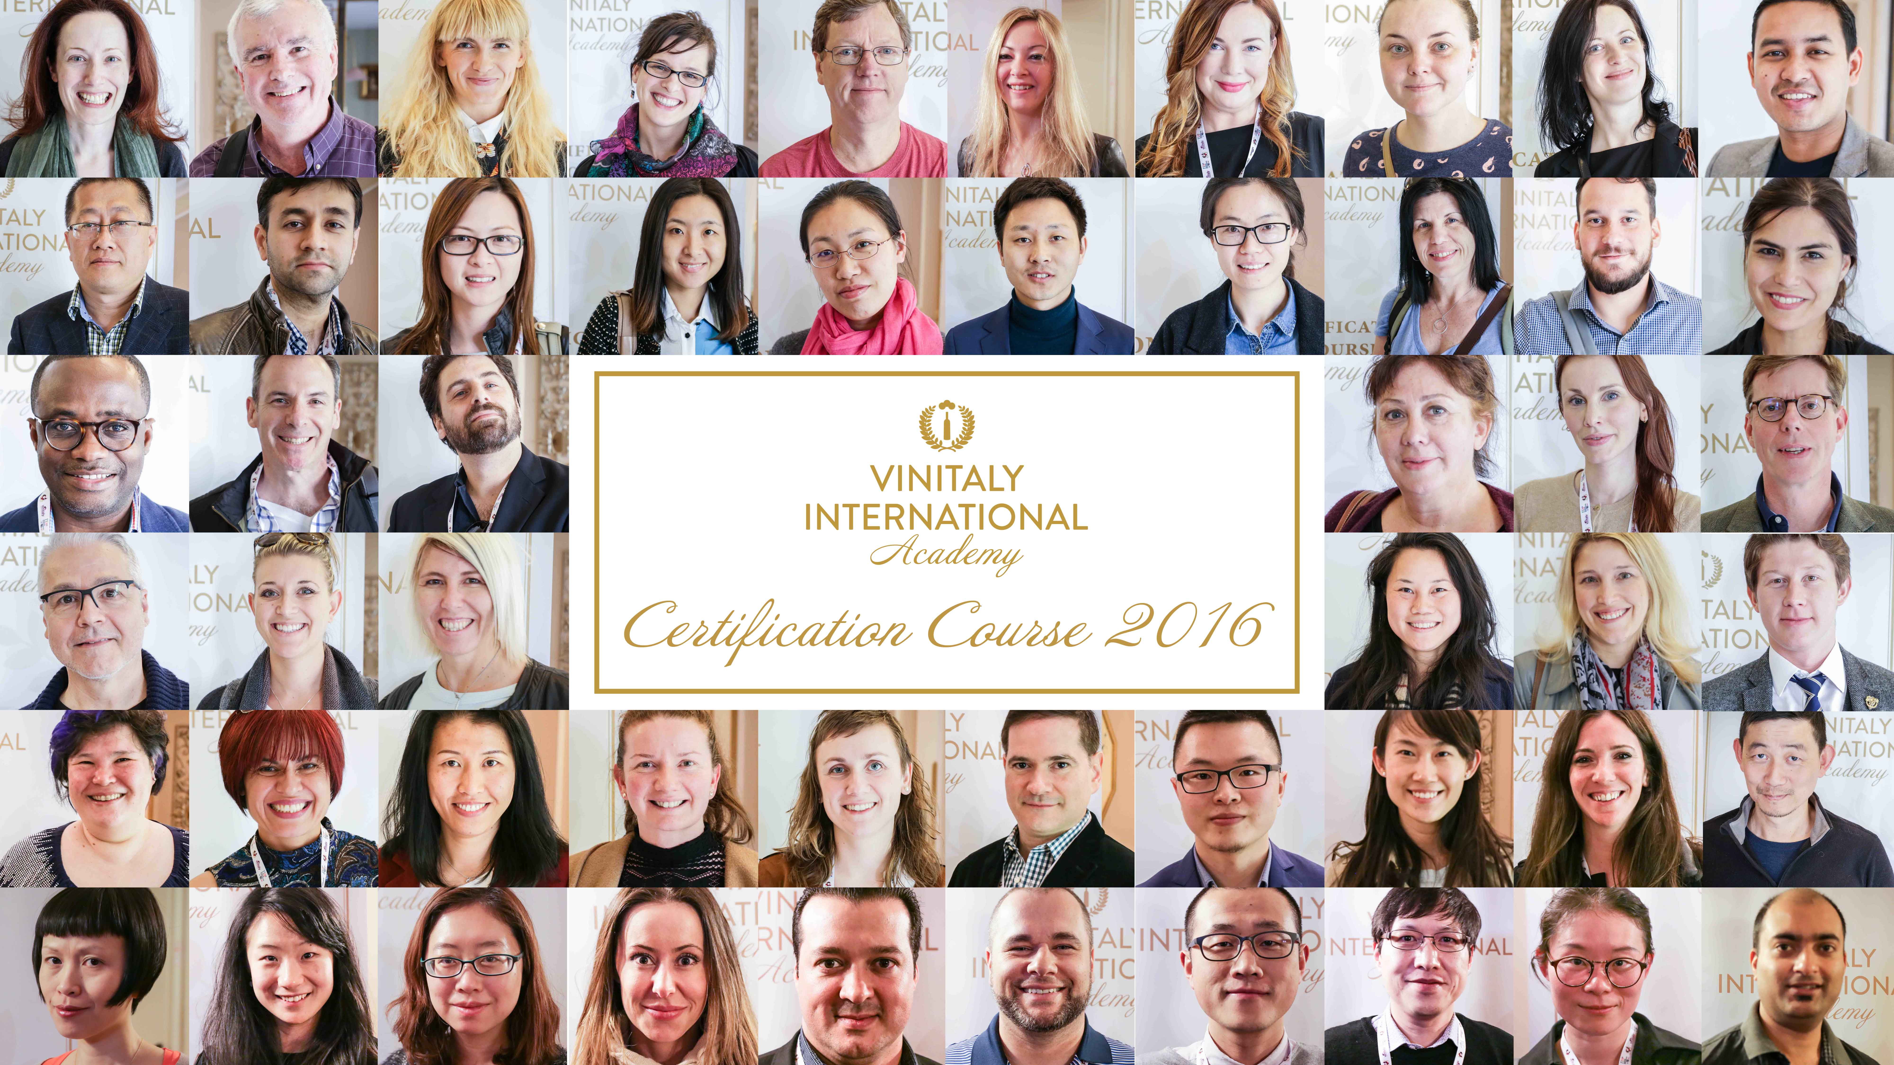

About:
Veronafiere is the leading organizer of trade shows in Italy including Vinitaly (www.vinitaly.com), the largest wine and spirits fair in the world. During its 49th edition Vinitaly counted some 4,000 exhibitors on a 100,000 square meter area and 150,000 visitors including 2,600 journalists from 46 different countries. The next edition of the fair will take place on 10 - 13 April 2016. The premier event to Vinitaly, OperaWine (www.vinitalyinternational.com) “Finest Italian Wines: 100 Great Producers,” will unite international wine professionals on April 9th in the heart of Verona, offering them the unique opportunity to discover and taste the wines of the 100 Best Italian Producers, as selected by Wine Spectator. Since 1998 Vinitaly International travels to several countries such as Russia, China, USA and Hong Kong thanks to its strategic arm abroad, Vinitaly International. In February 2014 Vinitaly International launched an educational project, the Vinitaly International Academy (VIA) with the aim of divulging and broadcasting the excellence and diversity of Italian wine around the globe. VIA has now also organized its very first Certification Course with the aim of creating new Ambassadors of Italian Wine in the World.
# # #

