Press Release Contacts:
For Immediate Release Vinitaly International
International Media Dept.
+39 045 8101447
media@vinitalytour.com
www.vinitalytour.com
Twitter: @VinitalyTour
Join Vinitaly International Network on LinkedIn

Surprise Musical Guest Sting Delivers “Message in a Bottle” at OperaWine

A surprise musical guest welcomed attendees at the press conference of OperaWine, the premier event of Vinitaly. Now in its 5th edition, “OperaWine, Finest Italian Wines: 100 Great Producers” offers invited members of the trade and press to get to know the wines of the 100 best Italian producers, as chosen by Wine Spectator Magazine. This year, those producers included British singer-songwriter Sting and his wife Trudie Styler, whose “Sister Moon,” an IGT Toscano produced at his 16th century estate Tenuta il Palagio was among the wines selected.

Managing Director of Vinitaly International Stevie Kim opened the press conference, underlining the fact that while OperaWine is the most exclusive event of Vinitaly, the wines themselves are not inaccessible. The wines selected come from all of Italy’s 20 regions, and include 60 different native grape varietals. Most notably, they represent an incredible value for the price; nearly 30% of the top 100 wines retail for an average of 30 euros or less. An analysis of the scores awarded to the wines reveals that consumers need not break the bank to enjoy outstanding Italian wines. “We don’t want to compete with French wines,” Kim explained. “In Italy the value you can get is amazing. This is the message we want to communicate.” (See attached chart for price/score analysis)

Thomas Matthews, Executive Editor of Wine Spectator, agreed. “Wine Spectator is the most widely read wine publication in the world, reaching one million online readers per week. The heart of our business is guiding people to good wines at a fair price, and Italy is a master at value for wine.”

After welcoming remarks by Maurizio Danese, President of VeronaFiere, and Dr. Ian D’Agata, Scientific Director of the Vinitaly International Academy, Sting treated an intimate audience to stunning renditions of two of his greatest hits, “Message in a Bottle” and “Fields of Gold.” Both Sting and Trudie Styler shared the story of their love affair with Italian wine, as a powerful social unifier. Sting told the crowd, “When we drink a glass of wine together we begin to talk - and it's only through talking that we create community.”

It was an auspicious beginning to the week’s events: “What a pleasure and what a gift to have a moment like that,” observed Stevie Kim. “It was very special for the 50th anniversary of Vinitaly.”

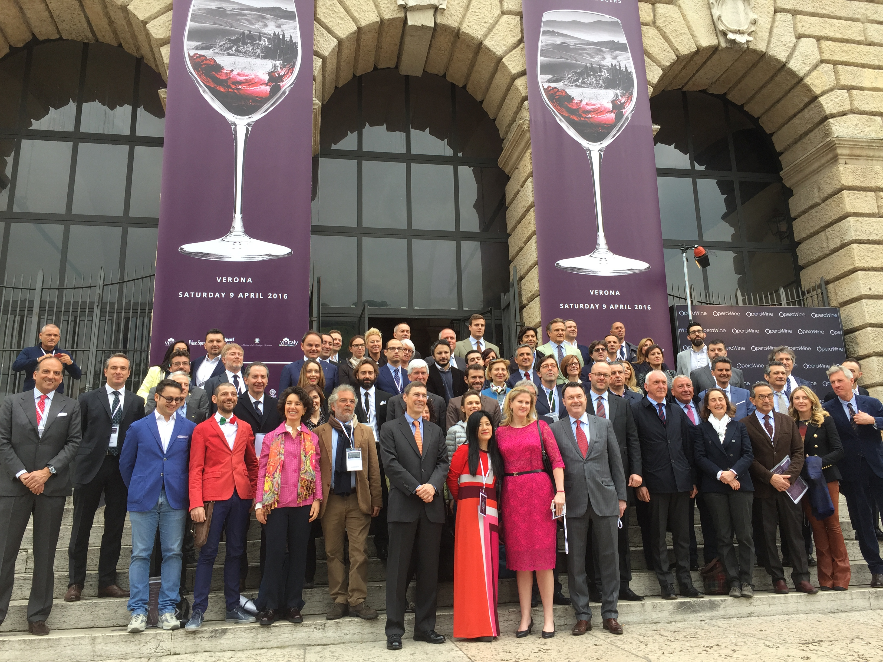

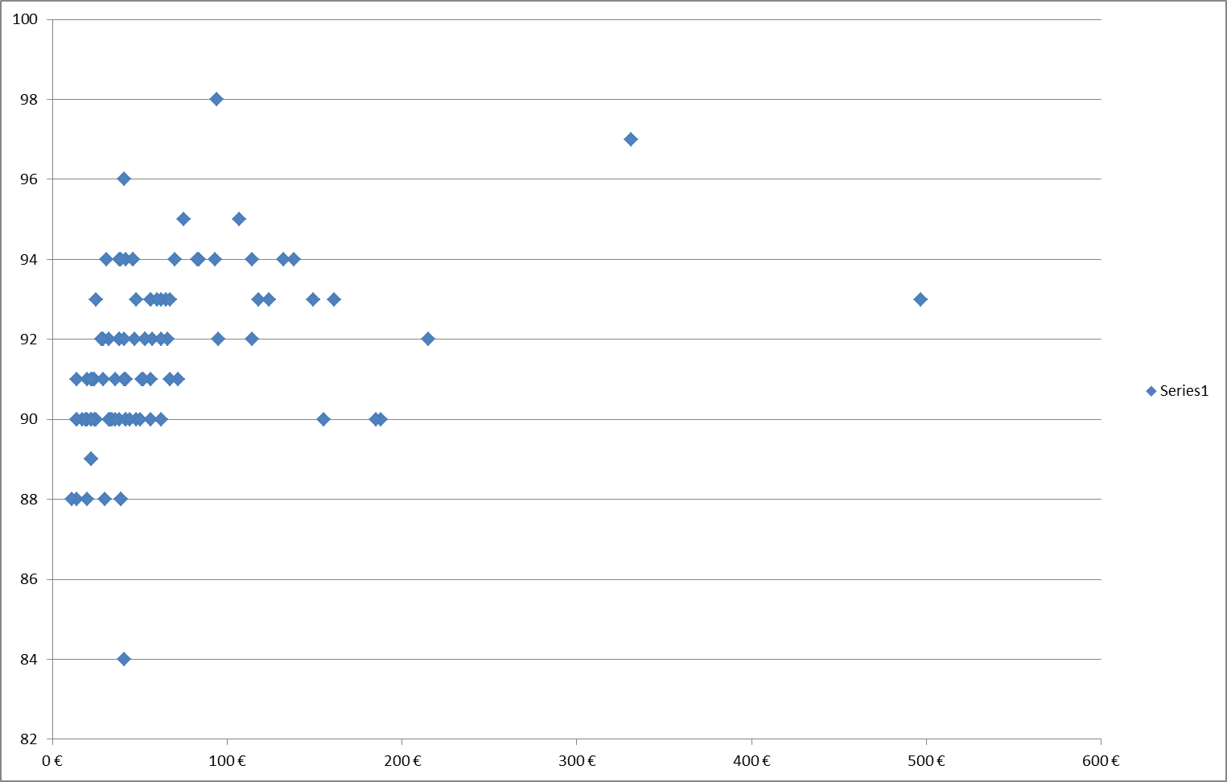
OperaWine2016, top 100 Italian wines score/price plot
About:
Veronafiere is the leading organizer of trade shows in Italy including Vinitaly (www.vinitaly.com), the largest wine and spirits fair in the world. During its 49th edition Vinitaly counted some 4,000 exhibitors on a 100,000 square meter area and 150,000 visitors including 2,600 journalists from 46 different countries. The next edition of the fair will take place on 10 - 13 April 2016. The premier event to Vinitaly, OperaWine (www.vinitalyinternational.com) “Finest Italian Wines: 100 Great Producers,” will unite international wine professionals on April 9th in the heart of Verona, offering them the unique opportunity to discover and taste the wines of the 100 Best Italian Producers, as selected by Wine Spectator. Since 1998 Vinitaly International travels to several countries such as Russia, China, USA and Hong Kong thanks to its strategic arm abroad, Vinitaly International. In February 2014 Vinitaly International launched an educational project, the Vinitaly International Academy (VIA) with the aim of divulging and broadcasting the excellence and diversity of Italian wine around the globe. VIA has now also organized its very first Certification Course with the aim of creating new Ambassadors of Italian Wine in the World.
# # #

