Press Release Contacts:
For Immediate Release Vinitaly International
International Media Dept.
+39 045 8101447
media@vinitalytour.com
www.vinitalytour.com
Twitter: @VinitalyTour
Join Vinitaly International Network on LinkedIn

Vinitaly at 50: Getting down to Business

As Vinitaly celebrates 50 years in business, Managing Director Stevie Kim has been on a steady campaign to expand the arsenal of business development tools under the umbrella of Vinitaly International – starting at the fairgrounds in Verona.

In addition to more than 4,100 exhibitors and an intense calendar of tastings and seminars, this year Vinitaly brings in an international delegation of nearly 1000 buyers from 30 countries. The ICE-Italian Trade Agency has collaborated with Vinitaly to invest heavily in the incoming program, in order to enhance the presence and prestige of Italian wine in foreign markets. Visitors will be able to taste wines and meet producers from all 20 of Italy’s regions; specialty areas include the VinInternational pavilion with wines from around the world, VinitalBio with organic wines, and ViViT (Vigne Vignaioli Terroir), an area dedicated to natural wines made by independent winemakers.

Wine consumers, conversely, are drawn to the city center by the “fuorisalone” format of Vinitaly and the City, a series of tastings, concerts and seminars designed to bring wine lovers out of the expo halls and into the heart of Verona, with a full calendar of events from April 8-11: http://www.vinitaly.com/en/vinitaly-and-the-city/. Wine may be the focus of the celebration, but the agenda has something for everyone: Piazza dei Signori hosts djs and live concerts; Piazza Arsenale showcases organic wine and street food; and departing from Piazza Bra, visitors can choose from 8 walking tours of Verona’s historic sites and enjoy food and wine tastings along the way.

Back at VeronaFiere, producers and visitors to Vinitaly alike will be encouraged to remain out at the booths tasting – and buying – wine, since the most important business-focused seminars have been shifted away from the annual April mega-fair and into a new Vinitaly International initiative, wine2wine. Stevie Kim is working to make wine2wine the established definitive wine business forum. Last year’s edition included over 2000 attendees, who participated in seminars and workshops on topics including law and finance, international markets and digital marketing. “All events focused on the business side of how to sell your wine is in December. We’ve organized it that way to help producers prepare for Vinitaly in April,” explains Kim.

With the creation of a dedicated, separate wine business forum, buyers at Vinitaly will be free to focus their attention on producers. “We are constantly working to come up with innovations to the standard wine fair program that will add value for our Italian producers,” says Stevie Kim. “And that includes growing the numbers of visitors from abroad, since overseas sales are crucial for growth of the wine market.”

The opening day of the 50th edition of Vinitaly had an especially official flavor, since for the first time ever the President of the Republic, Sergio Mattarella, was on hand to inaugurate the fair, together with Verona mayor Flavio Tosi, president of the Region of Veneto Luca Zaia, and Minister of Agriculture Maurizio Martina. Guests included the US Ambassador John R. Phillips and the Consulate General Philip T. Reeker.

“The presence of the President of the Republic, Sergio Mattarella, for the 50th year of Vinitaly is a very important recognition for us,” says VeronaFiere President Maurizio Danese. In these 50 years Vinitaly has become one of the most well-known fairs in the world – an achievement made possible by the thousands of winemakers who have always believed in this exhibition as a way of increasing our economic growth, and most importantly, of elevating the Italian wine sector to the world stage.”

The official state presence will continue tomorrow when Prime Minister Matteo Renzi meets with Jack Ma, Executive Chairman of the Alibaba Group.

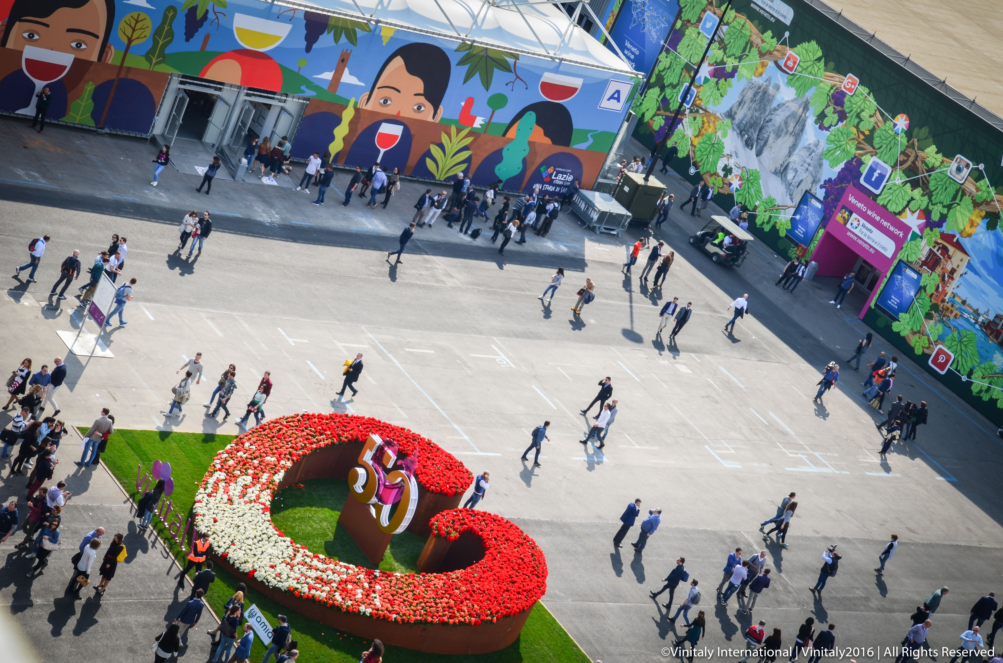

About:
Veronafiere is the leading organizer of trade shows in Italy including Vinitaly (www.vinitaly.com), the largest wine and spirits fair in the world. During its 49th edition Vinitaly counted some 4,000 exhibitors on a 100,000 square meter area and 150,000 visitors including 2,600 journalists from 46 different countries. The next edition of the fair will take place on 10 - 13 April 2016. The premier event to Vinitaly, OperaWine (www.vinitalyinternational.com) “Finest Italian Wines: 100 Great Producers,” will unite international wine professionals on April 9th in the heart of Verona, offering them the unique opportunity to discover and taste the wines of the 100 Best Italian Producers, as selected by Wine Spectator. Since 1998 Vinitaly International travels to several countries such as Russia, China, USA and Hong Kong thanks to its strategic arm abroad, Vinitaly International. In February 2014 Vinitaly International launched an educational project, the Vinitaly International Academy (VIA) with the aim of divulging and broadcasting the excellence and diversity of Italian wine around the globe. VIA has now also organized its very first Certification Course with the aim of creating new Ambassadors of Italian Wine in the World.
# # #

