Mister B.  Living with a 98-Year-Old Rocket Scientist  By A. Lynn Byk  Tip Sheet | 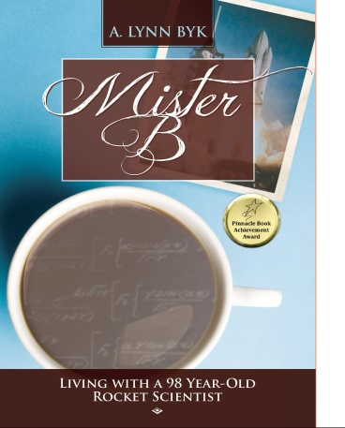
Formats: | Cloth hardcover /Trade pb mass market paperback/eBook ePub
Prices: | $36.99 hard cover / $23.99 perfect bound / $9.99 eBook/ePub
First Printing: | Yes
Ships: | Immediately and is Returnable in the U.S. and Canada
Trim Size: | 6 x 9 or 6.69" x 9.61" (16.993 x 24.409 cm)
Pages: | 420 cloth / 350 pb
Illustrations: | 25 autographed historic black and white photographs
Foreign rights: | Full global rights
Category:  Subjects:  Classification: | Aging Older Men / Family/memoir/ Humor/  Aerospace/WWII and Cold War  LCSH: Byk, Joseph John. | Aging parents-Family Relationships/ Engineers-Family relationships. | Older men-Family relationships. | Intergenerational relations.  LCC HQ1063.6 .B95 2016 (print) | LCC HQ1063.6 (ebook) | DDC 306.8740846-dc23 |  BISAC HUM011000 HUMOR / Topic / Marriage & Family
Capture Books ISBN: | (Hard Cover) 978-0997162561 Baker & Taylor  (Print) 978-0997162509 / eBook/ePub: 978-0-9971625-1-6

Keynote
When family members of a 98-year-old aerospace scientist decide to move into his home, becoming his caretakers, he determines to live forever taking them with him for the ride of their lives.

Positioning
Mister B offers us fast-paced, diary-styled, timely subject matter for adult children taking care of parents and grandparents. Book clubs will find a list of book club questions at www.CaptureMeBooks.com. Humorists and comedians can find samples and excerpts there as well.
With aging couched in the pillows of wit and kindness, MISTER B’s journal interprets the dangers of aging through principles of math, good humor, and the philosophy of will. It inspires us to learn from history, to give a little more to family relationships, and to seek scientific answers to life’s little perplexities. MISTER B rolls through controversies of old age with a humor that appeals to a variety of social circles. Aerospace engineers & history hounds, social studies and math students find inspiration.

Sales Points

Mister B charms the bejeebies out of the greatest generation memoir! If you liked Forrest Gump and Tuesdays with Morrie, you will love Mister B. The journal exudes a wry and witty, real-time humor met with foodie recipes, science tips, stressors of aeronautics engineers in war, and finding resolutions for the triangle of family relationships. Teachers are offered a free book through www.CaptureBookstore.com. Male friendly, yet reminiscent of Mayberry, mushroom collectors will delight in Polish practices. Lovers of life inspiration become devoted to Mister B.

Description
Born in 1916 to Polish speaking immigrants, Joseph Byk begins his schooling as a disruptive and uninterested Woonsocket, Rhode Island student. He helps to design the BT-13, the Vibrator, the repairs to the FDR Ship, and eventually the Gemini Space Shuttle, the Titan, the Viking Lander, the first Apollo Spacecraft dome and man-rated capsule and the tripod for the moon’s landing gear.

About The Author

Always the catalyst in creative circles, author Lynn Byk has also traveled extensively. She is the daughter-in-law who, being obligated to become Joseph Byk’s companion, gradually was wooed by her father-in-law’s stories, humor and scientific outlook on life to make the most of her drawn out days. Previously, she worked as a home health aid, managed a bookstore, developed a writer’s group and a musicians’ network, and published a music zine. More recently, she organized a writers conference, hired a national keynote speaker, Lynn also presented, and she helps new authors design marketing pieces on PRW, Cison, Facebook, Twitter, Pinterest and for eBlasts.

Marketing/Publicity
- Blog Tour, Virtual Book Club Tour, Offering Free Books to Math and Social Studies teachers who promote the book to students throughout 2016; News Releases through PRWeb and Cison 55% discount to library systems and author appearances; Facebook and Twitter social marketing including Mister B’s countdown to 100; Radio interviews; Help A Reporter Out with op-eds and bylines; Author/Promoter/Presenter at The Perfect Pitch Writers Conference.
- Publicity/ Sales Promotion: Hardcover and print: 55% discount to Libraries, Retailers and Indibound stores through www.CaptureMeBooks.com and Ingram; Targeted eblasts and catalog inclusions cross marketing all of www.CaptureBookstore.com selections.

Competition/Comparisons
- Tuesdays with Morrie, [ Doubleday, print $10.00, ISBN:76790592X] 1997, In Print

