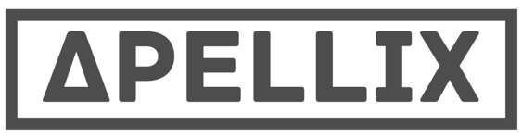

Apellix Seeks Industry Partner for Game-Changing Worker Safety Platform
Worker Bee™ robotics system ideal for large-scale industrial workplaces

Jacksonville, FL April 19, 2016... Apellix, creator of the Worker Bee robotics system, announced today that it is seeking an industry partner to implement its revolutionary platform in a use case conducive to automation. Created for industrial workplaces that need to complete tasks integral to their business but dangerous to workers, the Worker Bee physically interacts with and modifies its environment, moving workers from harm’s way. It’s a revolutionary new product for completing dirty and dangerous tasks, and for decreasing the asset down-time associated with essential maintenance tasks.

The coating, painting, cleaning, and maintenance of large-scale infrastructure such as water towers, bridges, skyscrapers, oil & gas manufacturing facilities, and ships is risky and expensive; climbers working on towers have a fatality rate that is 10 times that of construction workers. By replacing human judgment with science, Apellix increases safety and productivity, reduces costs and labor, and provides measurable standardized quality with environmentally sustainable benefits. In short, Apellix keeps workers safe so companies can focus on their operations.

Apellix CEO and founder Robert Dahlstrom: “Our proprietary, customized software enables drones to do things they’ve never done before. By combining interchangeable and easily upgradable high-tech hardware with leading edge software, our drones are able to paint buildings and towers, wash windows, safely apply chemicals, and more. We’d love to partner with a company that could benefit from the Worker Bee system, both in cost savings and worker safety.”

The potential applications are myriad and include painting power transmission or telecommunication towers, cleaning industrial equipment, and painting or coating bridges and ships.

Industry partners would be expected to share their knowledge and expertise to work with Apellix to build a solution for their unique use case. A collaborative agreement such as joint development or joint venture would be reached, including mutually developed budget and development milestones.

Read more about the Worker Bee and see a demo video at our website www.Apellix.com. and learn more about the Apellix Industry Partner search at http://bit.ly/1SpYbY9

For more information, contact Bob Dahlstrom +1-904-476-3798 or r.dahlstrom@apellix.com

