Texas to auction historic license plate numbers!

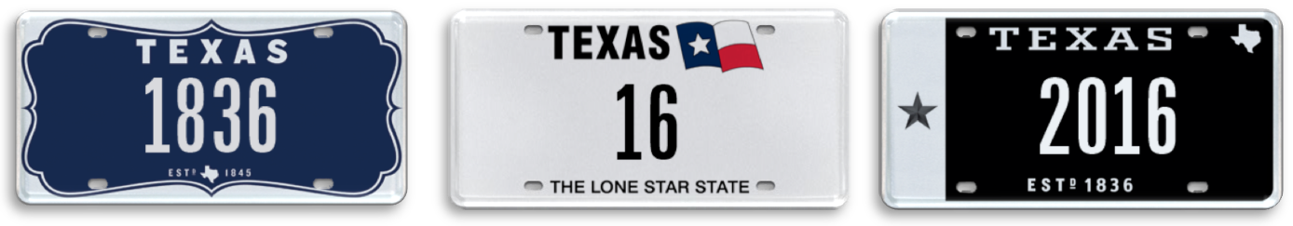

20 April 2016 (Austin, TX) –In the early days, license plates were issued to register all “horseless carriages” with the issuance of a license plate number. The first license plate in Texas was issued during the summer of 1907. Back then, all vehicles or machines had to be registered in order to legally use the public roads, streets or driveways.

Now, My Plates, the official vendor for specialty license plates in Texas is auctioning for the first time a limited release of historic license plate numbers. My Plates will be offering 25 rare license plate numbers during Texas’ first ever Number Plate Auction commencing April 27th, 2016. The auction will run through May 10th.

Texas has a rich history with the first official plates dating back to 1917 made of sheet iron with white numbers on a dark blue background. These were used from 1917 through 1922 and depicted a vertically placed “TEX” abbreviation on the right end of the license plate. By the end of 1917, the department had registered 194,720 motor vehicles, all of which were required to carry a distinguishing plate or radiator seal number.

“Numbers hold a special place in Texas’ license plate history, and this auction will give Texans the opportunity to own a rare piece of this history,” said Steve Farrar, President of My Plates.

In Delaware, numerical license plates attract huge interest and huge bids. In fact, the highest price ever paid for a license plate in the United States was for the Delaware plate number 6 for $675,000 in February 2008. In February this year, the plate numbers 14 and 457 were sold for $325,000 and $32,000 respectively.

The lowest number being offered in this first My Plates number plate auction is the sweetest of them all, the two-digit plate 16.

My Plates is offering another two-digit plate in the auction, the milestone decade plate number 40. Other significant numbers include the current year 2016 and the year the Republic of Texas was established, 1836.

Auction Details:
My Plates Number Plate Auction dates:
- Begin Bid Date: Wednesday, 04-27-16 at 8:00 am
- End Bid Date: Tuesday, 05-10-16 at 8:00 pm

Unlike other everyday Texas license plates, plate messages sold at auction by My Plates are offered for a 5-year term and are legally transferable. The plate owner then has the right to sell the plate message to another person with the same ongoing rights or gift it to a family member or friend. Transferability also means these plates could make great investments.

For more information on the auction and to see the full list of plates being offered, you can visit www.myplates.com/Auction.

License Plate Fun Facts:
- Most Expensive Plate in the World: UAE plate “1” sold for $14.3M, February 2008.
- Most Expensive Plate in U.S.A: Delaware plate “6” sold for $675,000, February 2008
- Most Expensive Plate in Texas: 12THMAN sold $115,000, September 2013.
- Last plate auctioned by My Plates: ALAMO sold for $10,250, March 2016.
____________________________________________________________

My Plates designs and markets new specialty license plates as a vendor for the Texas Department of Motor Vehicles. Texans have bought more than 260,000 My Plates since November 2009, putting more than $41M in the state general revenue fund. My Plates’ goal is to create a long-term, mutually beneficial relationship designed to maximize revenues for the state through the sale of My Plates specialty plates. www.myplates.com.

The Texas Department of Motor Vehicles (TxDMV) serves protects and advances the citizens and industries in the state with quality motor vehicle related services. For every $1 it spends, the TxDMV returns $11 to the state. Each year the agency registers nearly 24 million vehicles; issues more than 7 million vehicle titles; licenses more than 38,000 motor vehicle dealers and distributors; credentials nearly 60,000 motor carriers; issues more than 800,000 oversize/overweight permits; investigates more than 15,000 complaints against dealers and motor carriers; and awards grants to law enforcement agencies to reduce vehicle burglaries and thefts. Learn more at www.TxDMV.gov.

____________________________________________________________
Image Download:

Three hero plates:
1836
https://ce9a9387e1bc258c3cfa-af7906f4e771b24864bbfa3048e4a635.ssl.cf2.rackcdn.com/1836.jpg

16
https://ce9a9387e1bc258c3cfa-af7906f4e771b24864bbfa3048e4a635.ssl.cf2.rackcdn.com/16.jpg

2016
https://ce9a9387e1bc258c3cfa-af7906f4e771b24864bbfa3048e4a635.ssl.cf2.rackcdn.com/2016.jpg

Contact Steve Farrar at (512) 633-7978 or steve@myplates.com

TERMINOLOGY

-“Specialty” plate refers to any official license plate other than the state’s general issue plate.
-Specialty plates can be “personalized” plates, but they don’t have to be.

