For Immediate Release

Contact: Brooks Young
504-731-2989 x27
brooks@tascperformance.com
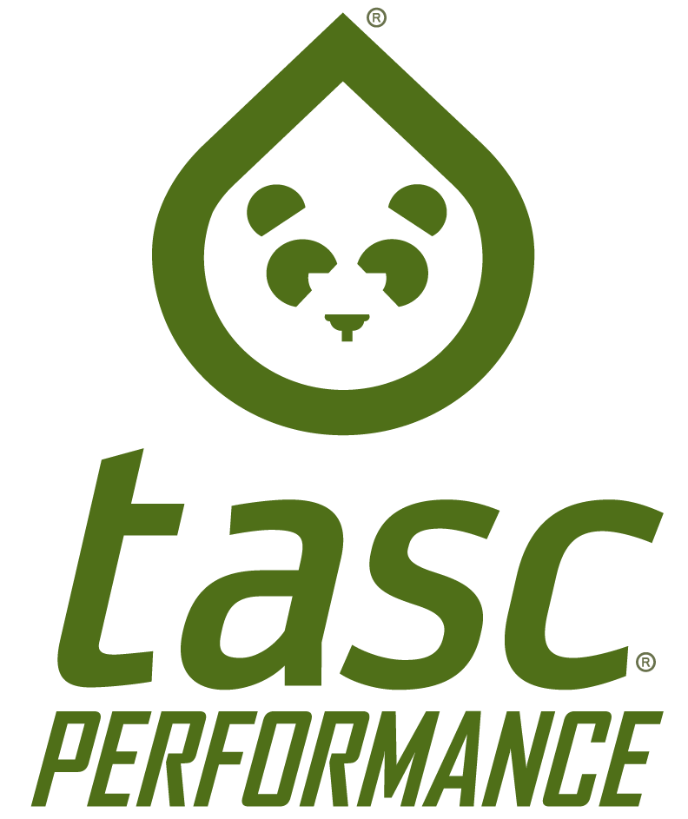

tasc Performance partners with Trombone Shorty Foundation and artist Frenchy to #SaveDatSound in New Orleans
#SaveDatSound shirts and a percentage of tascPerformance sales on 4/28 will support music education in New Orleans

(New Orleans, LA – April 25, 2016) tasc Performance is proud to partner with renowned musician Trombone Shorty and New Orleans artist Frenchy to support the #SaveDatSound Campaign. Proceeds from the sale of the #SaveDatSound commemorative T-shirt, designed by Frenchy and printed on tasc Performance signature shirts, will benefit the Trombone Shorty Foundation. In addition, tasc Performance will donate a percentage of online sales to the Trombone Shorty Foundation on April 28, the date of the Foundation’s annual fundraising concert, Shorty Fest.

“Partnering to benefit organizations like the Trombone Shorty Foundation is in the fabric of who we are,” said Todd Andrews, tasc Performance Co-Founder and President. “As a New Orleans born and based apparel company, we consider it our honor to help foster and preserve the things that make our city great, and that certainly includes our rich musical heritage.”

Founded by Troy “Trombone Shorty” Andrews in 2013, the Trombone Shorty Foundation is Andrews’ vision of sharing his passion to inspire the next generation by developing their musical talent and connecting them to the city’s unique musical heritage. The Foundation fosters music education programming for New Orleans youth.

“This partnership is what New Orleans is all about – we blend our creative juices together like a big pot of gumbo, and come up with something new. Having the local community support the kids and the music of our city means the world to me,” said Troy “Trombone Shorty” Andrews.

In bringing together music, art and philanthropic vision, tasc Performance, Trombone Shorty and Frenchy are creating a powerful fusion of some of the best things about New Orleans.

The exclusive #SaveDatSound shirts will be available at Shorty Fest, the largest fundraiser of the Trombone Shorty Foundation, on April 28 at the New Orleans House of Blues and at the Frenchy Gallery on Oak Street in the Riverbend. They will be available beginning Aril 28 at tascPerformance.com. In celebration of Shorty Fest, tasc Performance will donate a percentage of it’s sales that day to the Trombone Shorty Foundation.

More about tasc Performance
tasc Performance was brought to life in 2009 with one mission: the reinvention of performance apparel. The New Orleans-based, active apparel, company was founded and is operated by the Andrews family, which has a 40-year legacy in the garment industry. After years of dealing with the compromises of polyester athletic apparel – skin irritation, bad odor and more – Al Andrews, former Tulane University basketball standout (All SEC ‘65-’66) charged his son Todd with the difficult task of finding a solution to the polyester problem.

Over a 2+ year period of natural fiber research and textile engineering, the BamCo® (patent-pending) fabric finishing process was created. This process combines viscose from bamboo and organic cotton to create fabrics that hit every metric: Performance (moisture wicking, drying rate, UPF 50+), Feel (absolutely amazing), and Durability (color fastness, shape retention, easy care, anti-odor). tasc now has over ten proprietary fabrics that are built for the mission of enhancing the active experience through the innovation of original fabrics. www.tascperformane.com

More about Trombone Shorty Foundation
Founded by renowned New Orleans musician Troy “Trombone Shorty” Andrews in 2013, the foundation is Andrews’ vision of sharing his passion to inspire the next generation by developing their musical talent and connecting them to the city’s unique musical heritage. Frontman of the band Trombone Shorty & Orleans Avenue, Andrews credits the support of his own positive role models in the rich New Orleans music community for helping him make his way into the world of music, where he has grown into an internationally recognized Grammy Award-nominated artist.

The Foundation partners with Tulane University’s New Orleans Center for the Gulf South to deliver two music education programs offering underserved high school students the opportunity to pursue music as a career: the Trombone Shorty Academy music performance program and the Fredman Music Business Institute. The programs provide mentorship in music performance and education about the business side of the music industry. The foundation also presents “Trad Fridays” presented by Acura with New Orleans Center for Creative Arts, a free workshop program dedicated to the traditional New Orleans sound. For more information about the Trombone Shorty Foundation visit: www.tromboneshortyfoundation.org.

More about Frenchy
Frenchy Paints With Soul and Celebration as he travels the world capturing live music performances, festivals, fundraisers and sporting events with style and finesse. From his palette comes vibrantly colored brush strokes inspired by rhythms and melodies, giving emotions a shape in real time. His vivid, energetic pieces captivate art collectors, sports fans and music lovers alike, as if they had the best seat in the house. Based in the talent-rich city of New Orleans, Frenchy is an ambassador to the arts and a bastion of creativity. You can find Frenchy and his work on Oak Street at his gallery next to the Maple Leaf Bar. www.frenchylive.com

