Heilind Electronics Wins 2016 China Top 10 Value-Added Distributor Award

8 April 2016, Heilind Electronics won China Top 10 Value-Added Distributor Award during 2016 China Information Technology Expo (CITE) in Shenzhen, China.
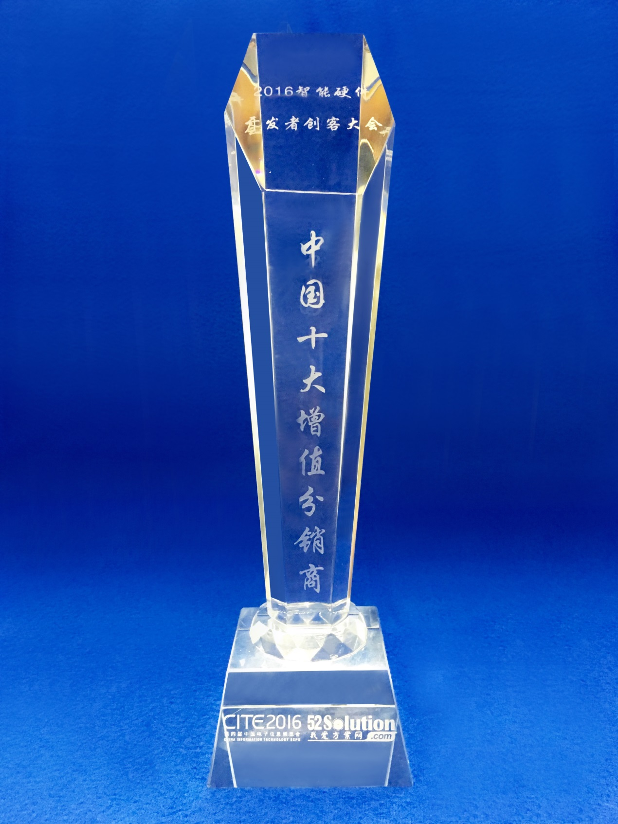 China Top 10 Value-Added Distributor Award from CITE 2016

Organized by Ministry of Industry and Information Technology (MIIT) and the Municipal Government of Shenzhen, CITE is one of the largest-scale Asia Expos for information technology, robots, cloud computing, wearable technology, new energy and electronic components.

This award evaluated value-added services of authorized distributors in China, especially their abilities in providing intelligent hardware innovation and supply-chain solutions. The selection result came from electronic industry experts’ selection and public vote.

Heilind Electronics operates fully-equipped value added centers in New Hampshire, USA and Hong Kong offering a complete menu of part assembly, part modification, and packaging services. Each facility has an in-house technical staff experienced in engineering custom manufacturing, packaging and tooling solutions for customers.

As Top 10 Value-Added Distributor in China, Heilind provides a high quality, flexible and responsive resource that can shorten lead times, consolidate SKUs, reduce manufacturing & handling costs, and improve inventory performance & response to manufacturing, which delivers multiple customer benefits.

Collins Yang, Dongguan branch manager of Heilind Asia Pacific, said, “Thanks for the support from electronic industry and Heilind customers. China Top 10 Value-Added Distributor Award proves our advantages in value added services and supply chain management, and we will continue to expand our existing product lines and services, bringing the core value of distribution to the electronic industry.”

Heilind supports both original equipment and contract manufacturers in all market segments of the electronics industry, stocking products from the industry’s leading manufacturers in 25 component categories, with a particular focus on interconnect and electromechanical products.
About Heilind Electronics
Founded in 1974, Heilind Electronics, Inc. (www.heilind.com) is one of the world's leading distributors of connectors, relays, switches, thermal management & circuit protection products, terminal blocks, wire & cable, wiring accessories and insulation & identification products. Heilind has over 40 facilities in the United States, Canada, Mexico, Brazil, Germany, Hong Kong, Singapore and China.

Heilind Asia Pacific (www.heilindasia.com) commenced operations in Dec 2012, and now has 19 locations throughout Asia. Its industry leading service offering to customers in Asia Pacific is the result of a commitment to the belief of “Distribution As It Should Be”.

Media Contact:
Vesper Hu, Heilind Electronics
Senior Marcom and PR Officer
+852 2611 9173
Vesper.hu@heilind.com

