https://jackofallshades.com/custom-lamp-shade-measuring.asp Copy and paste or click this link!

PLEASE CLICK THE TUTORIAL FOR MEASURING BELOW FOR YOUR SHADE SHAPE:

USING STILL PICTURES, HERE IS HOW TO MEASURE YOUR SHADE:
ROUND (Click to see a larger image):

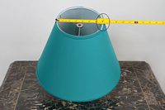

Round-Top Dimension

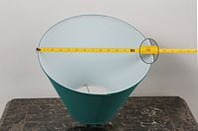

Round-Bottom Dimension

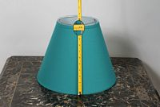

Round-Slant Height
SQUARE (Click to see a larger image):

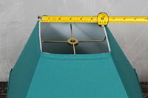

Square-Top Dimension

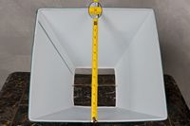

Square-Bottom Dimension

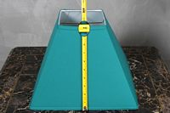

Square-Slant Height
OVAL (Click to see a larger image):

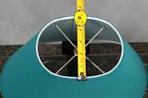

Oval-Top Width

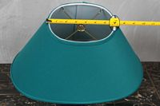

Oval-Top Length

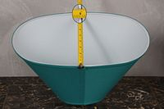

Oval-Bottom Width

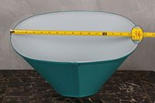

Oval-Bottom Length

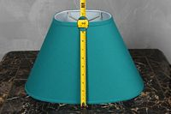

Oval-Slant Height
RECTANGLE (Click to see a larger image):

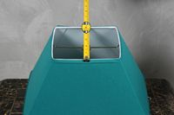

Rectangle-Top Width

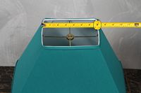

Rectangle-Top Length

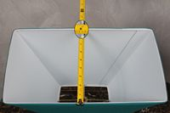

Rectangle-Bottom Width

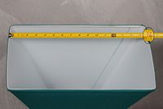

Rectangle-Bottom Length

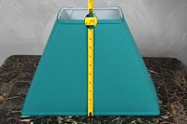

Rectangle-Slant Height

ALSO IMPORTANT! MEASURING YOUR FITTER DROP:
In general, your fitter drop is the distance from the "top of the lampshade" to the ring (fitter) that attaches to your lamp base. It is sometimes easier to turn your lampshade upside down on a table and measure from the table to the fitter. If you need help measuring your fitter drop, please give us a call at the support phone number listed at the top of this website. (Click on an image to see a larger view.)

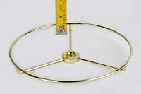

Standard 1/2" Washer; 1/2" Drop

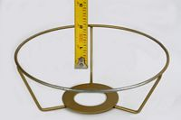

Euro; 2" Drop

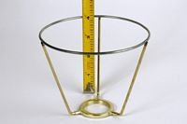

Uno; 4" Drop

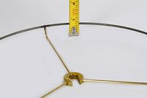

Cut Washer; 3/4" Drop

