
Media Contact:
Jane Lui
VIZ Media, LLC
jane.lui@viz.com
(415) 546-7073 x176

PRESS RELEASE

FOR IMMEDIATE RELEASE

VIZ MEDIA TO DEVELOP ORIGINAL ANIMATED KIDS SERIES GAKKIMALS

Japanese Children’s Property Combines Animals And Music Licensed For Development Into An Original Animated Series

San Francisco, CA, May 23, 2016 – VIZ Media, LLC (VIZ Media), a premier company in the field of publishing, animation distribution, and global entertainment licensing, has acquired the production and licensing rights to develop an original animated series based on the Japanese children’s property, GAKKIMALS.

The series will be produced under license from ShoPro, a subsidiary of three of Japan's largest publishing houses, Shogakukan Inc., Shueisha Inc. and Hakusensha Inc., that focuses on licensing and merchandising the properties owned by Shogakukan Inc. GAKKIMALS is based on an original concept created by Japanese production duo, PecanNuts.

Welcome to the wonderful adventures of the GAKKIMALS, where madcap mash-ups of musical instruments and animals combine to bring happiness and harmony to their fun-filled world.

“The acquisition of GAKKIMALS represents an important step in our initiative to develop new and engaging global content in partnership with our creative partners in Japan,” says Brad Woods, CMO, VIZ Media. “GAKKIMALS is a truly unique children’s property that combines the evergreen appeal of music and animals into a vibrant environment that inspires early childhood learning with a fun cast of endearing characters. We look forward to working closely with our partners at ShoPro to develop this exciting new show.”

For more information on GAKKIMALS and other titles available from VIZ Media, please visit www.VIZ.com.



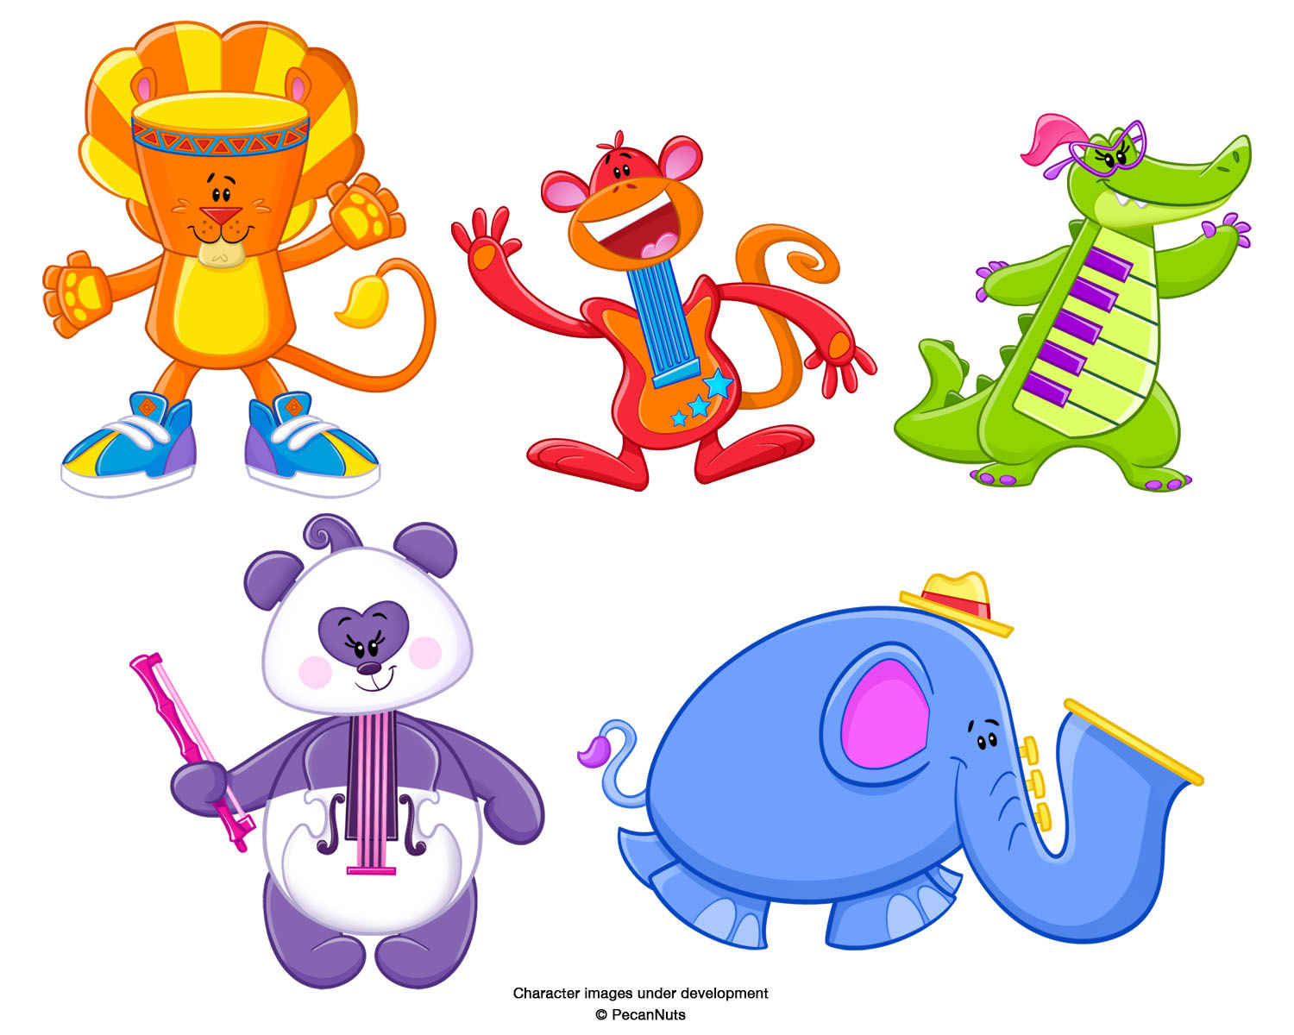

About VIZ Media, LLC
Established in 1986, VIZ Media is the premiere company in the field of publishing, animation distribution, and global entertainment licensing. Along with its popular digital magazine WEEKLY SHONEN JUMP and blockbuster properties like NARUTO, DRAGON BALL, SAILOR MOON, and POKÉMON, VIZ Media offers an extensive library of titles and original content in a wide variety of book and video formats, as well as through official licensed merchandise. Owned by three of Japan's largest publishing and entertainment companies, Shueisha Inc., Shogakukan Inc., and Shogakukan-Shueisha Productions, Co., Ltd., VIZ Media is dedicated to bringing the best titles for English-speaking audiences worldwide.

Learn more about VIZ Media and its properties at www.VIZ.com.
###

