News Release  For Immediate Release: May 21, 2016 | For more information contact:  Chris Pearson  Cell:517.899.6612  Office: 517.267.7440  cpearson@laketrust.org  Website: laketrust.org

Lake Trust Credit Union Foundation Awards $20,000 in Scholarships

(Brighton, Michigan) The Lake Trust Credit Union Foundation awarded $20,000 in scholarships to high school graduating seniors during its First Annual Scholarship Award Celebration. Lake Trust president and CEO David Snodgrass presented four students with scholarships of $5,000 each.

- Mackenzie Benning of Chelsea
- Lauren Janes of Mt. Pleasant
- Grace Koepele of Ann Arbor
- Rachel Welch of Frankenmuth

“Lake Trust Credit Union is proud to recognize and support the hardworking, young members of our community,” said Lake Trust Credit Union president and CEO David Snodgrass. “These students exemplify excellence in the classroom while making an impact in our communities.”

The 2016 Scholarship recipients are community-minded students who best represent Lake Trust’s core values of trust, teamwork, adaptability, learning and making a difference.
The Lake Trust Foundation is a 501(c)3 dedicated to making a difference by investing volunteer support and financial resources in Michigan Counties served by Lake Trust Credit Union. The Foundation’s mission is to bring people and organizations together to create strong, diverse vibrant communities through financial contributions and Team Lake Trust volunteerism.
Lake Trust Credit Union is Michigan’s sixth largest credit union, with branches stretching from Lake Michigan to Lake Huron and Lake Erie. With more than $1.6 billion in assets, Lake Trust provides over 166,000 members with best-in-class products offering individualized, trust-based member service. Membership is open to anyone within its 35-county service area. Learn more about Lake Trust online at laketrust.org or follow Lake Trust on Twitter @laketrust. Lake Trust is also on Facebook.

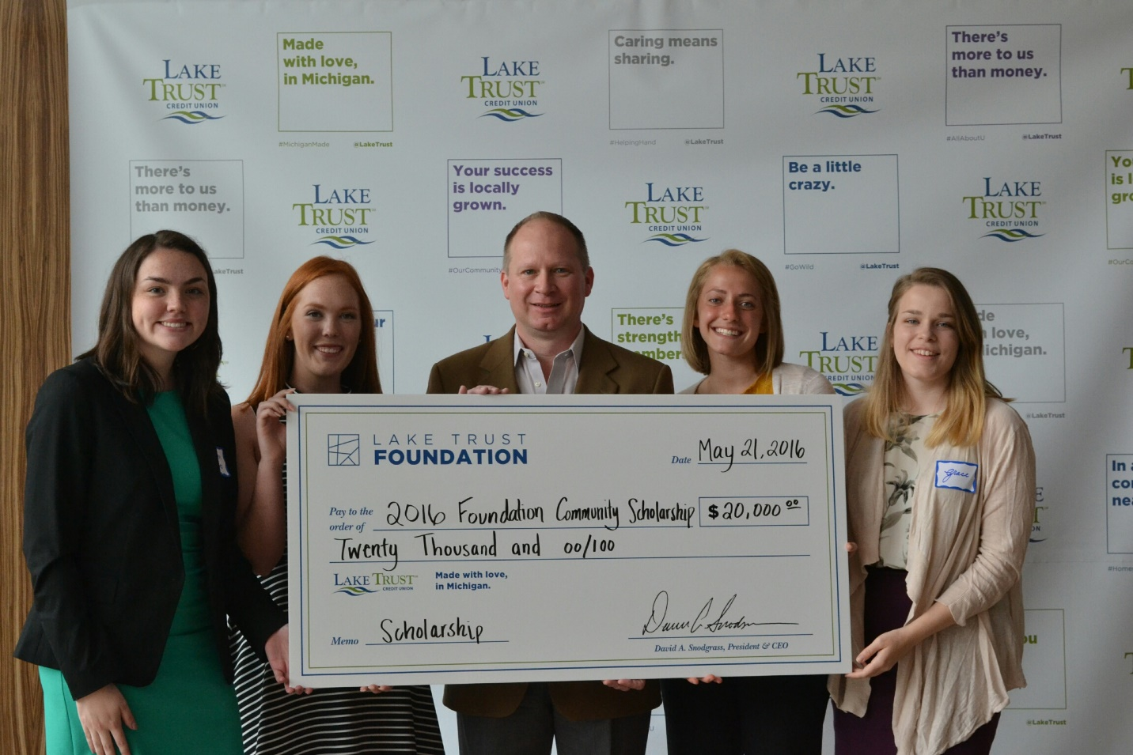

Lake Trust Credit Union President and CEO, David Snodgrass, pictured with (Left to Right) Lauren Janes, Rachel Welch, Mackenzie Benning and Grace Koepele.

####

